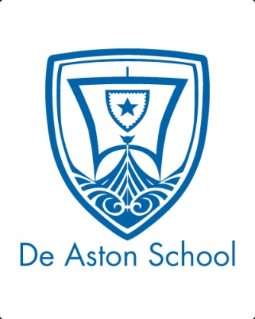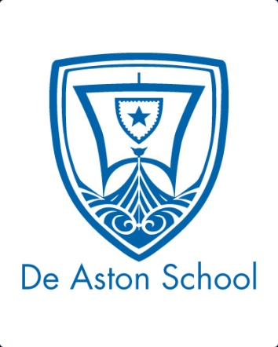**De Aston**

**English Department**

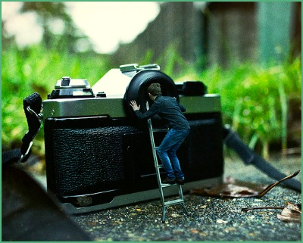

**Year 9: Big Imitation**

**Challenge Tasks**

**Name:**

**Week Two:**

The past is a different country. This week, choose a challenge task:

**Hard** – create your own character profile for someone who reflects on a childhood location/memory;

**Harder** – read one of Neil Gaiman’s other stories/novels, making a list of his favourite techniques;

**Hardest** – write an alternative beginning to one of the texts studied so far.

**Week Three:**

Graphic novels and symbolism. Choose a challenge!

**Hard** – Describe a party/disco you’ve been to.

**Harder** – write about a party/disco you’ve been to in the style of Nick Carraway from The Great Gatsby;

**Hardest** – research an actual celebrity party and describe it from the perspective of one of the caterers/servants/staff.

**Week One:**

This week, you will have learnt how different writers begin their narratives. Choose one of the tasks below to demonstrate your understanding of narrative techniques. You can work individually or with a partner.

* A detailed, labelled drawing of one of the settings studied in one of our texts;
* A review of the opening to one of the texts;
* A new book cover and blurb for one of the texts.

Be creative but be prepared to justify your choices and how they show your understanding of the text.

**Week Four-Six:**

Now it’s time for some poetry project work. This project will take you two weeks to complete.

With a partner or on your own, choose a task below.

1. Create your own poem on the theme of relationships.
2. Script and be prepared to explain a short scene from a play based on the events described in one of the poems;
3. Write a monologue as one of the characters from one of the poems!

**Bonus week:**

Read the review below from the Independent and complete the ‘all’ question and one more of the questions below:

**All:** list four things you learn about the book called The Not Dead.

**Hard:** what is the writer’s view of the poet Simon Armitage?

**Harder:** how does the writer use language to interest the reader in the topic?

**Hardest:** to what extent does the text provide an informative review of this collection of poetry?

Originally broadcast a year ago in a Channel 4 documentary of the same name, The Not Dead is a short collection of war poems written, not in battle, but as a response to the testimonies of ex-soldiers featured in the programme. As Simon Armitage points out in his eloquent, self-effacing introduction, time is no "great healer" for people scarred by war. One of the former soldiers in the documentary is still unable to talk without crying about a jungle ambush he took part in nearly 50 years previously in Malaya.

Each poem focuses on a flashback scene one of the ex-soldiers has struggled to forget. "Remains", for example, written for someone who served in Basra, tries to capture the moment when he shot a man looting a bank. The body was disposed of but the man's "blood shadow" remained on the street: "I blink / and he bursts again through the doors of the bank. / Sleep, and he's probably armed, possibly not."

Who are the Not Dead? The ex-servicemen and the ghosts trapped in their memories; the people who live and die and live again every time one of the veterans experiences a bad memory. This collection offers a strange, painful kind of memorial.

**Additional challenge tasks:**

Make sure you understand what each of these words means and show your understanding by trying to use them in your classwork. Then learn how to spell them – be ready for a spelling test in the last week of term.

**Hard:**

1. Prose 2. Representation 3. Eponymous 4. Characterisation 5. Setting

**Harder:**

1. Omniscient 2. Intensifier 3. Oxymoron 4. Parody 5. Satire

**Hardest:**

1. Impertinent 2. Novice 3. Obtuse 4. Parallel 5. Superfluous

**Final challenge:**

Finally, challenge yourself to read one of the following: The Curious Incident of the Dog in the Night-time by Mark Haddon, Rebecca by Daphne du Maurier, The Ocean at the End of the Lane by Neil Gaiman, The Great Gatsby by F. Scott Fitzgerald, The Driver’s Seat by Muriel Spark, The Help by Kahtryn Stockett, To Kill a Mockingbird by Harper Lee, The Book Thief by Marcus Zusak.



For more resources, including literacy support, visit www.deastonenglish.com