Year 8: Independent Learning Timetable
This timetable is planned for x3 hours a week of English. Do feel free to email teachers highlighted work to mark:
8S and 8N – Georgina.Clark@de-aston.lincs.sch.uk
8D – Elizabeth.Masterman@de-aston.lincs.sch.uk
8T – Elizabeth.Reynolds@de-aston.lincs.sch.uk and Kester.Halsall@de-aston.lincs.sch.uk
8A and 8O – Chloe.Mead@de-aston.lincs.sch.uk
Misc. or technical issues – Sarah.Peacock@de-aston.lincs.sch.uk

Week 1 – w.b. 23/3/20 | Lesson 1: Open the document titled ‘Year 8 Remote Learning Booklet’ – if you have any problems opening it, please let me know ASAP.  First complete the activity on page 3, matching the terminology to its definition – check your answers are correct by researching.  Move on to page 4 and read the extract from ‘The Lion, The Witch and The Wardrobe’ and complete the activities on pages 5 and 6.  Lesson 2:  Read the extract above to the novel ‘One of Us is Lying’ – what genre do you think it is and why? Answer in a full paragraph. Either write your own opening for a similar genre or carry on this narrative. Think about using some of this sophisticated vocabulary. Send this work to your teacher.  angst an acute but unspecific feeling of anxiety  anomaly deviation from the normal or common order or form or rule  capricious determined by chance or impulse rather than by necessity  epitome a standard or typical example  gregarious temperamentally seeking and enjoying the company of others  sycophant a person who tries to please someone to gain an advantage  Oblivious not aware of or concerned about what is happening around one  Exacerbate make (a problem, bad situation, or negative feeling) worse.  Lesson 3: Compare the opening you’ve just read of One of us is lying to this opening of Prince of Mist. What similarities and differences are there? Which do you prefer and why? Does Prince of Mist also fit into more than one genre? What language features do they use? Use SQUAD to compare these two openings.  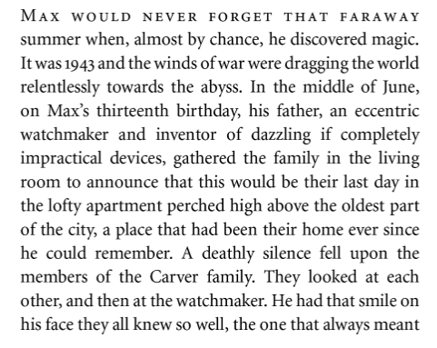  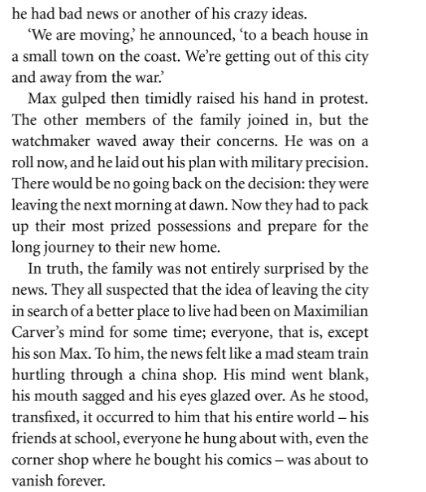
Week 2 – w.b. 30/3/20 | Lesson 1: Open the document titled ‘Year 8 Remote Learning Booklet’.  Go to page 7 and read the extract from ‘Dracula’ and complete the activities on pages 7-10. Send your answer to the question on page 10 to your teacher.  Lesson 2: Open up the document titled ‘Year 8 English Booklet’ and complete the activities on pages 3 and 4.  Lesson 3: Writing Challenge! Narrate a typical day from the perspective of the rain. Aim to use the words ‘transient’ (for a short while) and ‘apocalyptic’ (end of the world) in your description.
Week 3 – w.b. 20/4/20 | Lesson 1: Open the document titled ‘Year 8 Remote Learning Booklet’.  Go to page 11 and read the extract from ‘Pride and Prejudice’ and complete the activities on pages 11-13.  Lesson 2: Open up the document titled ‘Year 8 English Booklet’ and complete the activities on page 5.  Lesson 3: Writing Challenge! Begin a short story with the sentence ‘Noting is so painful to the human mind as a great and sudden change…’ Aim to use a semi colon, 3 verb start sentences and the word ‘inexorable’ (impossible to stop/prevent) in your work. Send this work to your teacher.
Week 4 – w.b. 27/4/20 | Lesson 1: Open the document titled ‘Year 8 Remote Learning Booklet’.  Go to page 14 and read the extract from ‘Hitchhiker’s Guide to the Galaxy’ and complete the activities on pages 15 and 16.  Lesson 2: Open up the document titled ‘Year 8 English Booklet’ and complete the activities on page 6. Send this work to your teacher.  Lesson 3: Writing Challenge! Describe the room you are in from the point of view of an insect. Aim to use hyperbole, superlatives and the word ‘lenient’ (relaxed) in your writing.
Week 5 – w.b. 4/5/20 | Lesson 1: Open the document titled ‘Year 8 Remote Learning Booklet’.  Go to page 17 and complete the creative writing task. Aim to use the techniques listed and stretch your vocabulary. Send this work to your teacher. Then complete the grammar activity on page 18.  Lesson 2: Open up the document titled ‘Year 8 English Booklet’ and complete the activities on pages 7 and 8.  Lesson 3: Writing Challenge! Your Time Travelling Machine has arrived. You read the handbook, program in the date and step in. Where are you? Aim to use personification, speech, and the word ‘superfluous’ (unnecessary) in your work.
Week 6 – w.b. 11/5/20 | Lesson 1: Open the document titled ‘Year 8 Remote Learning Booklet’.  Go to page 19 and read the extract from ‘The Great Gatsby’ and complete the activities on pages 19-21.  Lesson 2: Open up the document titled ‘Year 8 English Booklet’ and complete the activities on page 9.  Lesson 3: Writing Challenge! Budget cuts mean one subject must be cut from the curriculum. Pick a subject and write a letter to the Education Minister arguing why it shouldn’t be cut. Aim to use ellipses, oxymoron, a metaphor and the word ‘rudimentary’ (basic) in your work. Send this work to your teacher.
Week 7 – w.b. 18/5/20 | Lesson 1: Open the document titled ‘Year 8 Remote Learning Booklet’.  Go to page 22 and answer the question about ‘The Great Gatsby’ extract you read last week. Then complete the activity on page 23. Send both pieces of this work to your teacher.  Lesson 2: Open up the document titled ‘Year 8 English Booklet’ and complete the activities on pages 10 and 11.  Lesson 3: Writing Challenge! Write an informative essay on the title: My Biggest Fear’. Aim to use onomatopoeia, a metaphor, direct address and the word ‘loathing’ (hatred) in your work.
Week 8 – w.b. 1/6/20 | Lesson 1: Open the document titled ‘Year 8 Remote Learning Booklet’.  Go to page 24-25 and read the extract from ‘To Kill A Mockingbird’ and complete the activities on pages 26 and 27.  Lesson 2: Open up the document titled ‘Year 8 English Booklet’ and complete the activities on pages 12 and 13. Send this work to your teacher.  Lesson 3: Writing Challenge! It is the year 2099 and WW3 has just ended. The government has been disbanded and English is now an illegal language. Write a speech to inspire others to join your rebellion against the new rules. Aim to use hypophora (question then answer), a metaphor, an imperative sentence and the word ‘oppress’ (put down) in your work.
Week 9 – w.b. 8/6/20 | Lesson 1: Open the document titled ‘Year 8 Remote Learning Booklet’.  Go to page 29 and read the extract from ‘The Woman in Black’ and complete the activities on pages 30-31.  Lesson 2: Open up the document titled ‘Year 8 English Booklet’ and complete the activities on page 14.  Lesson 3: Writing Challenge! Dr Plum murdered Mrs Brown in the library with poisoned ink! Write the final scene of a detective story where the crime and motive are explained. Use list of three, a simile and the word ‘concealed’ (hidden) in your writing. Send this work to your teacher.
Week 10 – w.b. 15/6/20 | Lesson 1: Open the document titled ‘Year 8 Remote Learning Booklet’.  Go to page 32 and read the extract from ‘The Graveyard Book’ and complete the activities on pages 32-34. Send your work to your teacher.  Lesson 2: Open up the document titled ‘Year 8 English Booklet’ and complete the activities on pages 15 and 16.  Lesson 3: Writing Challenge! “I’m mad as hell and I’m not going to take it anymore!” Write a piece of writing that begins and ends with this sentence. Use a metaphor, repetition, personification and the word ‘temerity’ (boldness) in your writing.
Week 11 – w.b. 22/6/20 | Lesson 1: Open the document titled ‘Year 8 Remote Learning Booklet’.  Go to page 35 and read the extract from ‘Lord of the Rings’ and complete the activities on pages 35-38.  Lesson 2: Open up the document titled ‘Year 8 English Booklet’ and complete the activities on pages 17 and 18. Send this work to your teacher.  Lesson 3: Writing Challenge! Write a humorous how-to guide to using an everyday object (e.g. a paperclip). Aim to use the word ‘mundane’ (boring) in your writing.
Week 12 – w.b. 29/6/20 | Lesson 1: Open the document titled ‘Year 8 Remote Learning Booklet’.  Go to page 39 and complete the activities on pages 39-40. Send this work to your teacher.  Lesson 2: Open up the document titled ‘Year 8 English Booklet’ and complete the activities on page 19.  Lesson 3: Writing Challenge! What is the most important colour in the world and why? Write a persuasive speech. Aim to use metaphor, hyperbole, alliteration and emotive language. Use the word ‘aurora’ (dawn) in your work.
Week 13 – w.b 6/7/20 | Lesson 1: Open the document titled ‘Year 8 Remote Learning Booklet’.  Go to page 41 and read the extract from ‘King Midas’ and complete the activities on pages 41-43.  Lesson 2: Open up the document titled ‘Year 8 English Booklet’ and complete the activities on pages 20-22. Send this work to your teacher.  Lesson 3: Writing Challenge! ‘She was timid and moved with caution…’ Continue describing this character. Aim to use personification, zoomorphism and oxymoron in your writing.
Week 14 – w.b. 13/7/20 | Lesson 1: Open the document titled ‘Year 8 Remote Learning Booklet’.  Go to page 45 and complete the activities from pages 45-48. Send this work to your teacher.  Lesson 2: Open the document titled ‘Year 8 Remote Learning Booklet’. Go to page 49 and read the extract from ‘The Shepherd’s Crown’ and complete the activities on pages 49-52.  Lesson 3: Open up the document titled ‘Year 8 English Booklet’ and complete the activities on page 23.
Summer Holiday

