**De Aston**

**English Department**

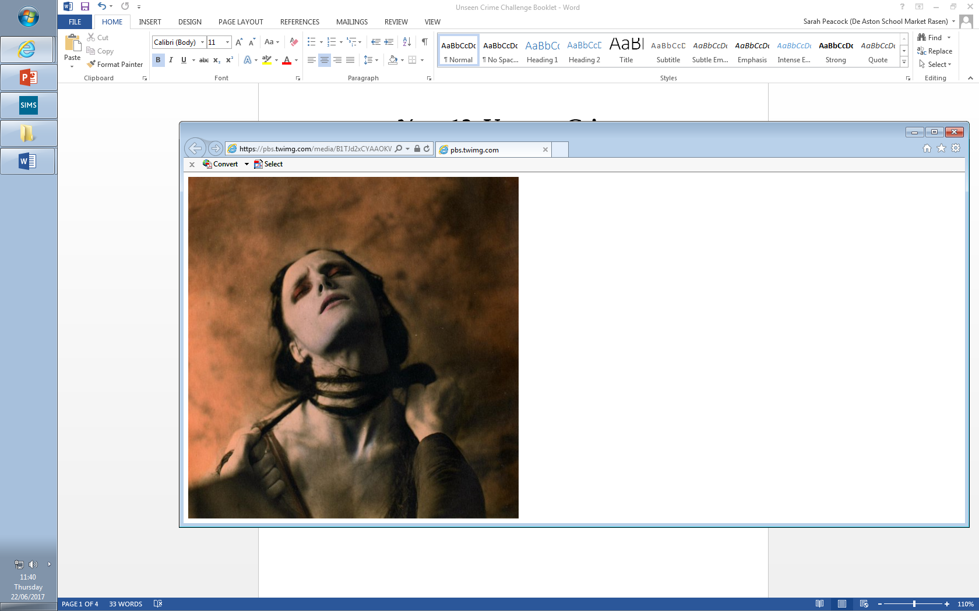

**Year 13: Crime Poetry Selection**

**Challenge Tasks**

**Name:**

**Week Two:**

To what extent does Browning show the Duke to be a villain in ‘My Last Duchess’?

How are women presented in the text?

**Week Three:**

‘Hell hath no fury like a woman scorned.' Describe how Robert Browning presents this technique in The Laboratory.

What is the impact of the setting in the poem?

**Week One:**

Oscar Wilde’s poem was praised for its social realism – to what extent do you feel this is the main focus of the poem?

Alternatively, religious themes dominate the poem too – to what extent do these point beyond social reform and instead point to final judgement?

**Week Four:**

1. How does the title of the poem change your interpretation? Look at the different titles it's had: "Porphyria," "Madhouse Cells," and "Porphyria's Lover." What does each title emphasise?
2. Why does the poem end with the speaker's assertion that there will be no consequences for his actions?

**Week Five:**

What does Crabbe highlight as a sin in this poem? Look at both explicit and implicit sins.

What is the impact of the religious imagery in the poem?

**Week Six:**

Track each of the following themes in the poems and refer to quotations:

* Murder and violence
* The criminal psyche
* Victims
* Punishment
* Settings
* Social commentary



For more resources, including literacy support, visit www.deastonenglish.com