**De Aston**

**English Department**

[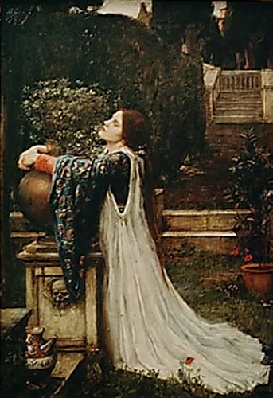](http://www.google.co.uk/url?sa=i&rct=j&q=&esrc=s&source=images&cd=&cad=rja&uact=8&ved=0ahUKEwi64Jz4ndHUAhXLLVAKHStLDRcQjRwIBw&url=http://www.john-keats.com/phpboard/viewtopic.php?f%3D2%26t%3D664&psig=AFQjCNFd4o0I-L-jWmp_4xLr2YUrKaEoYA&ust=1498213386062628)

**Year 12: Keats**

**Challenge Tasks**

**Name:**

**Week Four:**

After reading ‘Eve of St Agnes’ complete the ‘ALL’ task and one of the other following tasks:

ALL: Choose five quotations of significance from Eve and annotate them for language devices and effects.

1. Who is the tragic hero/heroine in ‘Eve’? Use your quotations to support your answer.
2. What is the effect of the setting in ‘Eve? Use your quotations to support your answer.

**Week Two:**

After reading ‘La Belle Dame Sans Merci’ complete the ‘ALL’ task and one of the other following tasks:

ALL: Choose five quotations of significance from ‘La Belle Dame’ and annotate them for language devices and effects.

1. Who is the tragic hero/heroine in ‘La Belle Dame’? Use your quotations to support your answer.
2. What is the effect of the setting in ‘La Belle Dame’? Use your quotations to support your answer.

**Week Three:**

Hard: What is the impact of the Belle Dame’s silence in the poem?

Harder: Rewrite the poem from the perspective of La Belle Dame.

Hardest: Conduct a feminist reading of La Belle Dame – to what extent does the text represent feminist ideas?

**Week One:**

Research art work inspired by Keats’ poems: google the title of each poem with ‘Keats’ and ‘painting’ or ‘art’ to ensure you get the right ones!

Choose one for each poem and write a commentary of the art piece – what do you expect of the poem from the piece of art, or, if you are familiar with the pieces, to what extent do they represent the poem?

**Week Five:**

Hard: What is the impact of Angela and the Beadsman’s deaths?

Harder: What is the impact of ‘the male gaze’ in the poem?

Hardest: To what extent do you believe the poem is a criticism of religion?

**Week Ten:**

Track the following tragedy elements in each poem (this will also help you with next week’s homework):

* Tragic victims and tragic heroes, loss of identity, resolution, inevitability and setting.
* Refer to quotations.

**Week Nine:**

Hard: Read the Greek myth of Lamia – to what extent is the poem faithful to it?

Harder: As above but consider how the myth may influence our opinions of Lamia.

Hardest: Consider the ending of the poem – is it cathartic?

**Week Eight:**

After reading ‘Lamia’ complete the ‘ALL’ task and one of the other following tasks:

ALL: Choose five quotations of significance from Lamia and annotate them for language devices and effects.

1. Who is the tragic hero/heroine in ‘Lamia’? Use your quotations to support your answer.
2. What is the effect of the setting in ‘Lamia’? Use your quotations to support your answer.

**Week Seven:**

Hard: What is the impact of the gore mixed with romance in Isabella?

Harder: Is Isabella a strong female in the text or is her portrayal weak?

Hardest: What is the impact of the pantheist imagery in the poem?

**Week Six:**

After reading ‘Isabella complete the ‘ALL’ task and one of the other following tasks:

ALL: Choose five quotations of significance from Isabella and annotate them for language devices and effects.

1. Who is the tragic hero/heroine in ‘Isabella’? Use your quotations to support your answer.
2. What is the effect of the setting in ‘Isabella’? Use your quotations to support your answer.

**Week Eleven & Twelve:**

In terms of your revision for this unit, track the following in each poem. You can present your revision how you wish (collage, cue cards, PPT etc…). Each element should include quotes.

* Plot
* Characters
* Themes
* Context
* Language, structure and form
* Links to tragedy elements
* Criticism



For more resources, including literacy support, visit www.deastonenglish.com