**De Aston**

**English Department**

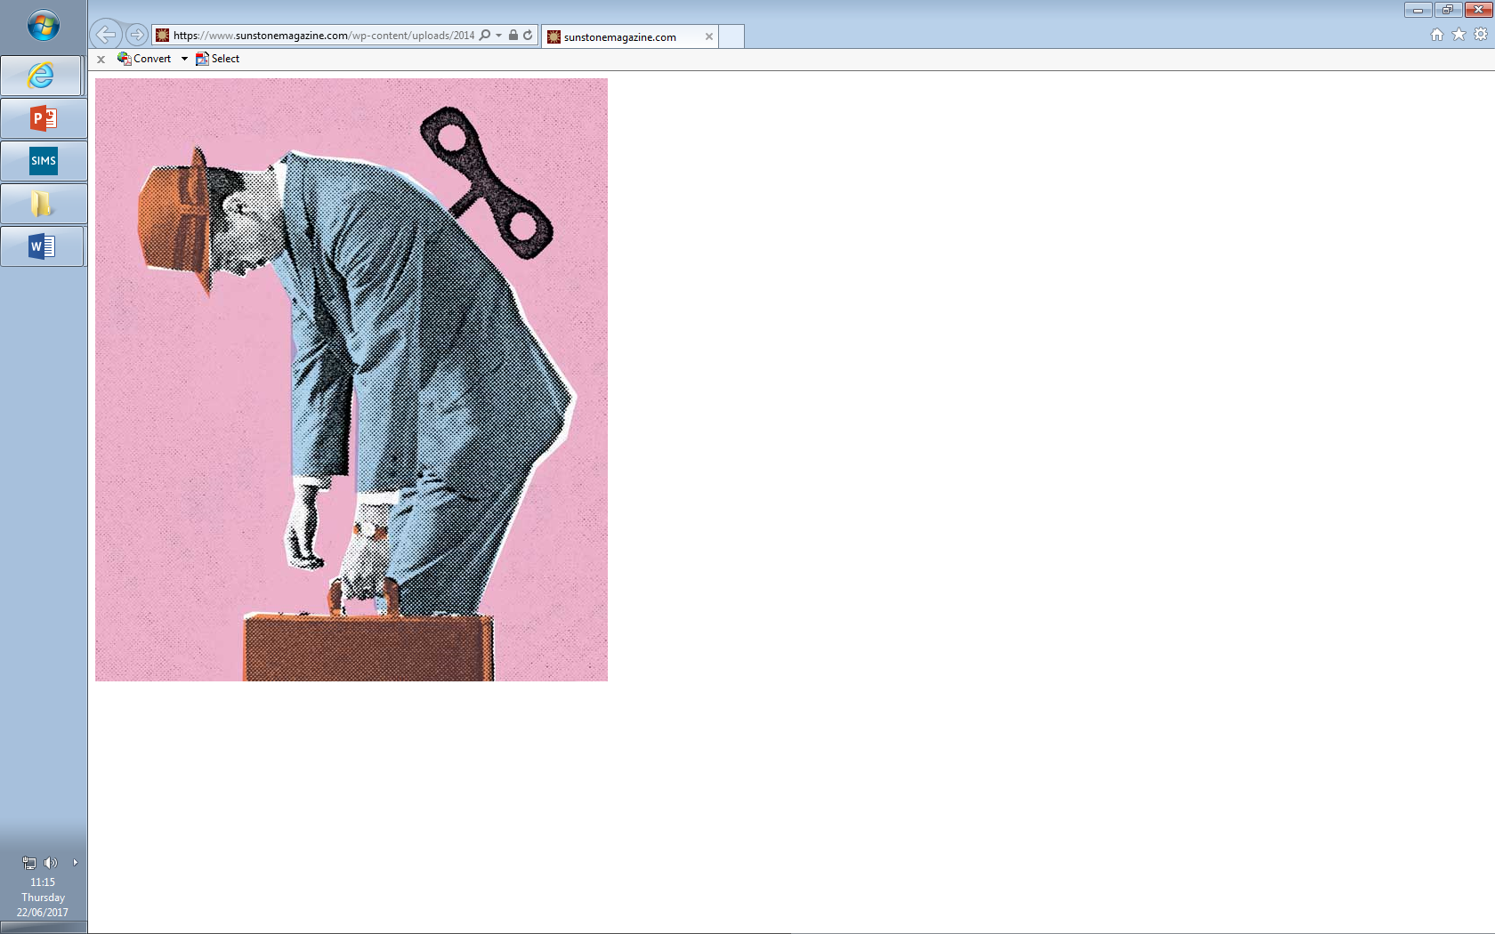

**Year 12: Death of a Salesman**

**Challenge Tasks**

**Name:**

**Week Two:**

Research the context of Death of a Salesman.

Present your research in a creative way, linking to the text. Also consider the creation of Miller’s tragedy style and how it was influenced by Shakespeare and Greek theatre.

**Week One:**

Now you understand what the setting looks like, answer the following question:

To what extent does the setting reveal the themes in the play?

**Week Three:**

Hard: Look on Youtube and different presentations of Willy in DOAS. Evaluate which is the most successful.

Harder: As above but compare the presentations to the play.

Hardest: As above but then write a short how-to guide, giving advice to actors playing Willy.

**Week Four:**

Hard: With your reading so far, answer the question: Is DOAS a Shakespearean tragedy?

Harder: With your reading so far, answer: Is DOAS a conventional tragedy?

Hardest: With your reading so far, answer: DOAS is a subversion of the tragedy genre. To what extent do you agree?

**Week Five:**

Hard: Read ThoughtCo review of *DOAS* and write down key ideas that could as criticism for the novel.

Harder: As above but explain your links to the play.

Hardest: Evaluate the criticism – do you agree with it? Why? Why not?

**Week Nine-Ten:**

In terms of your revision for this unit, track the following in the text. You can present your revision how you wish (collage, cue cards, PPT etc…). Each element should include quotes.

* Plot
* Characters
* Themes
* Context
* Language, structure and form
* Links to crime elements
* Criticism

**Week Eight:**

Hard: Consider how your impressions and views of characters may now have changed. Track each character and how we feel about them in each Act of the play. Support with quotations.

Harder: As above but also explain how the quotations included support your view.

Hardest: As above but evaluate each character. How do they fit into the crime genre?

**Week Seven:**

Hard: Linda is a strong woman. To what extent do you agree?

Harder: Biff is the real victim of the play. To what extent do you agree?

Hardest: Why do you believe Miller chose to leave Happy as an underdeveloped character?

**Week Six:**

Hard: Google and read Cardullo’s essay on *DOAS* called ‘The Swollen Legacy of Arthur Miller.’ Summarise the article and highlight the key ideas that could be used for criticism.

Harder: As above but link the ideas to the play.

Hardest: As above but also consider how the novel may fit the Feminism/Marxist lens.



For more resources, including literacy support, visit www.deastonenglish.com