**De Aston**

**English Department**

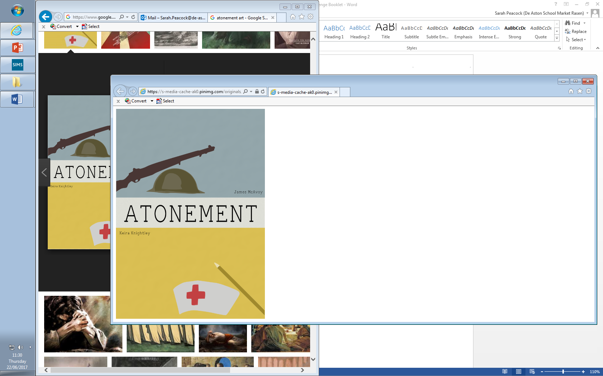

**Year 12/13: Atonement**

**Challenge Tasks**

**Name:**

**Week Three:**

So far, how does the novel conform to the crime genre? Include also ideas about how it subverts the crime genre.

**Week Two:**

Now you have started reading the text, you will have understood some of the settings described.

Give your first impressions of the Tallis home using evidence from the text but also consider how descriptions of the home foreshadow later events.

**Week One:**

Research the historical context of Atonement by looking at when it was set from 1930s to 1940s. Note down key events but remembering to stay focused on the text.

Also, consider what McEwan may have chosen to write a novel that spans over time so much, looking to the past and set relatively close to the present day towards the end. Why might he have chosen to do this?

**Week Four:**

Research how the novel uses intertextuality.

Find examples of intertextuality and consider the impact of them.

Evaluate McEwan’s use of intertextuality – is it effective?



For more resources, including literacy support, visit www.deastonenglish.com