Macbeth Key Scenes Booklet
Ideal study companion for the new 9-1 English Specification
Designed for the new (9-1 Specification)
Key Scenes & questions to help you master the play
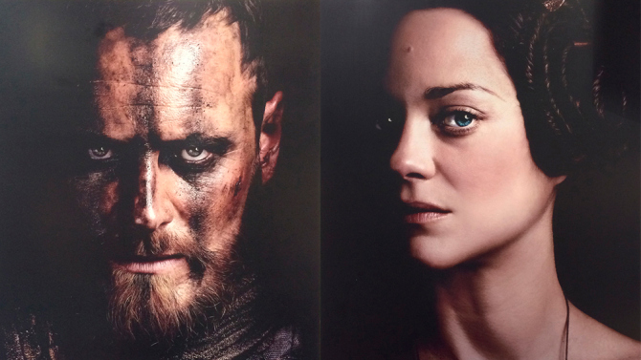
Ideal revision tool or study aid
Exam style questions and guidelines

Name:

The Plot
- The play opens as three witches plan a meeting with the Scottish nobleman Macbeth, who at that moment is fighting in a great battle.
- When the battle is over, Macbeth and his friend Banquo come across the witches who offer them three predictions: that Macbeth will become Thane of Cawdor and King of Scotland, and that Banquo's descendants will become kings.
- Banquo laughs at the prophecies but Macbeth is excited, especially as soon after their meeting with the witches Macbeth is made Thane of Cawdor by King Duncan, in return for his bravery in the battle.
- He writes to his wife, Lady Macbeth, who is as excited as he is. A messenger tells Lady Macbeth that King Duncan is on his way to their castle and she invokes evil spirits to help her slay him.
- Macbeth is talked into killing Duncan by his wife and stabs him to death. No-one is quite sure who committed this murder and no-one feels safe, but Macbeth is crowned king.
- Now that Macbeth is king he knows the second prediction from the witches has come true, but he starts to fear the third prediction (that Banquo's descendants will also be kings).
- Macbeth therefore decides to kill Banquo and his son, but the plan goes wrong - Banquo is killed but his son escapes.
- Macbeth then thinks he is going mad because he sees Banquo's ghost and receives more predictions from the witches. He starts to become ruthless and kills the family of Macduff, an important lord.
- Macbeth still thinks he is safe but one by one the witches' prophecies come true, Lady Macbeth cannot stop thinking about Duncan, becomes deranged and dies.
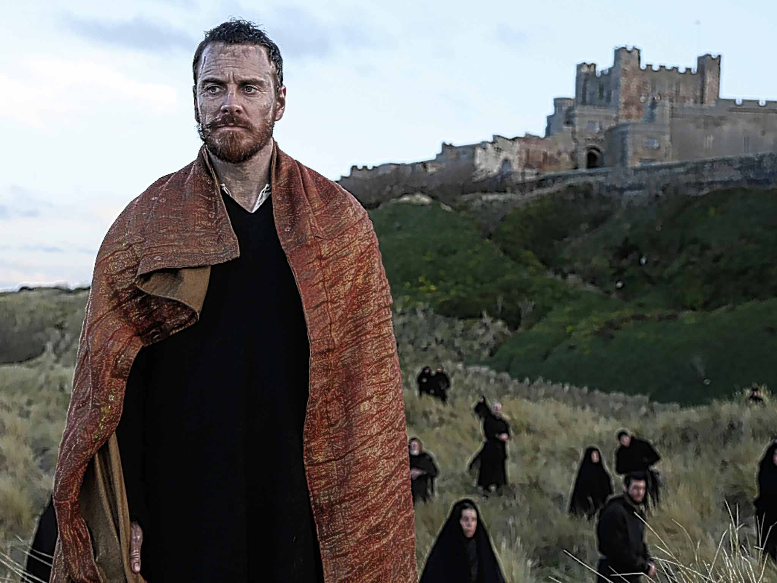
- A large army marches on Macbeth's castle and Macbeth is killed by Macduff.

Act 1 Scene 3
At this point in the play, Macbeth has just heard the prophecies of the Witches. He has been told that he will eventually become king.
Macbeth. [Aside]. Two truths are told, 240
As happy prologues to the swelling act
Of the imperial theme.—I thank you, gentlemen.
[Aside] This supernatural soliciting
Cannot be ill, cannot be good: if ill,
Why hath it given me earnest of success, 245
Commencing in a truth? I am thane of Cawdor:
If good, why do I yield to that suggestion
Whose horrid image doth unfix my hair
And make my seated heart knock at my ribs,
Against the use of nature? Present fears 250
Are less than horrible imaginings:
My thought, whose murder yet is but fantastical,
Shakes so my single state of man that function
Is smother'd in surmise, and nothing is
But what is not. 255
Banquo. Look, how our partner's rapt.
Macbeth. [Aside] If chance will have me king, why, chance may crown me,
Without my stir.
Banquo. New horrors come upon him,
Like our strange garments, cleave not to their mould 260
But with the aid of use.
Macbeth. [Aside] Come what come may,
Time and the hour runs through the roughest day.
Banquo. Worthy Macbeth, we stay upon your leisure.
Macbeth. Give me your favour: my dull brain was wrought 265
With things forgotten

- What is the impact of Macbeth speaking in ‘Asides’; what does it help to show?
- Find examples of sibilance (repetition of ‘S’ sounds) in Macbeth’s lines, what does this suggest/ why has Shakespeare done this?
- What evidence can you find to suggest that at this stage, Macbeth has no intention of killing the king?
- What does the use of personification in ‘make my seated heart knock at my ribs’ tell us about Macbeth?
- How does Macbeth’s mind-set change as the scene progresses? Track the changes with a highlighter
- What do Banquo’s lines suggest about the impact of the Witches on Macbeth?
- What does the final reveal about Macbeth’s ambition?

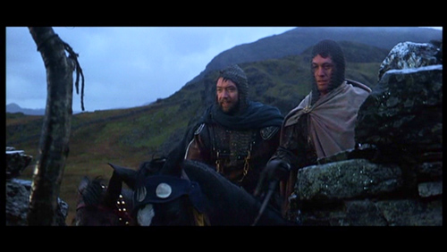

Act 1 Scene 5
Lady Macbeth has received news of Macbeth being made thane of Cawdor and about the fact that the witches have prophesied that he will become king. Here she is talking about Macbeth…

It is too full o' the milk of human kindness
To catch the nearest way: thou wouldst be great;
Art not without ambition, but without
The illness should attend it: what thou wouldst highly,
That wouldst thou holily; wouldst not play false, 365
And yet wouldst wrongly win: thou'ldst have, great Glamis,
That which cries 'Thus thou must do, if thou have it;
And that which rather thou dost fear to do
Than wishest should be undone.' Hie thee hither,
That I may pour my spirits in thine ear; 370
And chastise with the valour of my tongue
All that impedes thee from the golden round,
Which fate and metaphysical aid doth seem
To have thee crown'd withal.
[Enter a Messenger] 375
What is your tidings?
Messenger. The king comes here to-night.
Lady Macbeth. Thou'rt mad to say it:
Is not thy master with him? who, were't so,
Would have inform'd for preparation. 380
Messenger. So please you, it is true: our thane is coming:
One of my fellows had the speed of him,
Who, almost dead for breath, had scarcely more
Than would make up his message.
Lady Macbeth. Give him tending; 385
He brings great news.
[Exit Messenger]
The raven himself is hoarse
That croaks the fatal entrance of Duncan
Under my battlements. Come, you spirits 390
That tend on mortal thoughts, unsex me here,
And fill me from the crown to the toe top-full
Of direst cruelty! make thick my blood;
Stop up the access and passage to remorse,
That no compunctious visitings of nature 395
Shake my fell purpose, nor keep peace between
The effect and it! Come to my woman's breasts,
And take my milk for gall, you murdering ministers,
Wherever in your sightless substances
You wait on nature's mischief! Come, thick night, 400
And pall thee in the dunnest smoke of hell,
That my keen knife see not the wound it makes,
Nor heaven peep through the blanket of the dark,
To cry 'Hold, hold!'
- What are Lady Macbeth’s concerns over Macbeth in her opening soliloquy?
- What does she plan to do to help Macbeth? What techniques does Shakespeare use to present this?
- Highlight all the imperatives (commands) in Lady Macbeth’s ‘The Raven’ speech. What do you notice? What does it help to convey?
- Highlight all the words connected with the semantic field of death and destruction. What do you notice? What does this reveal about Lady Macbeth’s mind?
- What do you think Shakespeare was trying to tell us about women and ambition through Lady Macbeth?

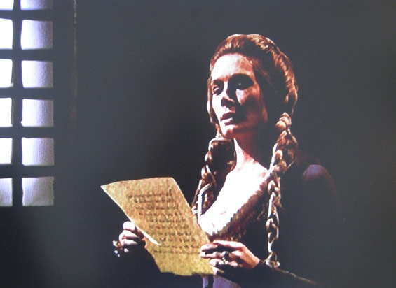
Act 2 Scene 1
Here. Macbeth is outside Duncan’s chamber, considering whether or not to kill the King

Is this a dagger which I see before me,
The handle toward my hand? Come, let me clutch thee.
I have thee not, and yet I see thee still.
Art thou not, fatal vision, sensible
To feeling as to sight? or art thou but 5
A dagger of the mind, a false creation,
Proceeding from the heat-oppressed brain?
I see thee yet, in form as palpable
As this which now I draw.
Thou marshall'st me the way that I was going; 10
And such an instrument I was to use.
Mine eyes are made the fools o' the other senses,
Or else worth all the rest; I see thee still,
And on thy blade and dudgeon gouts of blood,
Which was not so before. There's no such thing: 15

It is the bloody business which informs
Thus to mine eyes. Now o'er the one halfworld
Nature seems dead, and wicked dreams abuse
The curtain'd sleep; witchcraft celebrates
Pale Hecate's offerings, and wither'd murder, 20
Alarum'd by his sentinel, the wolf,
Whose howl's his watch, thus with his stealthy pace.
With Tarquin's ravishing strides, towards his design
Moves like a ghost. Thou sure and firm-set earth,
Hear not my steps, which way they walk, for fear 25
Thy very stones prate of my whereabout,
And take the present horror from the time,
Which now suits with it. Whiles I threat, he lives:
Words to the heat of deeds too cold breath gives.
A bell rings 30
I go, and it is done; the bell invites me.
Hear it not, Duncan; for it is a knell
That summons thee to heaven or to hell

- How would you describe Macbeth’s mood in this soliloquy? What different emotions is he feeling? Find quotes to support your ideas
- Macbeth describes his head as a ‘head-oppressed brain’ what does this suggest? Where is the ‘heat’ coming from?
- Look at the personification of the dagger in line 10. What makes it so effective?
- In line 14, Macbeth sees the dagger again, only this time with blood on it. What does this suggest?
- Highlight the alliteration in line 16 and explore the words used
- Between lines 16-25 highlight all the imagery to do with evil deeds and witchcraft, what do these show about Macbeth’s state of mind? Can you see any connections with Lady Macbeth here?
- Macbeth issues a command to the earth in line 25. What does this suggest about Macbeth’s ambition now?
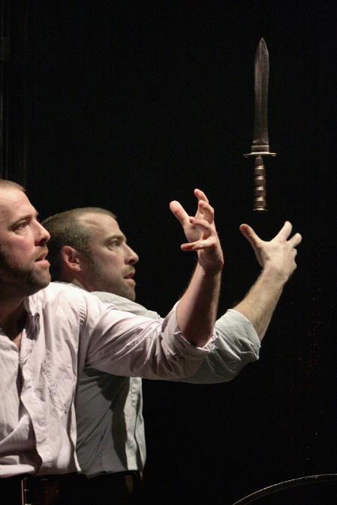
- This scene is considered a turning point in the play. At what point does Macbeth’s ambition overrun his doubt and what does Shakespeare do to show this?

Act 3 Scene 2
The King is dead, Macbeth is now thinking about Banquo and Fleance, as the witches predicted that is was Banquo’s offspring that would be king
Lady Macbeth. You must leave this.
Macbeth. O, full of scorpions is my mind, dear wife! 1210
Thou know'st that Banquo, and his Fleance, lives.
Lady Macbeth. But in them nature's copy's not eterne.
Macbeth. There's comfort yet; they are assailable;
Then be thou jocund: ere the bat hath flown
His cloister'd flight, ere to black Hecate's summons 1215
The shard-borne beetle with his drowsy hums
Hath rung night's yawning peal, there shall be done
A deed of dreadful note.
Lady Macbeth. What's to be done?
Macbeth. Be innocent of the knowledge, dearest chuck, 1220
Till thou applaud the deed. Come, seeling night,
Scarf up the tender eye of pitiful day;
And with thy bloody and invisible hand
Cancel and tear to pieces that great bond
Which keeps me pale! Light thickens; and the crow 1225
Makes wing to the rooky wood:
Good things of day begin to droop and drowse;
While night's black agents to their preys do rouse.
Thou marvell'st at my words: but hold thee still;
Things bad begun make strong themselves by ill. 1230
So, prithee, go with me. [Exeunt]
- What has changed in the relationship between the two? What would be the audience’s reaction to this scene?
- How has Lady Macbeth changed? What do the length and content of her lines tell us?
- What evidence can you find to suggest that Macbeth’s mind has darkened since the murder of Duncan? Highlight the words/phrases and explain their effects
- Highlight all the imperatives in the ‘be innocent’ speech. What do you notice? Can you see any connections with Lady Macbeth in act 1 scene 5?
- What sort of imagery does Macbeth use in his speech? What does it show?
- Why does Shakespeare use Iambic pentameter and rhyming couplets in the final 4 lines?

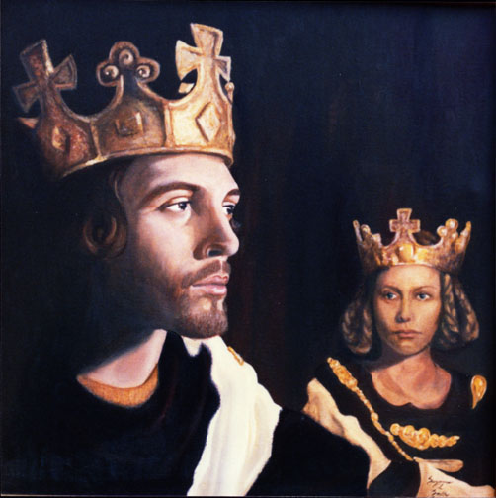

Act 3 Scene 6
Here, Lennox is reflecting on the events of the play so far, considering who is to blame for all the bloodshed.
Lennox. My former speeches have but hit your thoughts,
Which can interpret further: only, I say,
Things have been strangely borne. The
gracious Duncan
Was pitied of Macbeth: marry, he was dead: 1495
And the right-valiant Banquo walk'd too late;
Whom, you may say, if't please you, Fleance kill'd,
For Fleance fled: men must not walk too late.
Who cannot want the thought how monstrous
It was for Malcolm and for Donalbain 1500
To kill their gracious father? damned fact!
How it did grieve Macbeth! did he not straight
In pious rage the two delinquents tear,
That were the slaves of drink and thralls of sleep?
Was not that nobly done? Ay, and wisely too; 1505
For 'twould have anger'd any heart alive
To hear the men deny't. So that, I say,
He has borne all things well: and I do think
That had he Duncan's sons under his key—
As, an't please heaven, he shall not—they 1510
should find
What 'twere to kill a father; so should Fleance.
But, peace! for from broad words and 'cause he fail'd
His presence at the tyrant's feast, I hear
Macduff lives in disgrace: sir, can you tell 1515
Where he bestows himself?
- What do you think is the function of Lennox in this speech? What is he used by Shakespeare to show/represent?
- Notice how Lennox repeats the phrase ‘too late’ why is this important/significant?
- Look at the adjectives used to describe Duncan and Banquo, what do they reveal about his attitudes towards these characters?
- Highlight all the interrogatives (questions) and consider what this tells us about Lennox state of mind and the feelings of the Scottish people generally?
- What does the phrase ‘tyrant’s feast’ reveal about Lennox’ true attitude to Macbeth?
Act 4 Scene 3
Macduff and Malcolm are discussing what has become of Macbeth and his murderous campaign, whilst also considering their next move. They are also considering the impact this has had on the whole country.
Macduff. I am not treacherous.
Malcolm. But Macbeth is.
A good and virtuous nature may recoil
In an imperial charge. But I shall crave 1865
your pardon;
That which you are my thoughts cannot transpose:
Angels are bright still, though the brightest fell;
Though all things foul would wear the brows of grace,
Yet grace must still look so. 1870
Macduff. I have lost my hopes.
Malcolm. Perchance even there where I did find my doubts.
Why in that rawness left you wife and child,
Those precious motives, those strong knots of love,
Without leave-taking? I pray you, 1875
Let not my jealousies be your dishonours,
But mine own safeties. You may be rightly just,
Whatever I shall think.
Macduff. Bleed, bleed, poor country!
Great tyranny! lay thou thy basis sure, 1880
For goodness dare not cheque thee: wear thou
thy wrongs;
The title is affeer'd! Fare thee well, lord:
I would not be the villain that thou think'st
For the whole space that's in the tyrant's grasp, 1885
And the rich East to boot.
Malcolm. Be not offended:
I speak not as in absolute fear of you.
I think our country sinks beneath the yoke;
It weeps, it bleeds; and each new day a gash 1890
Is added to her wounds: I think withal
There would be hands uplifted in my right;
And here from gracious England have I offer
Of goodly thousands: but, for all this,
When I shall tread upon the tyrant's head, 1895
Or wear it on my sword, yet my poor country
Shall have more vices than it had before,
More suffer and more sundry ways than ever,
By him that shall succeed
- What are the differences in the attitudes and emotions of Macduff and Malcolm here?
- What does the heavenly imagery in Malcom’s first speech show? What does it tell us about the reign of a true king?
- What do all the exclamatory (!) phrases in ‘bleed bleed’ speech tell us about Macduff’s feelings?
- What does the use of personification in that ‘bleed bleed’ line tell us about Macduff’s attitude towards his country?
- Track the extended metaphor in Malcom’s ‘be not offended’ speech. What do you notice?
- Both Macduff and Malcolm refer to Macbeth as a tyrant. Why is this such an important word choice?
- What does Malcolm mean in his last 5 lines when he suggests that Scotland might be worse off after Macbeth is dead?

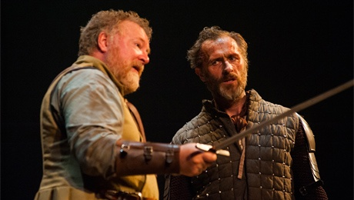

The final stages: Macbeth’s decline
…
Caithness. Great Dunsinane he strongly fortifies: 2220
Some say he's mad; others that lesser hate him
Do call it valiant fury: but, for certain,
He cannot buckle his distemper'd cause
Within the belt of rule.
Angus. Now does he feel 2225
His secret murders sticking on his hands;
Now minutely revolts upbraid his faith-breach;
Those he commands move only in command,
Nothing in love: now does he feel his title
Hang loose about him, like a giant's robe 2230
Upon a dwarfish thief.
- How does Shakespeare use minor characters to reveal Macbeth’s state of mind?
- Look closely at Angus’ speech. What does he tell the audience about Macbeth’s failing authority and what techniques does he use to show this?
- Look closely at the metaphor on line 2226, what does this suggest?
……………………………………………………………………………

Macbeth. Bring me no more reports; let them fly all:
Till Birnam wood remove to Dunsinane,
I cannot taint with fear. What's the boy Malcolm?
Was he not born of woman? The spirits that know
All mortal consequences have pronounced me thus: 2250
'Fear not, Macbeth; no man that's born of woman
Shall e'er have power upon thee.' Then fly,
false thanes,
And mingle with the English epicures:
The mind I sway by and the heart I bear 2255
Shall never sag with doubt nor shake with fear.
- What does the imperative in ‘bring me no more reports’ tell us?
- What’s Macbeth’s state of mind as he considers the forthcoming battle? How do we know?
- Macbeth makes reference to his heart in the last two lines, what does this reveal? How is this different to the very beginning of the play where he also made reference to his heart?
……………………………………………………………….

Macbeth. Throw physic to the dogs; I'll none of it.
Come, put mine armour on; give me my staff.
Seyton, send out. Doctor, the thanes fly from me. 2305
Come, sir, dispatch. If thou couldst, doctor, cast
The water of my land, find her disease,
And purge it to a sound and pristine health,
I would applaud thee to the very echo,
That should applaud again.—Pull't off, I say.— 2310
What rhubarb, cyme, or what purgative drug,
Would scour these English hence? Hear'st thou of them?
- Look closely at the imperative ‘throw physic to the dogs’. Why has Macbeth abandoned medicine and science?
- Highlight the imperatives in this speech – what do they help to convey?
- Scotland is personified here, what sort of state is she in and why?
- How does this connect with Malcolm’s speech earlier on?
…………………………………………………………..
[Enter MACBETH, SEYTON, and Soldiers, with drum and colours]
Macbeth. Hang out our banners on the outward walls;
The cry is still 'They come:' our castle's strength
Will laugh a siege to scorn: here let them lie 2355
Till famine and the ague eat them up:
Were they not forced with those that should be ours,
We might have met them dareful, beard to beard,
And beat them backward home.
[A cry of women within] 2360
What is that noise?
Seyton. It is the cry of women, my good lord.
[Exit]
Macbeth. I have almost forgot the taste of fears;
The time has been, my senses would have cool'd 2365
To hear a night-shriek; and my fell of hair
Would at a dismal treatise rouse and stir
As life were in't: I have supp'd full with horrors;
Direness, familiar to my slaughterous thoughts
Cannot once start me. 2370
[Re-enter SEYTON]
Wherefore was that cry?
Seyton. The queen, my lord, is dead.
Macbeth. She should have died hereafter;
There would have been a time for such a word. 2375
To-morrow, and to-morrow, and to-morrow,
Creeps in this petty pace from day to day
To the last syllable of recorded time,
And all our yesterdays have lighted fools
The way to dusty death. Out, out, brief candle! 2380
Life's but a walking shadow, a poor player
That struts and frets his hour upon the stage
And then is heard no more: it is a tale
Told by an idiot, full of sound and fury,
Signifying nothing. 2385
- Compared to the previous scenes, what do you notice about Macbeth here?
- Highlight the alliteration in the ‘hang out our banners’… what does it show about Macbeth’s attitude?
- How and why does the mood of the scene change?
- How would you describe Macbeth’s reaction to the death of his wife? What is Shakespeare trying to show?
- Macbeth uses two extended metaphors in the final speech of this scene. What does each show and what do they suggest about Macbeth’s mind in the closing stages of the play?
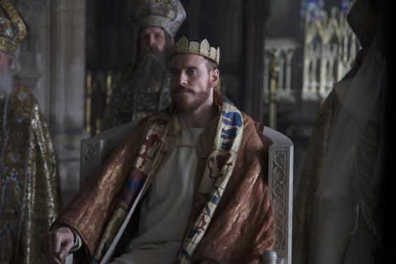

Assessment Extract 1: Act 5 Scene 1
Read the following extract from Act 5 Scene 1 of Macbeth and then answer the question that follows.
At this point in the play Lady Macbeth is sleepwalking. The Doctor and the Gentlewoman overhear her as she reveals her role in the events of the play so far.

Doctor. You see, her eyes are open.
Gentlewoman. Ay, but their sense is shut.
Doctor. What is it she does now? Look, how she rubs her hands.
Gentlewoman. It is an accustomed action with her, to seem thus
washing her hands: I have known her continue in
this a quarter of an hour. 2155
Lady Macbeth. Yet here's a spot.
Doctor. Hark! she speaks: I will set down what comes from
her, to satisfy my remembrance the more strongly.
Lady Macbeth. Out, damned spot! out, I say!—One: two: why,
then, 'tis time to do't.—Hell is murky!—Fie, my 2160
lord, fie! a soldier, and afeard? What need we
fear who knows it, when none can call our power to
account?—Yet who would have thought the old man
to have had so much blood in him.
Doctor. Do you mark that? 2165
Lady Macbeth. The thane of Fife had a wife: where is she now?—
What, will these hands ne'er be clean?—No more o'
that, my lord, no more o' that: you mar all with
this starting.
Doctor. Go to, go to; you have known what you should not. 2170
Gentlewoman. She has spoke what she should not, I am sure of
that: heaven knows what she has known.
Lady Macbeth. Here's the smell of the blood still: all the
perfumes of Arabia will not sweeten this little
hand. Oh, oh, oh! 2175
Doctor. What a sigh is there! The heart is sorely charged.
Gentlewoman. I would not have such a heart in my bosom for the
dignity of the whole body.
Doctor. Well, well, well,—
Gentlewoman. Pray God it be, sir. 2180
Doctor. This disease is beyond my practise: yet I have known
those which have walked in their sleep who have died
holily in their beds.
Lady Macbeth. Wash your hands, put on your nightgown; look not so
pale.—I tell you yet again, Banquo's buried; he 2185
cannot come out on's grave.
Doctor. Even so?
Lady Macbeth. To bed, to bed! there's knocking at the gate:
come, come, come, come, give me your hand. What's
done cannot be undone.—To bed, to bed, to bed!

Starting with this speech, explain how Shakespeare presents the transformation in the character of Lady Macbeth.
Write about:
- How Shakespeare presents Lady Macbeth in this speech
- How Shakespeare presents Lady Macbeth in the play as a whole.
[30 Marks]
SPaG [4 Marks]
Assessment Extract 2: Act 3 Scene 4
Read the following extract from Act 3 Scene 4 of Macbeth and then answer the question that follows.
At this point, Macbeth is hosting a banquet to celebrate his gaining of the throne. During the event, Macbeth notices the ghost of Banquo.

MACBETH | The table's full.
LENNOX | Here is a place reserved, sir.
MACBETH | Where?
LENNOX | Here, my good lord. What is't that moves your highness?
MACBETH | Which of you have done this?
Lords | What, my good lord?
MACBETH | Thou canst not say I did it: never shake | 50
 | Thy gory locks at me.
ROSS | Gentlemen, rise: his highness is not well.
LADY MACBETH | Sit, worthy friends: my lord is often thus,
 | And hath been from his youth: pray you, keep seat;
 | The fit is momentary; upon a thought
 | He will again be well: if much you note him,
 | You shall offend him and extend his passion:
 | Feed, and regard him not. Are you a man?
MACBETH | Ay, and a bold one, that dare look on that
 | Which might appal the devil.
LADY MACBETH | O proper stuff! | 60
 | This is the very painting of your fear:
 | This is the air-drawn dagger which, you said,
 | Led you to Duncan. O, these flaws and starts,
 | Impostors to true fear, would well become
 | A woman's story at a winter's fire,
 | Authorized by her grandam. Shame itself!
 | Why do you make such faces? When all's done,
 | You look but on a stool.
MACBETH | Prithee, see there! behold! look! lo!
 | how say you?
 | Why, what care I? If thou canst nod, speak too. | 70
 | If charnel-houses and our graves must send
 | Those that we bury back, our monuments
 | Shall be the maws of kites.
[GHOST OF BANQUO vanishes]
LADY MACBETH | What, quite unmann'd in folly?

Starting with this scene, explain how Shakespeare presents ideas about madness and guilt.
Write about:
- How Shakespeare presents madness and guilt in this speech
- How Shakespeare presents madness and guilt in the play as a whole.
[30 Marks]
SPaG [4 Marks]

Revision – Character Profile - Macbeth
Themes – What themes does this character connect with and how?
Plot – What happens to them in the story? Summarise their role
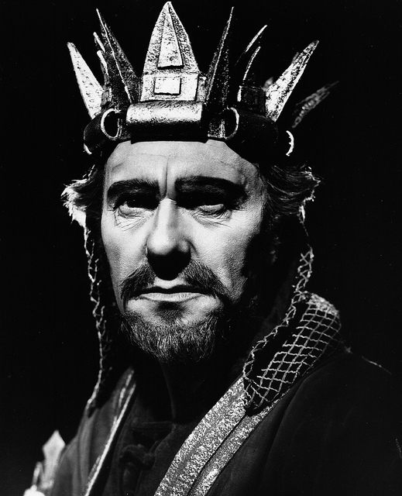

Characterisation – How would you describe this character’s personality? How would the audience react to this character?
Quotes – Write down 3 key quotes that relate to this character and explore their meaning & effect.

Revision – Character Profile – Lady Macbeth
Themes – What themes does this character connect with and how?
Plot – What happens to them in the story? Summarise their role

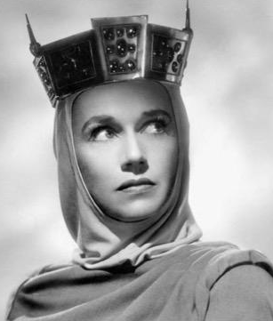

Characterisation – How would you describe this character’s personality? How would the audience react to this character?
Quotes – Write down 3 key quotes that relate to this character and explore their meaning & effect.

Revision – Character Profile - Banquo
Themes – What themes does this character connect with and how?
Plot – What happens to them in the story? Summarise their role

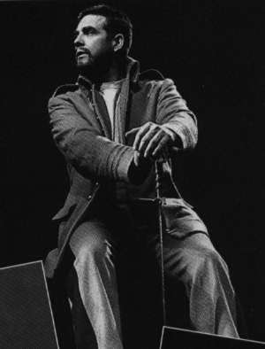

Characterisation – How would you describe this character’s personality? How would the audience react to this character?
Quotes – Write down 3 key quotes that relate to this character and explore their meaning & effect.

Revision – Key Themes
For each of the themes below, think about:
- How the theme is presented and why this themes is important to our understanding of the play.
- Characters that connect with the theme and explain how they link with it.
- Quotations that connect with that specific theme.

Betrayal

Ambition

Guilt

Madness

Downfall

Loss

Violence

Tackling the Exam – Tips
- Start by underlining the key words in the question, think carefully about who/what you are being asked to analyse.
- ACTIVELY READ the extract you have been given. Highlight or underline some ‘juicy quotes’ as you read, quotes you know you will come back to analyse in your response
- Once you have read the extract, spend a couple of minutes mind mapping ideas about links to the rest of the text: what other characters/scenes can you explore in your response in order to show the examiner you know the WHOLE TEXT (not just what’s in this extract)
- Aim for 3 paragraphs analysing the extract, and 2 analysing the play as a whole

Structuring a Paragraph
Write in PEEZL paragraphs: guaranteed to hit all the assessment foci (and keep your examiner happy!)
- P-E-E-Z-L POINT-EVIDENCE-EXPLAIN-ZOOM-LINK
- Make your POINT: ensure that this is clear, focused and addresses the question directly
- Relevant EVIDENCE from the text to support point
- Detailed explanation of the quote (come up with 2 or 3 different ideas about the quote by using phrases such as ‘this could also suggest’ or ‘furthermore, this quote might mean’)
- Pick out and ‘ZOOM’ in on key words or phrases – what do they show/reveal?
- Link your analysis back to Writer’s message: what are they trying to say/ how might the audience react?

