**De Aston**

**English Department**

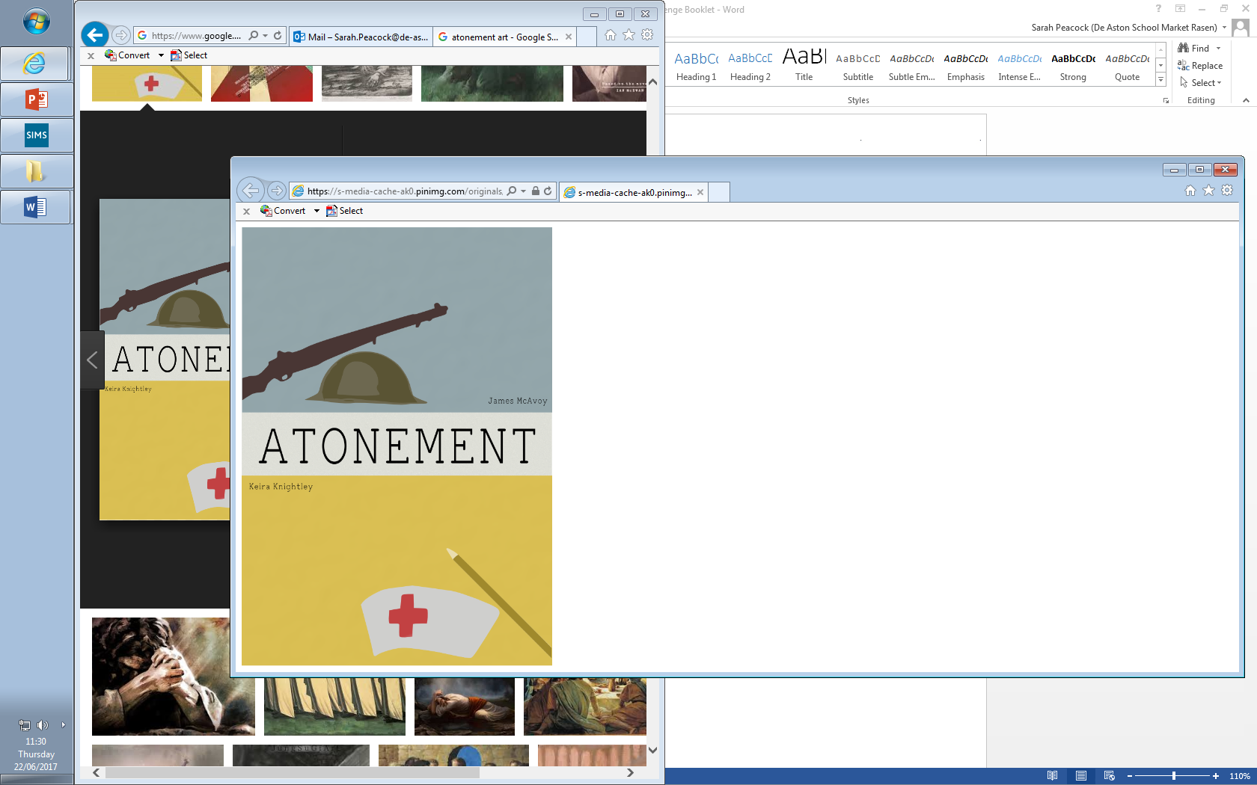

**Year 12/13: Atonement**

**Challenge Tasks**

**Name:**

**Week Three:**

Hard: Now the crime has taken place, write a police report of the incident. Include eyewitness testimony from Briony. Look closely at the novel to inform your evidence.

Harder: Include textual detail in your police report.

Hardest: Include direct quotation from the text in your work.

**Week Two:**

Now you have started reading the text, you will have met some characters. Briony is our chief protagonist in this novel and as such your impression of her may change.

Hard: Evaluate your first impressions of Briony, linking to the text as much as possible.

Harder: Give your first impressions of Briony and be sure to consider how she fits in the crime genre as a protagonist as well.

Hardest: Give your first impressions of Briony and link to McEwan’s inclusion of *Northanger Abbey*.

**Week One:**

At the beginning of the text, McEwan includes an extract from Austen’s *Northanger Abbey*. Research the plot of this text and write a paragraph justifying why McEwan has included this extract. What predictions could you make of *Atonement* in relation to this extract from Austen’s novel?

Be sure to consider Austen’s use of satire and the gothic in your response.

**Week Four:**

Hard: Read The Guardian’s review of *Atonement* and write down key ideas that could as criticism for the novel.

Harder: As above but explain your links to the novel.

Hardest: Evaluate the criticism – do you agree with it? Why? Why not?

**Week Five:**

Hard: Google and read Finney’s essay on *Atonement* ‘Briony’s Stand Against Oblivion’. Summarise the article and highlight the key ideas that could be used for criticism.

Harder: As above but link the ideas to the novel.

Hardest: As above but also consider how the novel may fit the Feminism/Marxist lens.

**Week Seven-Nine:**

In terms of your revision for this unit, track the following in the text. You can present your revision how you wish (collage, cue cards, PPT etc…). Each element should include quotes.

* Plot
* Characters
* Themes
* Context
* Language, structure and form
* Links to crime elements
* Criticism

**Week Six:**

Hard: Consider how your impressions and views of characters may now have changed. Track each character and how we feel about them in each Part of the novel. Support with quotations.

Harder: As above but also explain how the quotations included support your view.

Hardest: As above but evaluate each character. How do they fit into the crime genre?



For more resources, including literacy support, visit www.deastonenglish.com