**De Aston**

**English Department**

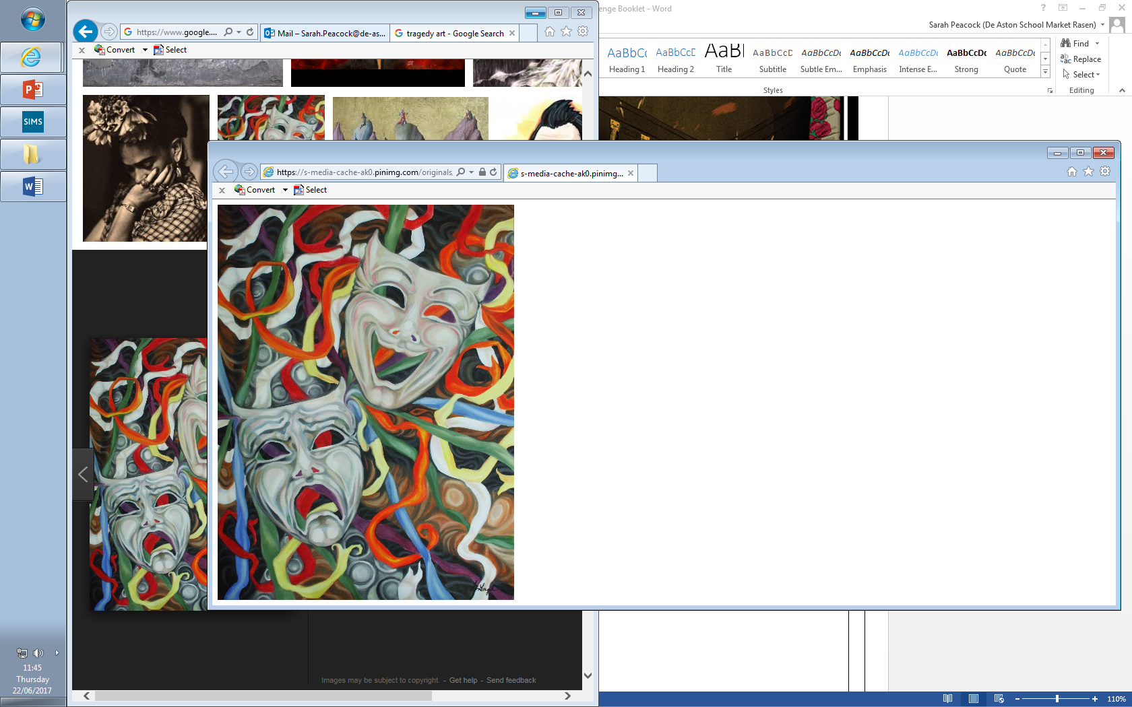

**Year 13: Tragedy Revision**

**Challenge Tasks**

**Name:**

**Week Two:**

Revisit A.C. Bradley’s discussion of Shakespearean tragedies – pull out five key ideas that can link to Othello.

**Week Three:**

Revise 10 key quotations for each tragedy text (use your quotation booklet) – learn them, test yourself on them.

**Week One:**

Revise your time management and understanding of DOAS and Keats by creating an essay plan in ten minutes, with quotations as this is a closed book exam, for the following question:

Any learning or moral growth gained by the tragic protagonist is outweighed by the suffering they have undergone.

To what extent do you agree in relation to two texts you have studied?

**Week Four:**

Revisit the key tragedy elements and track them in Othello – pay close attention to Iago as villain, Othello as hero, settings, victims, death and resolution.

**Week Five:**

Revisit the key tragedy elements and track them in DOAS – Willy as tragic hero, Biff as tragic figure, disorder and chaos, setting and structure.

**Week Six:**

Revise your time management and understanding of DOAS and Keats by creating an essay plan in ten minutes, with quotations as this is a closed book exam, for the following question:

Tragedies show pride to be the ultimate enemy of mankind.

To what extent do you agree in relation to two texts you have studied?



For more resources, including literacy support, visit www.deastonenglish.com