**De Aston**

**English Department**

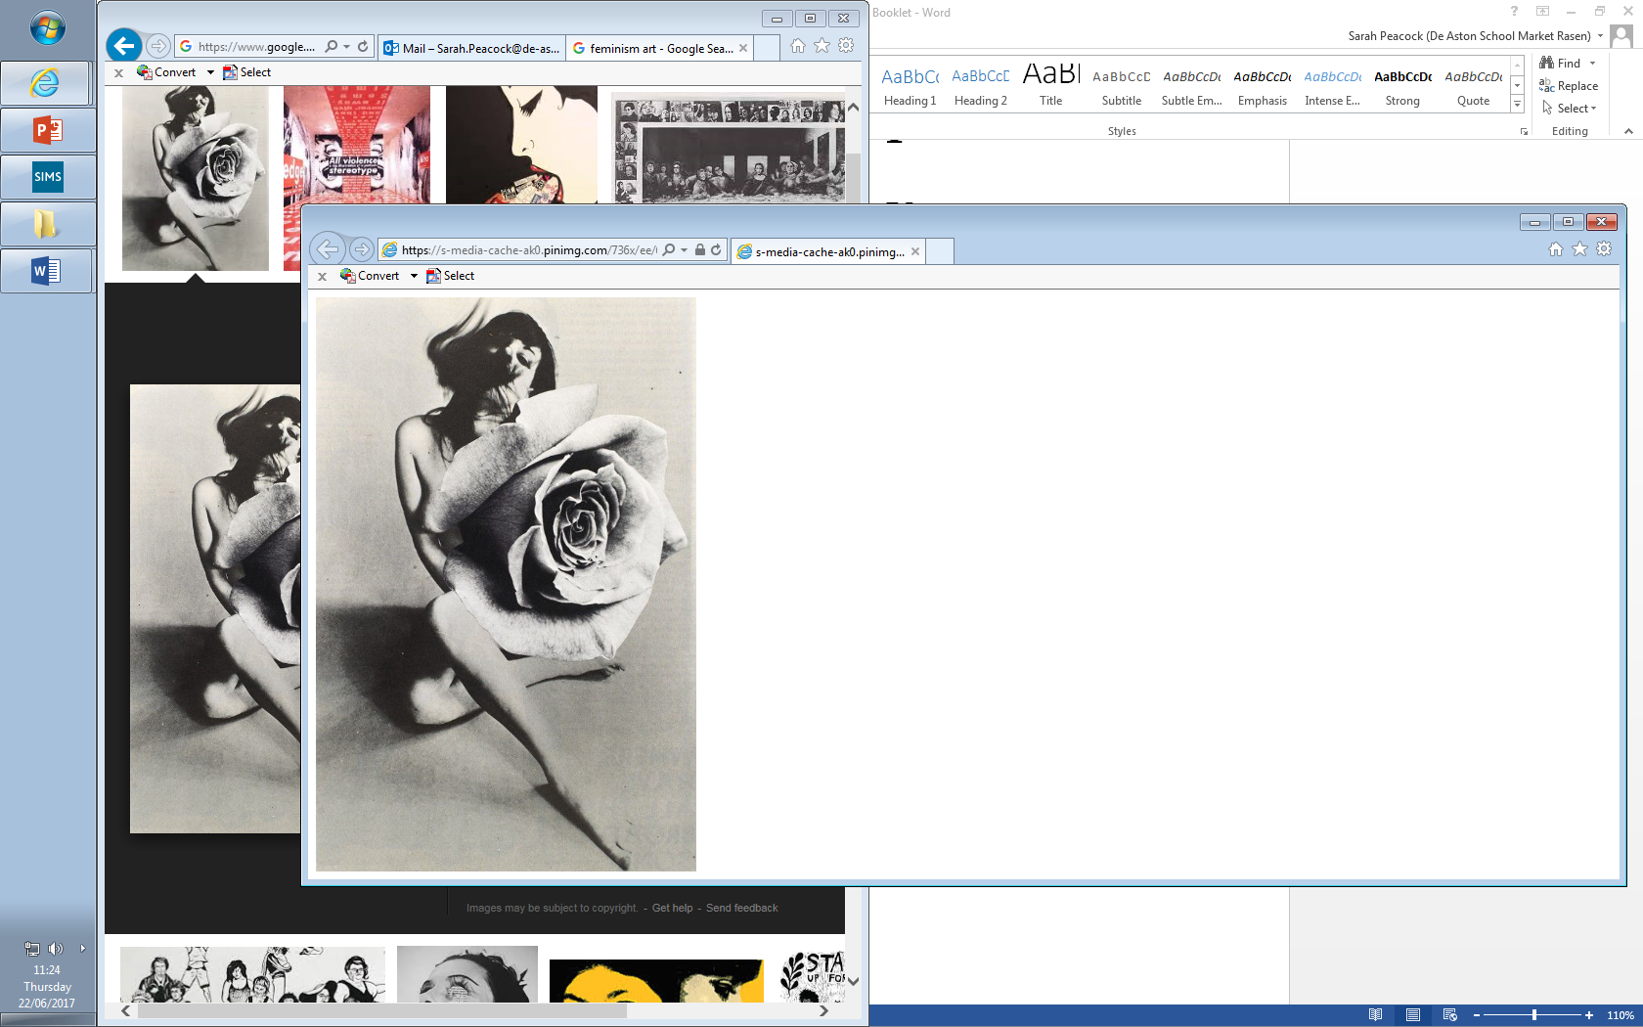

**Year 12: Feminism**

**Challenge Tasks**

**Name:**

**Week Five:**

[**https://history.hanover.edu/courses/excerpts/111wollstone.html**](https://history.hanover.edu/courses/excerpts/111wollstone.html)- Vindication of the Rights of Woman.

Visit the website above and summarise the text, then link the text to the poems studied.

**Week Four:**

Read a summary of Germaine Greer’s *The Female Eunuch.*

Hard: Briefly outline your opinion on the text.

Harder: Evaluate how relevant the text is for the modern day feminist.

Hardest: Link the text to the poems studied.

**Week Three:**

Gilbert and Gubar believed women in Literature could be categorised as two stereotypes: The Madwoman in the Attic or The Angel in the Home.

To what extent do you agree in the poems we have studied?

**Week Two:**

Read the HuffPost article about Plath by Anis Shivani ‘Sylvia Plath 50 years later…’

Hard: Summarise the writer’s opinion on Plath and her poetry.

Harder: Highlight key criticism from the article and explain how you can link it to your study of Plath so far.

Hardest: As above but link to Plath’s poetry using direct quotations.

**Week One:**

Research Feminism Through the Ages.

Your research should be presented to show you have a good understanding of the four waves of feminism. It should also track key events which developed the feminist movement.

Finally, give your predictions for the feminist movement in the future.



For more resources, including literacy support, visit www.deastonenglish.com