**De Aston**

**English Department**

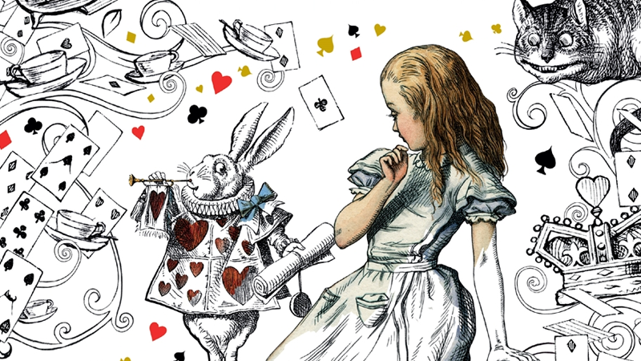

**Year 7: Alice in Wonderland**

**Name:**

**Week Two:**

Some ideas about surrealism were inspired by dreams. For a few nights, create a dream diary documenting the dreams you have. If you can’t remember one, ask your friends or family or write about a dream you have had in the past.

Once you have written down what your dreams were, do some research into what your dreams could mean. For example, dreaming about clocks suggest time is important to you – maybe a deadline is looming!

**Week One:**

This week, you will get your creative hat on!

Imagine falling down the rabbit hole yourself. Choose a task from below.

* Describe what you see as you fall down the rabbit hole.
* Create a poem about Alice falling down the rabbit hole.
* Write from the perspective of the white rabbit who sees Alice fall down the hole.

**Week Three:**

Lewis Carroll was inspired by a movement called Surrealism, a 20th-century avant-garde movement in art and literature which sought to release the creative potential of the unconscious mind, for example by the irrational juxtaposition of images.

Conduct your own research into Surrealist artists. Choose an image that appeals to you and use it to inspire a piece of writing. You could simply describe the picture, or you could write a poem or story inspired by the image

**Week Five:**

Imagine your own wonderland. Either draw and label your wonderland, or challenge yourself to write a detailed description of your wonderland, using surreal ideas or metaphors.

**Week Four:**

Now that you know a bit more about surrealism, consider how the novel fits in.

**Hard –** Explain why Alice In Wonderland fits into the surrealism category.

**Harder** – using your understanding of the novel so far, come up with one event that is particularly surreal (strange) and explain it.

**Hardest** – choose some surreal events/characters from the novel – what do you think these might represent?

**Week Six:**

Following on from week four, now imagine a surreal character that appears in your wonderland. Either:

* Draw and label your character
* Write a description of them. What do they look like? How do they behave? What is their role in the story?
* Write a diary entry of the main character as they meet your surreal character. What are their first impressions?

**Additional challenge tasks:**

Make sure you understand what each of these words means and show your understanding by trying to use them in your classwork. Then learn how to spell them – be ready for a spelling test in the last week of term.

**Hard:** 1. Victorian 2. Tone 3. Inference 4. Formality 5. Transformation

**Harder:** 1. Connective 2. Ambiguous 3.Diction 4. Hyperbole 5. Implicit

**Hardest:** 1. Surrealism 2. Benevolent 3. Callous 4. Fabricate 5. Modicum

**Bonus week:**

Read the extract below and complete the ‘all’ question and one more of the questions below:

**All:** List four things the poem describes.

**Hard:** How does the writer feel? Use evidence to explain.

**Harder:** How does the writer use language to interest the reader?

**Hardest:** To what extent does the extract remind you of Alice in Wonderland?

*All in the golden afternoon*

*Full leisurely we glide;*

*For both our oars, with little skill,*

*By little arms are plied,*

*While little hands make vain pretence*

*Our wanderings to guide.*

*Ah, cruel Three! In such an hour,*

*Beneath such dreamy weather,*

*To beg a tale of breath too weak*

*To stir the tiniest feather!  
Yet what can one poor voice avail*

*Against three tongues together?*

*Imperious Prima flashes forth*

*Her edict ‘to begin it’-*

*In gentler tone Secunda hopes*

*‘There will be nonsense in it!’-*

*While Tertia interrupts the tale*

*Not more than once a minute.*

*Anon, to sudden silence won,*

*In fancy they pursue*

*The dream-child moving through a land*

*Of wonders wild and new,*

*In friendly chat with bird or beast-*

*And half believe it true.*

*And ever, as the story drained*

*The wells of fancy dry,*

*And faintly strove that weary one*

*To put the subject by,*

*‘The rest next time-‘ ‘It is next time!’*

*The happy voices cry.*

*Thus grew the tale of Wonderland:*

*Thus slowly, one by one,*

*It’s quaint events were hammered out-*

*And now the tale is done,*

*And home we steer, a merry crew,*

*Beneath the setting sun.*

*Alice! a childish story take,*

*And with a gentle hand*

*Lay it where Childhood’s memories are twined*

*In memory’s mystic band,*

*Like pilgrim’s wither’d wreath of flowers*

*Pluck’d in a far-off land.*



For more resources, including literacy support, visit www.deastonenglish.com