**De Aston**

**English Department**

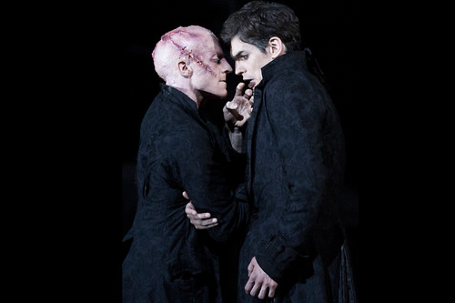

**Year 7: From Prose to Playscript –**

**Frankenstein**

**Name:**

**Week Three:**

You will need to watch this on Youtube: Mary Shelley’s conception of Frankenstein - The Secret Life of Books - BBC Four.

**Hard** – write a summary of the things you learn from the video.

**Harder** – If you could write a letter to a living author who means a great deal to you, what would you tell them? What would you ask them about? Brainstorm ideas in a creative way.

**Hardest** – Write the letter to your author. Find their publisher’s address and send it! Wait for a response…

**Week Two:**

Let’s think about the setting of the play.

**Hard** – Design the set for Victor’s laboratory. Draw it. Make some notes to help the carpenters and artists as they make it.

**Harder** – Create your own set for Frankenstein. Also create a separate sheet which explains your chocies.

**Hardest** – Research the Gothic genre in literature and architecture. Now design a classically gothic set for the opening of the play. Make some notes to explain your ideas to the artistic director to convince her to use your designs.

**Week One:**

This week, you will have been learning about Mary Shelley’s story ‘Frankenstein’. Now do some research of your own about Mary Shelley. Then choose one of the tasks below.

* Present your research as a rap or a poem.
* Create a leaflet.
* Write a short biography.

**Week Four:**

Read part (or all!) of the novel or watch a film adaptation. Both are available online for free if required, the full text at <https://www.gutenberg.org/files/84/84-h/84-h.htm> and many film adaptations can be accessed through Youtube. How does it compare to the version you read in class? Which do you prefer and why?

**Week Five:**

Imagine you are the monster. Choose a moment from the play so far and write your diary entry, aiming to show knowledge of the plot and empathy and understanding of the monster.

**Week Six:**

What phrase would you use to sum up the moral of the story, e.g. ‘Don’t judge a book by its cover’. Write your own short story that explores this theme.

**Additional challenge tasks:**

Make sure you understand what each of these words means and show your understanding by trying to use them in your classwork. Then learn how to spell them – be ready for a spelling test in the last week of term.

**Hard:** 1. Prologue 2. Symbolism 3. Empathy 4. Dialogue 5. Monologue

**Harder:** 1. Epilogue 2. Pathetic fallacy 3.Dramatic irony 4. Soliloquy 5. Doppel ganger

**Hardest:** 1. Aberration 2. Malevolent 3. Dehumanise 4. Eccentric 5. Nemesis

**Final challenge:**

Finally, watch this video on youtube: <https://www.youtube.com/watch?v=tkYgCZ0DWwc>

In this video, the director explains some of the choices he made when creating this production and the video also includes some clips from a live performance. In your exercise book, explain in your own words some of the choices the director made and why, and explore your own opinions about this production.

**Bonus week:**

Read the extract below and complete the ‘all’ question and one more of the questions below:

**All:** List four reasons the monster gives for Frankenstein to create him a wife.

**Hard:** What features of layout tell us that this is from a play script? Why is each feature used?

**Harder:** How does the writer use language to show the monster’s desperation?

**Hardest:** To what extent does this extract make you feel sorry for the monster?

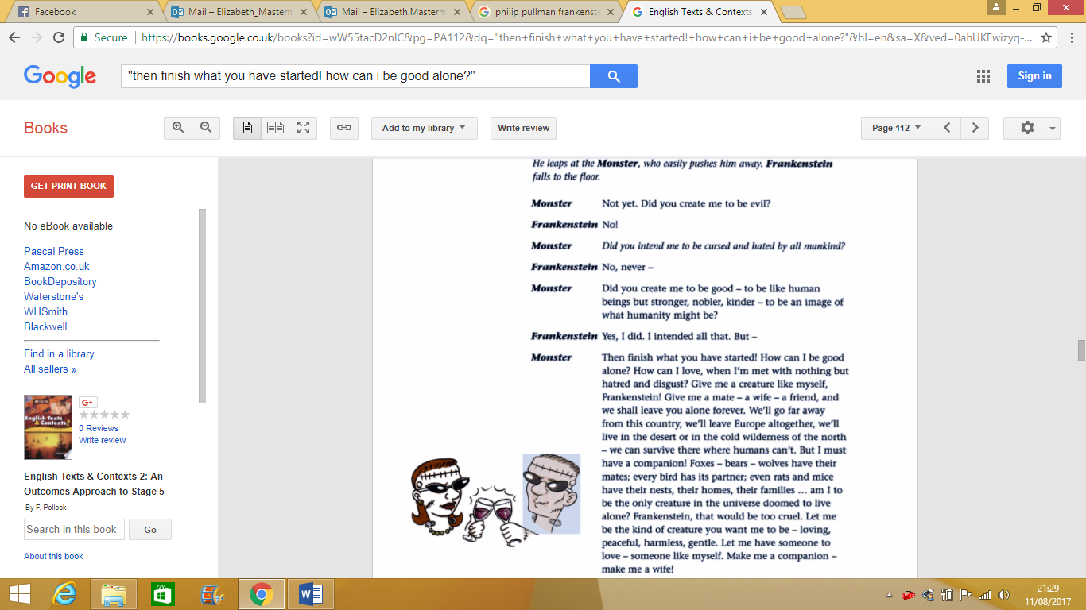



For more resources, including literacy support, visit www.deastonenglish.com