**De Aston**

**English Department**



**Year 8: Globetrotting**

**Academic Excellence Booklet**

The role of the Academic Excellence Booklet is for you to complete these tasks over the next six weeks. These activities are purposely designed to challenge you, so don’t worry if you find them difficult. You’re meant to! Learning happens when people have to think hard. That being said, your English teacher is a specialist, so ask any of us for help, anytime!

1. Read this article about Verona in Italy, written over 150 years ago by renowned Victorian novelist, Charles Dickens:

Pleasant Verona! With its beautiful old palaces, and charming country in the distance, seen from terrace walks, and stately, **balustraded galleries**. With its Roman gates, still spanning the fair street, and casting, on the sunlight of to-day, the shade of fifteen hundred years ago. With its marble-fitted churches, lofty towers, rich architecture, and quaint old quiet thoroughfares, where shouts of **Montagues and Capulets** once resounded. With its fast-rushing river, picturesque old bridge, great castle, waving cypresses, and prospect so delightful, and so cheerful! Pleasant Verona!

*In the midst of it, in the Piazza di Bra — a spirit of old time among the familiar realities of the passing hour — is the great Roman Amphitheatre. So well preserved, and carefully maintained, that every row of seats is there, unbroken. Over certain of the arches, the old Roman numerals may yet be seen; and there are corridors, and staircases, and* ***subterranean*** *passages for beasts, and winding ways, above ground and below, as when the fierce thousands hurried in and out, intent upon the bloody shows of the arena. Nestling in some of the shadows and hollow places of the walls, now, are smiths with their forges, and a few small dealers of one kind or other; and there are green weeds, and leaves, and grass, upon the parapet. But little else is greatly changed.*

*When I had traversed all about it, with great interest, and had gone up to the topmost round of seats, and turning from the lovely panorama closed in by the distant Alps, looked down into the building, it seemed to lie before me like the inside of a* ***prodigious*** *hat of plaited straw, with an enormously broad brim and a shallow crown; the plaits being represented by the four-and-forty rows of seats. The comparison is a homely and fantastic one, in sober remembrance and on paper, but it was irresistibly suggested at the moment, nevertheless.*

I walked through and through the town all the rest of the day, and could have walked there until now, I think. In one place, there was a very pretty modern theatre, where they had just performed the opera (always popular in Verona) of Romeo and Juliet. In another there was a collection, under a **colonnade**, of Greek, Roman, and Etruscan remains, presided over by an ancient man who might have been an Etruscan relic himself; for he was not strong enough to open the iron gate, when he had unlocked it, and had neither voice enough to be audible when he described the curiosities, nor sight enough to see them: he was so very old. In another place, there was a gallery of pictures: so abominably bad, that it was quite delightful to see them mouldering away. But anywhere: in the churches, among the palaces, in the streets, on the bridge, or down beside the river: it was always pleasant Verona, and in my remembrance always will be.

**Glossary**

balustraded gallery = a type of balcony

Montagues and Capulets = the two families from Shakespeare’s Romeo and Juliet, which is set in Verona Amphitheatre = an open, circular building with a central space for the presentation of dramatic or sporting events surrounded by tiers of seats for spectators

subterranean = underground

prodigious = impressive, extraordinary

colonnade = a type of walkway with a row of columns supporting a roof

Referring only to the section in *italics*, how does the writer use language to describe the amphitheatre?

2. Read this modern article, also about Verona:

**Verona: City of Romance**

*By Rick Steves*

About two hours from bustling Milan and touristy Venice is Verona — a welcome sip of pure, easygoing Italy. Made famous by Shakespeare's star-crossed lovers, Verona is Italy's fourth-most-visited city and second in the Veneto region only to Venice in population and artistic importance. If you don't need world-class sights, this town is a joy.

Shakespeare's Romeo and Juliet made Verona a household word. Locals marvel that each year, about 1,600 Japanese tour groups break their Venice-to-Milan ride for an hour-long stop in Verona just to stand in a courtyard. The House of Juliet, where the real-life Cappello family once lived, is a crass and throbbing mob scene. The tiny, admittedly romantic courtyard is a spectacle in itself, with visitors from all over the world posing on the almost believable balcony and taking snapshots of each other rubbing Juliet's bronze breast, hoping to get lucky in love.

The city is so famous for love that it gets countless letters addressed simply to "Juliet, Verona, Italy." There are even volunteers to respond to these mostly lovesick people (see www.julietclub.com). And they're getting even busier, thanks to the movie Letters to Juliet, about a girl (Amanda Seyfried) who finds a letter while visiting the House of Juliet and travels through Italy to help reunite the author with her lost love.

Despite the romantic fiction, the town is packed with genuine history. Because ancient Romans considered Verona an ideal resting spot before crossing the Alps, the city has a wealth of Roman ruins. *The well-preserved amphitheater — the third largest in the Roman world — dates from the first century a.d. and still retains most of its original stone. Over the centuries, crowds of up to 25,000 spectators have cheered Roman gladiator battles, medieval executions, and modern plays — including Verona's popular summer opera festival, which takes advantage of the arena's famous acoustics.*

Here, the writer uses a combination of the facts he chooses and his word choices to make us want to visit Verona. Create two lists: one of the facts we learn about Italy; and another of the words and phrases he uses to make Verona sound tempting.

Using your first list, write a page about Verona for a guide book about Italy. Make sure you don’t use any persuasive language – this piece should be purely factual!

3. Both texts describe the amphitheatre (see the section in *italics* in both texts). An amphitheatre is an open-air theatre. Use details from both sources to write a summary of what you learn about the amphitheatre.

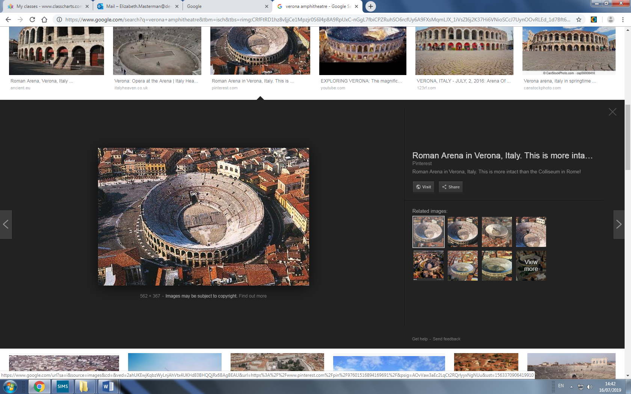



For more resources, including literacy support, visit www.deastonenglish.com