AQA A Level English Literature B

Elements of Crime Writing

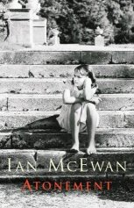

“Atonement”
by Ian McEwan (2001)

Studying a (crime) novel
(Adapted from York Notes Advanced and Cambridge English Literature B Student Book)
- Read the novel more than once. Start by reading it quickly for pleasure, then read it slowly and thoroughly.
- On your second reading make detailed notes on the plot, characters and themes of the novel and how these relate to the genre of crime writing. Further readings will generate new ideas and help you to memorise the details of the story.
- When was the novel written and set, and what is the significance of this, both historically and in terms of literary context?
- What constitutes crime and transgressions against law and order in this novel? Are these punished, and if so how?
- Some of the characters will develop as the plot unfolds. How do your responses towards them change during the course of the novel? How do they align with the characters you would expect to find in a piece of crime writing?
- Think about how the novel is narrated. From whose point of view are events described? Is the narrator trustworthy, and what is the narrator’s link to any crimes that are committed?
- A novel may or may not present events chronologically: the time scheme may be a key to its structure and organisation. What is the significance of the time scheme, and how important is this to the way crime is presented in the novel?
- What part do settings play in the novel? Look particularly at the setting(s) which might be described as the crime scene(s)?
- Make careful notes on the themes of deception, guilt, remorse, confession, and the desire for restitution and liberation (make sure you know the precise meanings of all these)
- Are words, images or incidents repeated so as to give the work a pattern? Do such patterns help you to understand the novel’s themes? Which of these are particularly relevant to the novel as a crime text?
- What is the nature of right and wrong as explored in the novel? Does the novel present a moral and just world?
- Identify what styles of language are used in the novel.
- What is the effect of the novel’s ending? Is the action completed and closed, or left incomplete and open? How does the ending of the novel fit with what you might be expecting at the end of a crime text?
- Cite exact sources for all quotations, whether from the text itself or from critical commentaries. Wherever possible find your own examples from the novel to back up your opinions.
- What is the effect of this novel on readers?
- How could different readings shed other light on this novel, eg narrative theory; feminist theory; Marxist theory? Can any of these link to a study of this novel as a crime text?
- Always express your ideas in your own words.

If you could write an answer to each of the above questions then you will have a good understanding of the novel. This list will provide a useful guide to your revision.

Pre-Reading Questions/Activities
- What does atonement mean?
- Research the year 1935. Why has McEwan chosen this year as the point at which his novel begins?
- What was life like for the upper middle classes in England in 1935? And for the lower classes?
- McEwan used an epigraph from Jane Austen’s novel “Northanger Abbey”. Use the internet to find a short summary of the novel. McEwan said he thought of “Atonement” as “my Jane Austen novel, my country house novel, my one-hot-day novel.” Why do you think McEwan begins his novel with the following epigraph?
“Dear Miss Morland, consider the dreadful nature of the suspicions you have entertained. What have you been judging from? Remember the country and the age in which we live. Remember that we are English, that we are Christians. Consult your own understanding, your own sense of the probable, your own observation of what is passing around you. Does our education prepare us for such atrocities? Do our laws connive at them? Could they be perpetrated without being known, in a country like this, where social and literary intercourse is on such a footing, where every man is surrounded by a neighbourhood of voluntary spies, and where roads and newspapers lay everything open? Dearest Miss Morland, what ideas have you been admitting?"
They had reached the end of the gallery, and with tears of shame she ran off to her own room.”
— Jane Austen, Northanger Abbey
- Using the internet write a short biography of Ian McEwan (no more than half a page). Consider where he lives/grew up, family life, what he has published and critical receptions of his work. Does any of this link to what you already know about the novel “Atonement”?

The Structure of the Novel – an overview
Part | Time and Place | Main Action | Notes on Crime
One
Two
Three
Epilogue

Part One: Questions/Activities
- Where and when is Part One set? What is the significance of both the time and place setting?
- What sort of picture does McEwan paint of the Tallis’s family life?
- What can you say about the narrative voice of Chapter One?
- What impression do we get of Briony from Chapter One? Begin a “notes and quotes” sheet for her, always remembering you are exploring this novel through the lens of crime.
- In this chapter we are also introduced to:
  - Emily Tallis
  - Cecilia Tallis
  - Lola Quincey
  - The Quincey twins
Begin a “notes and quotes” sheet for each, but don’t forget we are seeing all these from Briony’s point of view in Chapter One.
- Look at the list of “crimes” on page 9: “betrayal, illness, thieving, assault and mendacity.” Why has McEwan included this list do you think?
- In Chapter Two the narrative voice, though remaining in the third person, shifts to Cecilia as the focaliser. Why has McEwan done this? What are the differences in style?
- We learn much more about Cecilia in this chapter: add to your notes on her.
- Why do you think McEwan emphasises more than once the ugliness of the Tallis house?
- Chapter Two was the first part of the novel McEwan wrote. He once explained in an interview: “After about 15 months, I found I’d written a couple of paragraphs which I knew had taken me into the novel I was going to write. And it was just this girl stepping into the room with a bunch of wildflowers.” What is the impact of this as a statement?
- We meet Robbie for the first time in Chapter Two. What impression do we get (always remembering we are seeing him through Cecilia’s eyes)? Why might it be significant that Robbie achieved a First from Cambridge, but Cecilia only managed a Third?
- When did Cambridge first award degrees to women? Why does McEwan point out on page 27 Cecilia was not awarded a degree? Is this a book about, among other things, gender? As you read on, look out for further evidence of this.
- In Chapter Three we see the fountain incident through Briony’s eyes, and at one point, on page 41, the narrative viewpoint draws back as she says “Six decades later she would describe how at the age of thirteen she had written her way through a whole history of literature.” What is the effect of this way of ending the chapter and the fact we realise we are in fact reading the account she has just planned to write?
- In Chapter Four we meet Paul Marshall, who will gradually be revealed as the actual criminal of this novel. Begin a “notes and quotes” sheet for him. In this Chapter he is seen through Cecilia’s eyes.
- What is determinism? How and why does McEwan explore this on page 53?
- Look at the way the relationship between Cecilia and Briony is presented in this chapter, and in other chapters. Why has McEwan chosen a ten year age gap between them?
- In Chapter Five, Briony is not present. Whose viewpoint(s) do we see?
- What is the significance of the story about Lola’s trousers?
- How does this chapter further our understanding of the character of Paul Marshall? Look particularly at the way he is described physically.
- Chapter Six is devoted to Emily Tallis’s point of view. What impression do we get of her as a mother? Look at how sound is used in this chapter.
- What do you think is the function of Chapter Seven?
- Explore the significance of the setting of the “island temple”.
- “She would simply wait on the bridge, calm and obstinate, until events, real events, not her own fantasies, rose to her challenge, and dispelled her insignificance” (page 77) Why is this quotation important?
- In Chapter Eight we hear Robbie’s voice. What impression do we get of him? How does his voice compare to Cecilia’s? Add to your notes.
- Why does McEwan make him the son of the Tallis’s charlady?
- How do you respond to the note he writes and what he adds to it?
- What more do we learn of Cecilia and Emily Tallis in Chapter Nine?
- Comment on Briony’s view on page 113 that “With the letter, something elemental, brutal, perhaps even criminal had been introduced, some principle of darkness, and even in her excitement over the possibilities, she did not doubt that her sister was in some way threatened and would need help.”
- Having read Chapter Ten, make notes on the misconceptions which have so far occurred in the novel.
- How are issues of growing up explored in Chapter Ten?
- How does McEwan use language to build up the atmosphere of stifled tension in Chapter Eleven? What effect does it have on your involvement as a reader?
- Why does McEwan describe what happened in the library from Robbie’s (very detailed) point of view?
- Look at how Paul Marshall is presented on pages 141-2.
- What clues are there that Lola’s injuries have not been inflicted by the twins?
- What is the significance of the disappearance of the twins to the novel as a whole?
- Why does McEwan end Chapter Eleven in the way he does?
- What more does Chapter Twelve reveal about the character of Emily Tallis?
- What conclusion do we, and Emily, jump to when Leon returns? Why does McEwan do this?
- Comment on the first sentence of Chapter Thirteen!
- The word “maniac” is used several times in the first part of this chapter, climaxing on page 158. Emily has described the look in Robbie’s eyes as “manic” in the previous chapter. Look back to Chapter Ten and the discussion between Lola and Briony about the word “maniac”. Why does McEwan emphasise these words?
- How does Briony’s imagination explore villains in this chapter?
- What is the effect of Briony imagining her mother’s funeral in Chapter Thirteen?
- “She could have gone in to her mother then and snuggled close beside her…If she had she would not have committed her crime.” (page 162) Comment on this statement.
- Read carefully pages 164-5 when Briony comes across Lola and someone else by the temple. Make careful notes about what she sees, and doesn’t see. What is going through her mind here?
- “Suddenly Briony wanted her to say his name. To seal the crime, frame it with the victim’s curse, close his fate with the magic of naming.” (page 165) What does this mean?
- “Everything connected. It was her own discovery. It was her story, the one that was writing itself around her.” (page 166) What is the significance of these sentences?
- Lola is described on page 168 as “treasured patient, recovering victim, lost child.” What do you make of these descriptions?
- How does Briony respond to her role as witness on page 169-171?
- In Chapter Thirteen, McEwan plays with time. How and why?
- Look at the emphasis this chapter places on the visual, which is interesting as it is dark. What is the significance of this?
- Look at the first paragraph of Chapter 14. How does McEwan explore the connection between legal guilt and religious guilt?
- In Chapter Fourteen, for the first time in the novel, a lot of real action take place and Briony’s desire for excitement is fulfilled. How do we feel about her character in this chapter?
- How is Paul Marshall presented in this chapter?
- Why does Briony give the police Robbie’s letter to Cecilia?
- How are the police and legal system presented in Chapters 13 and 14?
- How does the language of the policeman suggest his profession and his class?
- Look at the way Robbie’s arrest is described on page 184. How do you respond to this?
- How is the word “forgiveness” introduced on page 185?
- Why does McEwan end this part of the novel with the relatively minor character of Robbie’s mother Grace Turner?
- Look at the pace of Part One. How would you describe it? Why does McEwan do this?
- How does Part One follow or differ from the conventions of a piece of crime writing?

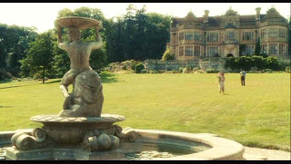
The Tallis house and fountain from the 2007 film of "Atonement"
Part Two: Questions/Activities
- Part Two takes place in May-June 1940 in northern France. Research the early stages of the Second World War so you are clear about what Turner, Nettle and Mace are doing and why.
- All of Part Two has Robbie as the focaliser. What changes do you notice in the voice, when you compare it with earlier instances of Robbie’s voice in Part One?
- Make notes about the main points of the three men’s experiences throughout Part Two, and the significance of each, eg the child’s leg in the tree, the old woman’s hostility, her sons’ kindness etc.
- Make notes about the characters of Nettle and Mace. Are they distinguishable as separate characters?
- In Part One, McEwan explores issues of social class. Is this continued in Part Two? Make notes about any instances you find where social class is explored.
- Why does McEwan give Robbie an injury in Part Two?
- What do we learn about Robbie’s treatment by the justice system, and his experiences in prison during Part Two?
- On page 204 Robbie lists pairs of lovers. What is the significance of each couple he mentions?
- What do we learn about relationships within the Tallis family five years on from Part Two?
- Why is it significant that Briony has not gone “up” to Cambridge?
- “She’s saying that she wants to be useful in a practical way. But I get the impression she’s taken on nursing as a sort of penance. She wants to come and see me and talk. I might have this wrong, and that’s why I was going to wait and go through this with you face to face, but I think she wants to recant.” (page 212) Comment on the significance of this statement to the novel as a whole.
- What do we learn about Cecilia through the letters she writes? Why do you think McEwan communicates information through letters (epistolary narrative) at this point of the novel?
- Notice the various events that hold the men up in their journey to the coast. Again McEwan keeps the pace of his novel slow. What is the effect and significance of this?
- Read the paragraph at the bottom of p.226 beginning “But these heresies…” up until “a triumphant return.” Comment on the significance of this section, including its religious significance.
- How does Robbie feel towards Briony now? Read pages 228-9 to help with your answer.
- “She had pursued his persecution with a strange ferocity.” (page 227) Why does Robbie assume this was the case? Make notes on how McEwan recreates the scene when Robbie saves Briony. Think about the function of this section of the novel, and its place within Part Two.
- What is the significance of the incident with the RAF man on pages 250-254?
- As we near the end of Part Two, Robbie is clearly becoming delirious. Make notes on how McEwan achieves this within the narrative voice on pages 261-265.
- Read page 261 from “Briony would change her evidence” to page 263 “No, you are not guilty. No.” What is McEwan exploring here about guilt, crime and war?
- What is the significance of the comment “We’ll sleep it off, Briony” on page 262?
- Why does McEwan end Part Two with Robbie remembering his arrest?
- Read the poem on the next page by W H Auden, entitled Musee des Beaux Arts. What do you think is the connection between this poem and Part Two of “Atonement”, and maybe even the whole novel?
- Explore the theme of guilt in Part Two.
- What is the link between war and crime as presented in Part Two?
- What is the function of Part Two within the novel as a whole?
- What is the function of Part Two when this novel is explored as a piece of crime writing?
- How has McEwan made Part Two so believable?

Musee des Beaux Arts
W. H. Auden
About suffering they were never wrong,
The old Masters: how well they understood
Its human position: how it takes place
While someone else is eating or opening a window or just walking dully along;
How, when the aged are reverently, passionately waiting
For the miraculous birth, there always must be
Children who did not specially want it to happen, skating
On a pond at the edge of the wood:
They never forgot
That even the dreadful martyrdom must run its course
Anyhow in a corner, some untidy spot
Where the dogs go on with their doggy life and the torturer's horse
Scratches its innocent behind on a tree.
In Breughel's Icarus, for instance: how everything turns away
Quite leisurely from the disaster; the ploughman may
Have heard the splash, the forsaken cry,
But for him it was not an important failure; the sun shone
As it had to on the white legs disappearing into the green
Water, and the expensive delicate ship that must have seen
Something amazing, a boy falling out of the sky,
Had somewhere to get to and sailed calmly on.
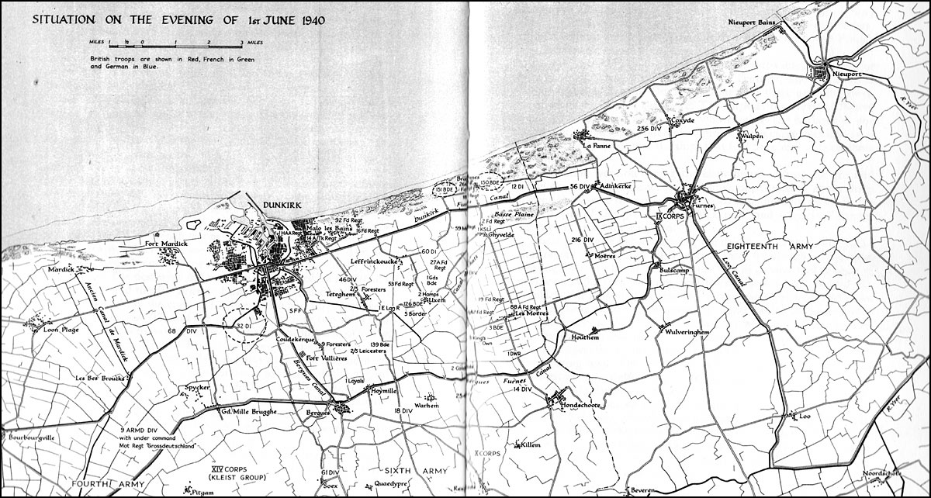
A Map of the land around Dunkirk dated 1 June 1940

Part Three: Questions/Activities
- Part Three is also set in May/June 1940, but now we are in London. Research what life in London and England was like in the early stages of World War Two, before the heavy bombing began in September 1940.
- What evidence does McEwan give us in the first section that the hospital is readying for a large number of casualties? How does this provide a link with Part Two of the novel?
- Look at some of the tasks and rules that might seem pointless within Briony’s nursing experience. Why do you think these tasks were insisted on? Were there any examples of pointless tasks in Part Two?
- Look at what Emily writes about to Briony on page 278-9. What point is McEwan making here do you think?
- Read 280-282. How has Briony’s attitude towards writing developed since Part One?
- In the early parts of Part Three look for evidence that Briony has grown up, but are there also signs of the old Briony we knew in Part One?
- When Briony learns of Lola’s coming marriage to Paul Marshall, McEwan tells us “Briony was more than implicated in this union. She had made it possible.” (Page 285) What do you make of this statement, particularly the word “implicated”?
- On page 285 we have the phrases “her familiar guilt” and “she would never undo the damage. She was unforgiveable.” How does this link to her decision to go into nursing rather than up to Cambridge?
- On page 288, Briony thinks that “her secret torment and the public upheaval of war had always seemed separate worlds, but now she understood how the war might compound her crime. The only conceivable solution would be for the past never to have happened.” What is the significance of this statement to the novel as a whole, and to your studying of the novel as a crime text?
- Make notes of the various terrible situations Briony witnesses and/or must deal with in the section from pages 290-311. How does she develop as a character in this short time?
- The tone and pace of Part Three changes on page 290. Make notes on how McEwan does this.
- Briony discovers on page 304 that “a person is, among all else, a material thing, easily torn, not easily mended.” What is the significance of this statement to the novel as a whole? McEwan then writes “She came the closest she would ever be to the battlefield.” Why do you think he juxtaposes these two sentences?
- What is the effect of McEwan’s inclusion of the letter Briony receives from Horizon (pages 311-5)? In what way might it feel unnerving to a reader?
- Why do you think Briony decides to go to Lola and Paul’s wedding?
- Comment on McEwan’s use of setting on page 322-3, both in terms of what Briony imagined the church would be like and what it turns out to be.
- Why does McEwan include that particular part of the traditional marriage service at the bottom of page 323?
- Pages 324-325 are important in terms of the crime that has occurred in Part One. Write a detailed commentary of this section beginning at the bottom of page 323 “Facing the altar…” and ending on page 325 “…and humbly inclined her head.” What is the significance of this extract to the genre of crime writing?
- Why doesn’t McEwan let us know straightaway where Briony is heading after the wedding?
- Why does he provide such a detailed description of Cecilia’s lodging on pages 330-1 and pages 334-5? Look closely at the details and see if you can work out their significance.
- Briony knows she must talk about “the sensitive subjects – the subjects she was going to have to confront in any case.” What do we realise then about her visit to Cecilia?
- How has Cecilia changed? How has the relationship between the sisters changed?
- Why is Cecilia interested in the vase being broken? Why is the fact that “the Old Man shouted at Betty” significant?
- Why is Cecilia preoccupied with Hardman on pages 335-6?
- The sisters’ discussion of the Briony’s “crime” on pages 336-7 is significant. Look closely at this section and make careful notes.
- How surprising is Robbie’s entrance on page 338?
- Make notes on the way the relationship between Cecilia and Robbie is presented.
- Why has McEwan made Cecilia and Robbie both so certain that Danny Hardman attacked Lola? Does this alter the way in which we view Briony’s “crime”?
- “It was Paul Marshall.” (page 346) How significant is this statement to reading this novel as a crime text?
- What do we realise about this novel at the end of Part Three? Does this affect our reaction to anything in the novel?
- How do we feel about the characters of Briony, Cecilia and Robbie at the end of Part Three? How hopeful do we feel about their futures?
- What is the function of Part Three within the novel as a whole?
- What is the function of Part Three when this novel is explored as a piece of crime writing?
- How has McEwan made Part Three so believable?

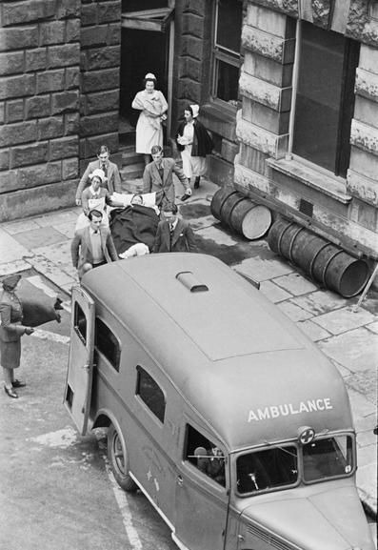
An ambulance at St Thomas Hospital in 1940

Epilogue – London 1999: Questions/Activities
- The narrative voice shifts to the first person. Why has McEwan done this and what is its effect?
- Consider the significance of:
  - Briony’s illness
  - The sighting of Paul and Lola, now Lord and Lady Marshall
  - The fates of the various members of the Tallis family
  - The return to the Tallis house, now a hotel
  - The first and last performance of The Trials of Arabella
  - The revelation that this is the first version in which Robbie and Cecilia have not been given a happy ending
- “Let me not be mad” (page 355) is a quote from Shakespeare’s “King Lear”. Why do you think McEwan has included this here?
- Why is Briony unlikely to publish the novel in her lifetime?
- “If I really cared so much for facts, I should have written a different kind of book.” (page 360) How does this statement affect our reading of the novel?
- “There was our crime – Lola’s, Marshall’s, mine –” Consider the significance of this statement to your reading of this as a crime novel. Is there any significance in the order of these names?
- Read the paragraph on page 371 beginning “The problem these fifty-nine years…” Make sure you understand what the narrator is saying here. How does this link to your reading of this novel as a crime text?
- Further doubt is added on the last page of the novel. Why do you think McEwan is constantly playing with his reader in this way?
- What do you make of the final sentence of this novel?
- Think about the ways in which a more conventional crime novel often ends. How does the epilogue McEwan gives us link and/or deviate from these conventions?
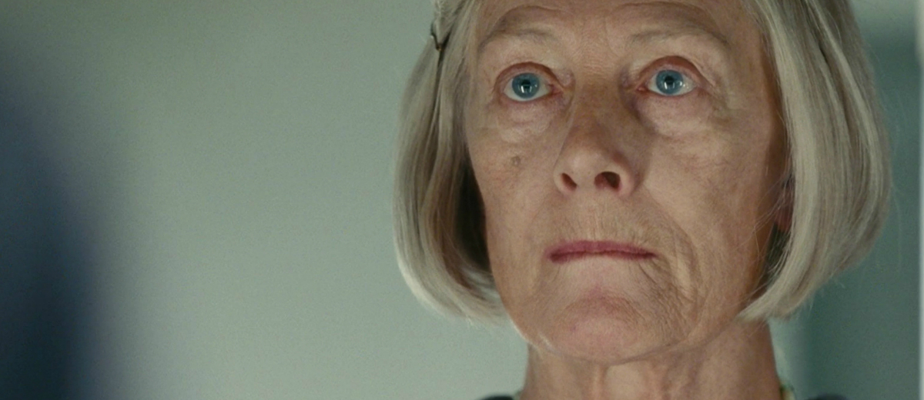
Vanessa Redgrave as the older Briony in the 2007 film of "Atonement"
Discussion/Essay/Exam Questions
- Why do you think Part One is split in to chapters but Parts Two and Three are not?
- How significant is the narrative structure of the novel?
- Early in Chapter One Briony says that there is nothing she cannot describe. It has been said that “this ability to describe, to fashion the world in words, is both Briony’s gift and her curse.” To what extent is this true?
- Briony is both participant and narrator in the novel at different times of the story. How does McEwan’s playing with narrative positions affect how we read the story?
- “The whole of “Atonement” can be seen as an exploration of the complex nature of moral and narrative responsibility. Briony’s extended process of atonement for her crime within the narrative is paralleled by her position as narrator. She becomes a metaphor for the moral dilemma of the novelist in terms of the authorial role, mixing and selecting “truth” and “fiction” to achieve a particular end.” (AQA English Literature B Oxford text book) Discuss what this means. Find evidence in the text for this view.
- In Chapter Three we see the first example of Briony misinterpreting what she sees. What other instances of mistaken seeing are there in “Atonement”?
- Explore how marriage is presented in this novel.
- What are the “crimes” committed in this novel?
- Is there a “detective” in this novel?
- The “motives” of the “criminal” are always significant. Discuss in terms of Briony’s motives.
- Consider how the consequences of Briony’s “crime” dominate the novel.
- How important is social class in the unfolding of character and events in “Atonement”?
- How culpable is Lola for the events that take place in the novel?
- Think about Leon’s comment in Chapter 10: “I love England in a heat wave. It’s a different country. All the rules change.” What is the significance of rules to the novel as a whole?
- Why does McEwan mention that Robbie played Malvolio in a play at Cambridge? Are there any other links between “Atonement” and Shakespeare’s “Twelfth Night”?
- What use does McEwan make of letters in the novel? What do they become in a crime text?
- What is the role of memory in “Atonement”?
- McEwan has said “[in writing about violence] you’ve got to embrace it, you’ve got to make your reader…see. So, when people accuse me of being too graphic in my depictions of violence, my response is, “Well, either you do violence, or you sentimentalise it”” How important is violence to this novel, and to a reading of this novel as a crime text?
- Is Briony successful in atoning for what she has done? Is atonement possible/relevant/ appropriate?
- “There was a crime. But there were also lovers.” You are reading this novel through the lens of crime writing. What other ways are there to read this novel?
- There are several themes worth exploring in “Atonement”: Atonement and guilt (the main one you will need to focus on); War; Love; Writing and Imagination; Truth and Memory
- “When I got to the end of “Atonement” I felt that Briony was the most complete character I had ever created” said Ian McEwan. What do you think about this statement?
- McEwan, like Briony, felt that he grew up as an only child because his step-brother and step-sister were much older than him. To what extent is this relevant to your understanding of Briony’s character?
- What points of comparison can you find between “Atonement” and “The Rime of the Ancient Mariner”?

Answering on “Atonement” in the exam
You will be answering on “Atonement” in Paper 2A Elements of Crime Writing. This is an open book exam in which you will be answering questions on “The Rime of the Ancient Mariner”, “Oliver Twist” as well as “Atonement”. This paper has the following structure:

Section A Unseen text (crime writing)
Section B Answer a question on one of the set texts
Section C Answer a question about crime writing using your other two set texts
All questions are worth 25 marks. It is a three hour exam, so you would spend an hour on each question. This exam is worth 40% of your A level.

Sample Question for “Atonement” Section B
‘McEwan suggests Briony’s crime can easily be forgiven because she is just a child.’ To what extent do you agree with this view? Remember to include in your answer relevant detailed exploration of McEwan’s authorial methods.
Sample Question for Section C
‘In crime writing there are always victims.’ Explore the significance of the ways that victims are presented in two crime texts you have studied.

Wider Reading
There are many texts mentioned in “Atonement”. This is called intertextuality. Here is a list of some of these, as well as some other useful reading for A Level English Literature students.

Kate Adie “Corsets to Camouflage” (non-fiction history about women and war)
Jane Austen “Mansfield Park”, “Northanger Abbey”
Elizabeth Bowen “The Last September”
Vera Brittain “Testament of Youth”
Sebastian Faulks “Birdsong”
Michael Frayn “Spies”
L P Hartley “The Go-Between”
Joseph Heller “Catch-22”
A E Housman “A Shropshire Lad”
Henry James “What Maisie Knew”
D H Lawrence “Lady Chatterley’s Lover”
Rosamund Lehmann “Dusty Answer”
Ian McEwan “The Child in Time”, “Enduring Love”
Vladimir Nabokov “Lolita”
Samuel Richardson “Clarissa” (dip in and out of this – it’s very long!)
William Shakespeare: “King Lear”, “Twelfth Night”
Virginia Woolf “The Waves”, “To the Lighthouse”

