AQA Power and Conflict Poetry
Wider Reading Booklet

Ozymandias
London
Extract from The Prelude
My Last Duchess
Exposure
Storm on the Island
Bayonet Charge
Remains
Poppies
War Photographer
Tissue
The Emigrée
Checking Out Me History
The Emigrée

All extracts taken from websites below
The British Library
The Guardian
The British Council
BBC

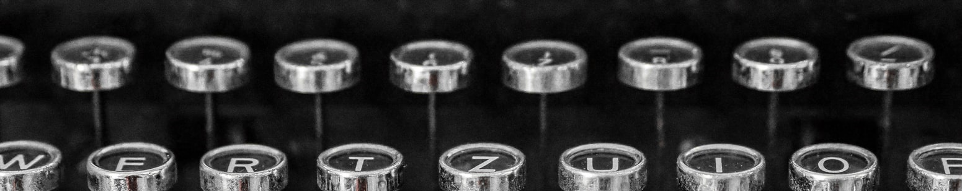
Extracts from Look on my works, ye mighty… Ozymandias statue found in mud
Source: https://www.theguardian.com/world/2017/mar/09/look-on-my-works-ye-mighty-ozymandias-statue-found-in-mud

Archaeologists from Egypt and Germany have found an eight-metre (26ft) statue submerged in groundwater in a Cairo slum that they say probably depicts revered Pharaoh Ramses II, who ruled Egypt more than 3,000 years ago. The discovery – hailed by Egypt’s antiquities ministry on Thursday as one of the most important ever – was made near the ruins of Ramses II’s temple in the ancient city of Heliopolis, located in the eastern part of modern-day Cairo. The pharaoh, also known as Ramses the Great or Ozymandias, was the third of the 19th dynasty of Egypt and ruled for 66 years, from 1279BC to 1213BC. He led several military expeditions and expanded the Egyptian empire to stretch from Syria in the east to Nubia (northern Sudan) in the south. His successors called him the Great Ancestor.

Percy Bysshe Shelley’s 1818 sonnet ‘Ozymandias’ – which contained the line ‘Look on my works, ye Mighty, and despair!’ – was written soon after the British Museum acquired a large fragment of a statue of Ramses II from the 13th century BC.

On Thursday, archaeologists, officials, local residents and news media looked on as a massive forklift pulled the statue’s head out of the water. The joint Egyptian-German expedition also found the upper part of a life-sized limestone statue of Pharaoh Seti II, Ramses II’s grandson, measuring 80cm in length. The sun temple in Heliopolis was founded by Ramses II, lending weight to the likelihood the statue is of him, archaeologists say.

It was one of the largest temples in Egypt, almost double the size of Luxor’s Karnak, but was destroyed in Greco-Roman times. Many of its obelisks were moved to Alexandria or to Europe and stones from the site were looted and used for building as Cairo developed.

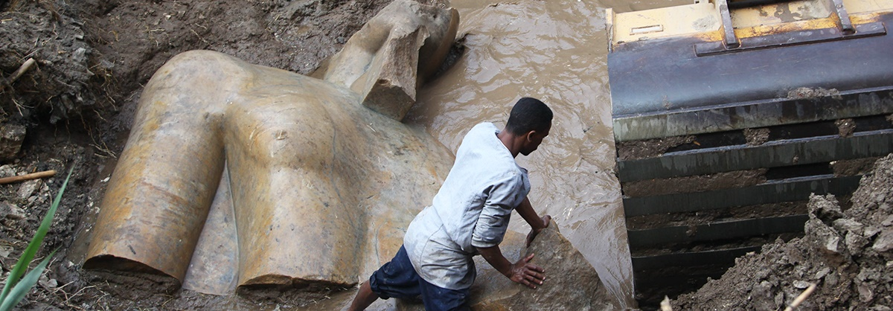

Experts will now attempt to extract the remaining pieces of both statues before restoring them. If they are successful and the colossus is proven to depict Ramses II, it will be moved to the entrance of the Grand Egyptian Museum, set to open in Giza in 2018. The discovery was made in the working-class area of Matariya, among unfinished buildings and mud roads.

Dietrich Raue, head of the expedition’s German team, said ancient Egyptians believed Heliopolis was the place where the sun god lives, meaning it was off-limits for any royal residences.

‘The sun god created the world in Heliopolis, in Matariya,’ he said. ‘That’s what I always tell the people here when they ask if there is anything important. According to the pharaonic belief, the world was created in Matariya. ‘That means everything had to be built here. Statues, temples, obelisks, everything. But … the king never lived in Matariya, because it was the sun god living here.’
Extracts from Looking at the manuscript of William Blake’s ‘London’
Source: https://www.bl.uk/romantics-and-victorians/articles/looking-at-the-manuscript-of-william-blakes-london

One of the major political events of William Blake’s lifetime was the French Revolution. For Blake, it was a moment of radical hope turned to violent disillusion. He was initially a supporter. In the summer of 1792 he wore a ‘bonnet rouge’ to show his solidarity with the revolutionaries abroad. The ‘bonnet rouge’ was a pointed red cap that had its roots in classical antiquity. For the ancient Romans, the cap symbolised freedom from tyranny. It was first seen publicly in France in 1790 and it became an icon of the Revolution and continued to be a sign of revolutionary support throughout the Reign of Terror. When Blake walked round London with the cap on his head, he left no-one in doubt as to his revolutionary sympathies.

In that same summer of 1792 Blake wrote his first version of the poem ‘London’, which he included in The Songs of Experience. In this early draft, Blake described the streets of London as ‘dirty’. ‘Dirty’ was quite an accurate description as the late 18th-century London streets that he knew so well were piled with filth of all kinds. It also suggests the fallen state of contemporary society.

Blake saw a world in turmoil: blood running down palace walls, prostitutes suffering from sexually-transmitted diseases, children forced to become chimney sweeps and innocent babies born to mothers who couldn’t look after them. ‘Dirty’ describes this state of moral and physical degeneration but it doesn’t have the political weight of the later term: ‘charter’d’. Chartering was an 18th-century process of corporate ownership, effectively transferring public land to private hands. Blake’s readers would quickly have recognised the political implications of the word. Supporters of chartering claimed that it gave people rights over the land. Those against claimed that it took rights away from the many in order to give them to the few. The English-born, American writer and revolutionary, Tom Paine, declared: ‘Every chartered town is an aristocratical monopoly in itself.’ He felt strongly that chartering was anti-democratic and unnatural.

The poem gives some indication of how this redemption might come about. We are constantly reminded of the need to listen. The verb ‘hear’ appears three times in emphatic positions. The rhymes are heavy and repetition is frequent, creating echoes in the middle as well as at the end of lines. Blake’s London is a noisy place. The sounds of the city reverberate throughout, ranging from the chimney sweep’s ‘cry’, to the harlot’s ‘curse’ and the soldier’s ‘sigh’. The voice that sings this song is not that of a child but that of the bard, who, we are told in the ‘Introduction’ to Experience, ‘present, past and future sees’. By opening our ears and our eyes, Blake suggests we may also open our minds. Here, as always, lies the key to his vision of redemption.

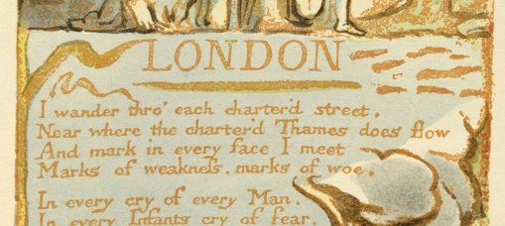
Extracts from An Introduction to the Romantics
Source: https://www.bl.uk/romantics-and-victorians/articles/the-romantics

Today the word ‘romantic’ evokes images of love and sentimentality, but the term ‘Romanticism’ has a much wider meaning. It covers a range of developments in art, literature, music and philosophy, spanning the late 18th and early 19th centuries. The ‘Romantics’ would not have used the term themselves: the label was applied retrospectively, from around the middle of the 19th century.

In 1762 Jean-Jacques Rousseau declared in The Social Contract: ‘Man is born free, and everywhere he is in chains.’ During the Romantic period major transitions took place in society, as dissatisfied intellectuals and artists challenged the Establishment. In England, the Romantic poets were at the very heart of this movement. They were inspired by a desire for liberty, and they denounced the exploitation of the poor. There was an emphasis on the importance of the individual; a conviction that people should follow ideals rather than imposed conventions and rules. The Romantics renounced the rationalism and order associated with the preceding Enlightenment era, stressing the importance of expressing authentic personal feelings. They had a real sense of responsibility to their fellow men: they felt it was their duty to use their poetry to inform and inspire others, and to change society.

The Romantics were inspired by the environment, and encouraged people to venture into new territories – both literally and metaphorically. In their writings they made the world seem a place with infinite, unlimited potential. A key idea in Romantic poetry is the concept of the sublime. This term conveys the feelings people experience when they see awesome landscapes, or find themselves in extreme situations which elicit both fear and admiration. For example, Shelley described his reaction to stunning, overwhelming scenery in the poem ‘Mont Blanc’ (1816).

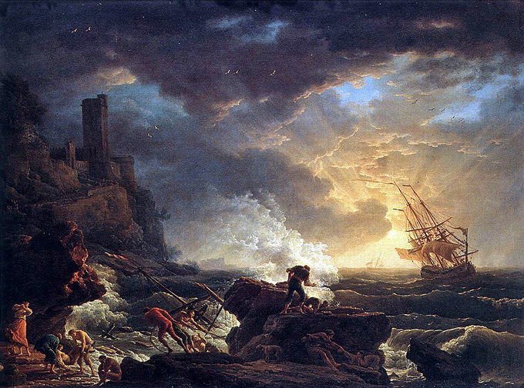
Extracts from Portrait of a lady
Source: https://www.theguardian.com/books/2008/jul/19/poetry1

The gold standard of all dramatic monologues is Browning’s ‘My Last Duchess’, published in 1842. Set in Renaissance Italy, the poem reflects the Victorian fascination with the period - with its sumptuousness, its dynamism, its unparalleled belief in the human animal. Browning drew on an actual episode in Tuscan history for his donnée, but the interpretation, and the glittering diction, are his own. The scene is the grand staircase of the ducal palace in Ferrara, in northern Italy, in the mid-1500s. The speaker is the lusty, avaricious Duke of Ferrara, and as the poem opens he is brokering a marriage deal with the envoy of the Count of Tyrol, whose daughter he intends to acquire as his second duchess - Ferrara’s ‘last’ duchess, we realise, is dead. Rather like a modern aristocrat planning some calculated PR in Hello! magazine (‘To celebrate his engagement to the stunning Barbara, Ferrara welcomes us into his charming home’), the duke offers the silent envoy, and the reader, an access-all-areas tour of the art he has amassed.

Sequestered behind a curtain which only he is allowed to part hangs the jewel of his collection: a portrait of his late wife. By his own account, the young duchess was not only beautiful but girlish, unaffected, tender and spontaneous. She blushed easily, was warmly appreciative of small acts of kindness, and was clearly utterly lacking in vanity. Without ever having laid eyes on the girl, we feel as if we, too, have savoured ‘the depth and passion of her earnest glance’, the ‘spot of joy’ in her cheek, and ‘the faint half flush’ tinting the delicate skin of her throat. Yet it’s soon clear that the duchess’s very freshness made her irksome to her authoritarian husband: he found her altogether too impulsive, too unpredictable and therefore too threatening - too human, in other words. So he had her killed. But no matter: ‘There she stands / As if alive.’ Ferrara in fact prefers the image to the original because the image is inert, and therefore easier to control.

None of this is said in so many words: because the self-satisfied Ferrara utters the whole poem, his loathsomeness and megalomania have to be inferred. They seep out at the edges of what he says; he is unaware of his own repulsiveness. And yet he is perversely vital: we are mesmerised by his fluency. As a whole, the monologue is a profoundly human picture that is simultaneously a celebration of art’s power - because art, after all, is a peculiarly human undertaking.

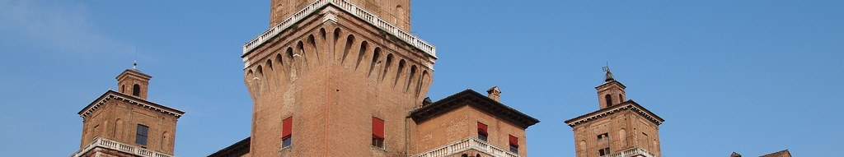

Though the poem was written before his marriage, Browning republished ‘My Last Duchess’ in 1849, three years after his escape to Italy with Elizabeth Barrett, or EBB as she thenceforth signed herself. He and Elizabeth quarrelled frequently about politics, about her interest in spiritualism, about how to bring up their son. Robert wanted Pen to wear trousers and short hair; Elizabeth preferred him in velvet pantaloons and candle curls. Elizabeth won. Awkwardly, her money supported the entire household: husband, servants, dog, child, clothes, food, pet rabbits, the writing of poetry, holidays abroad in the hot months, and her addiction to laudanum, which she took daily for pains in her spine and chest. She never complained. We all know the temptation to kill our spouse (especially a saintly one). In fact, Browning’s poems often feature husbands who kill or resent their wives, or men who do away with their mistresses: along with Ferrara there is the murderous Franceschini in The Ring and the Book; Porphyria’s homicidally possessive lover; and an exasperated Andrea del Sarto, who feels that his other half, the high-maintenance Lucrezia, has stopped him from becoming another Leonardo, Raphael or Michelangelo by making him paint commercial trash. It’s a curious fact that Browning himself hardly wrote any poetry during the 15 years of his marriage. Did he, one wonders, sometimes have a Ferrara-like urge to rid himself of EBB?
Extracts from ‘The Charge of the Light Brigade’: making poetry from war
Source: https://www.bl.uk/romantics-and-victorians/articles/the-charge-of-the-light-brigade-making-poetry-from-war

On 25 October 1854, as part of the Battle of Balaklava, an episode in the Crimean War, the Light Cavalry Brigade of the British Army made a disastrous frontal assault upon a well-positioned battery of Russian artillery. The British soldiers rode the mile’s length of a valley, vulnerable to heavy enemy fire on both sides as well as from the front. Despite losses, they reached the Russian forces and, using sabres, drove them from their position, before turning to ride back down the long valley, exposed once again to insistent cannon fire. About 670 men had begun the charge, of whom 118 were killed and 127 wounded: by the end of the episode, only 195 men were left with horses.

It was a complete military disaster, the awfulness of which was only compounded by it being the result of a misunderstanding. The order had been given to capture some heavy guns that the Russians were attempting to withdraw from the hills to the south of the valley; but when Captain Nolan brought the order back to the brigade its precision had somehow got lost, and the charge was launched instead at the substantial artillery dug in at the valley’s far end – a task for which the lightly armoured brigade was suicidally unsuited. Nolan may have realised that a mistake had been made as his first action upon charging was, extraordinarily, to ride to the front of the company, before his senior officer; but if this was indeed an attempt to get the men to change direction it was futile: he was shortly killed by Russian artillery, and so the cavalry rode on.

Terrible mistakes happen in war all the time, of course, but this one had an unprecedented sort of publicity as the Crimean War was the first to be covered by photographers and reporters, who sent news home within just a few weeks. It was the first campaign to be covered by a war correspondent, the Irishman W H Russell, who was dispatched by The Times, where his compelling account of the Light Brigade’s catastrophe was published on 14 November 1854. The day before, however, The Times had offered a first treatment of the story in its leader column. It was indeed a ‘disaster’, said the newspaper, evoking vividly the brigade ‘simply pounded by the shot, shell, and Minié bullets from the hills’ as the cavalry advanced through ‘that valley of death’, and registering a loss all the more lamentable ‘because it seems to have arisen from some misunderstanding’. But still there was something to be celebrated: ‘Causeless as the sacrifice was, it was most glorious … The British soldier will do his duty, even to certain death, and is not paralyzed by feeling that he is the victim of some hideous blunder’. Years later, Tennyson’s son would recall his father writing his response to the charge on 2 December, ‘in a few minutes, after reading the description in The Times in which occurred the phrase ‘someone had blundered’, and this was the origin of the metre of the poem’; but in fact The Times report does not contain the phrase: that is Tennyson’s work. The poem first appeared in The Examiner on 9 December, signed ‘A.T.’, before being collected, in a revised version, in Tennyson’s volume Maud the following year.

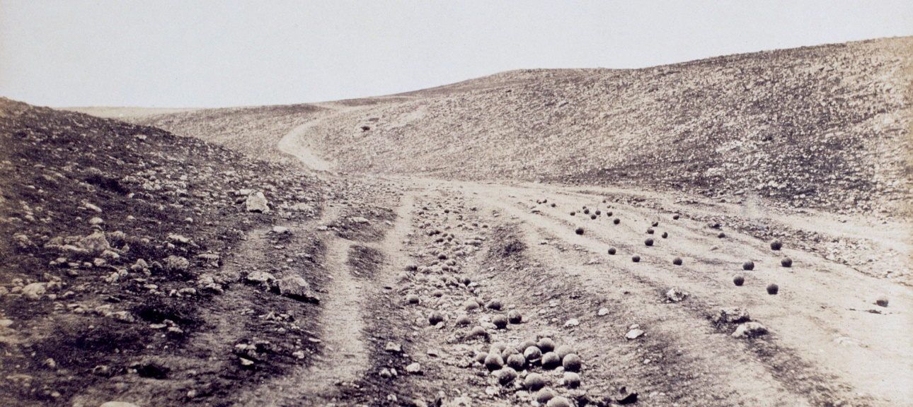
Extracts from The Life of Wilfred Owen
Source: https://www.bl.uk/people/wilfred-owen

Wilfred Owen (1893–1918) is widely regarded as one of Britain’s greatest war poets. Writing from the perspective of his intense personal experience of the front line, his poems, including ‘Anthem for Doomed Youth’ and ‘Dulce et Decorum Est’, bring to life the physical and mental trauma of combat. Owen’s aim was to tell the truth about what he called ‘the pity of War’. Born into a middle-class family in 1893 near Oswestry, Shropshire, Owen was the eldest of three. His father, Tom Owen, was a railway clerk and his mother, Susan, was from a fervently religious family.

In 1915, Owen enlisted in the army and in December 1916 was sent to France, joining the 2nd Manchester Regiment on the Somme. Within two weeks of his arrival he was commanding a platoon on the front line. In the midst of heavy gunfire, he waded for miles through trenches two feet deep in water with the constant threat of gas attacks. The brutal reality of war had a profound effect on him, as he recounted in letters to his mother. His poems ‘The Sentry’ and ‘Exposure’ record specific ordeals of this time.

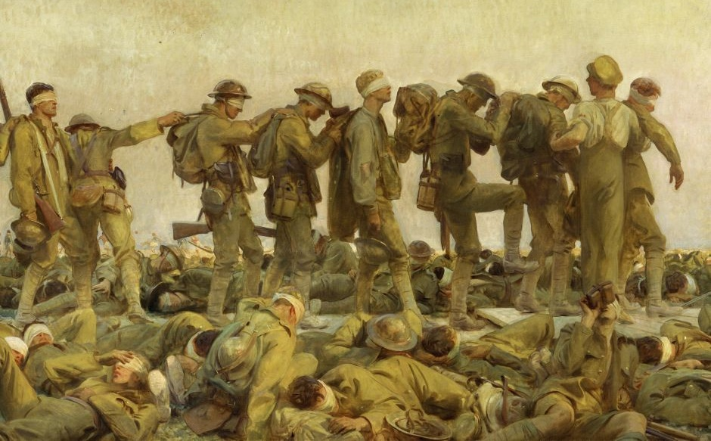

In April, after being blown into the air by a shell, Owen spent several days sheltering in a hole near the corpse of a fellow officer, and was shortly after diagnosed with shell shock. In June 1917 he was sent to Craiglockhart War Hospital, near Edinburgh, where he spent four months under the care of the renowned doctor, Captain Arthur Brock. Here Owen wrote many poems and became editor of the Hospital magazine, Hydra. He also met fellow poet Siegfried Sassoon who gave him crucial support and encouragement in a literary friendship which transformed Owen’s life.

In September 1918, Owen returned to the front during the final stages of the war. He fought a fierce battle and was awarded the Military Cross for his bravery. He was killed, at the age of 25, while leading his men across the Sambre and Oise Canal near Ors, on 4 November – just one week before the Armistice was declared. Virtually unknown as a poet in his lifetime, most of Owen’s poems were published after his death. Aware that his work could do nothing to help his own generation, he succeeded in warning the next, his poetic legacy having a major impact on attitudes to war.
Extracts from Obituary: Seamus Heaney
Source: https://www.bbc.co.uk/news/entertainment-arts-13930435

Seamus Heaney was internationally recognised as the greatest Irish poet since WB Yeats. Like Yeats, he won the Nobel Prize for literature and, like Yeats, his reputation and influence spread far beyond literary circles. Born in Northern Ireland, he was a Catholic and nationalist who chose to live in the South. ‘Be advised, my passport’s green / No glass of ours was ever raised / To toast the Queen,’ he once wrote.

He came under pressure to take sides during the 25 years of the Troubles in Northern Ireland, and faced criticism for his perceived ambivalence to republican violence, but he never allowed himself to be co-opted as a spokesman for violent extremism. His writing addressed the conflict, however, often seeking to put it in a wider historical context. The poet also penned elegies to friends and acquaintances who died in the violence. Describing his reticence to become a ‘spokesman’ for the Troubles, Heaney once said he had ‘an early warning system telling me to get back inside my own head’.

Born on 13 April, 1939, on a family farm in the rural heart of County Londonderry, he never forgot the world he came from. ‘I loved the dark drop, the trapped sky, the smells / Of waterweed, fungus and dank moss,’ he recalled in Personal Helicon. He was a translator, broadcaster and prose writer of distinction, but his poetry was his most remarkable achievement, for its range, its consistent quality and its impact on readers: Love poems, epic poems, poems about memory and the past, poems about conflict and civil strife, poems about the natural world, poems addressed to friends, poems that found significance in the everyday or delighted in the possibilities of the English language.

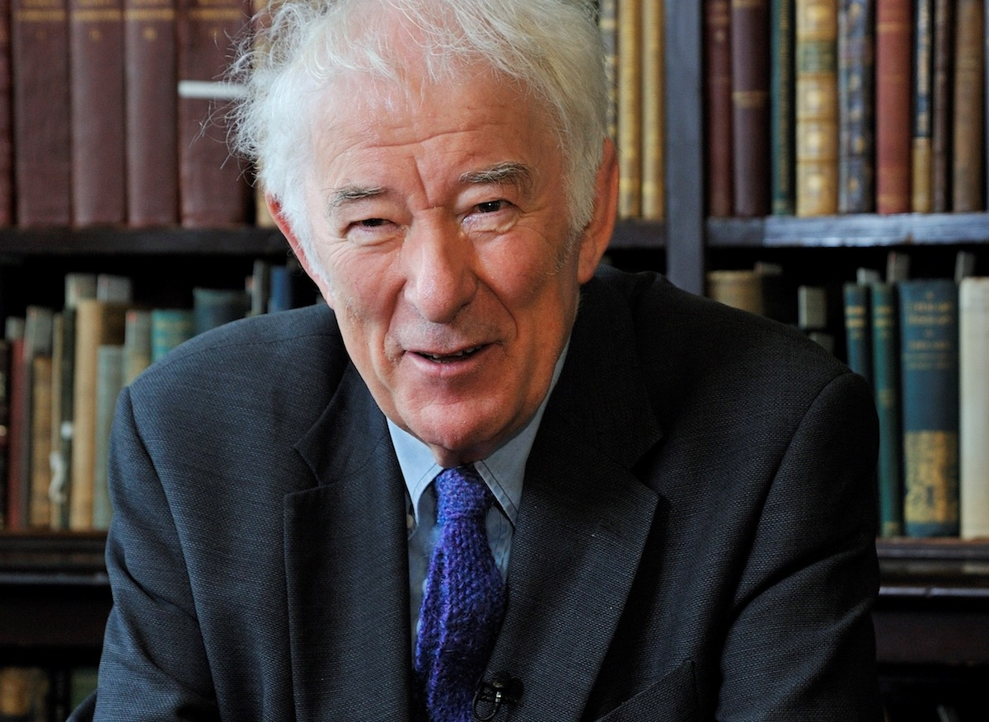

Extracts from Ted Hughes and war
Source: https://www.bl.uk/20th-century-literature/articles/ted-hughes-and-war

As a child growing up in the 1930s, Ted Hughes’s childhood was overshadowed by the legacy of one war and foreshadowed by the arrival of the next. Throughout his career, Hughes wrote poems in which he reflected upon these conflicts and their impact, from The Hawk in the Rain (1957) to Wolfwatching (1989). While the impact of the First World War was particularly striking, the Second World War also affected the young Hughes, with the departure of his much-loved older brother, Gerald, to the RAF keenly felt. It is interesting to note that the subject of Hughes and war is one of the less explored areas of the poet’s work. Nevertheless, war had a major impact upon Hughes’s life and work, and as Professor Dennis Walder wrote, Hughes was a ‘war poet at one remove, writing out of the impact of memory – the individual memory of his father, and the collective memory of English culture’.

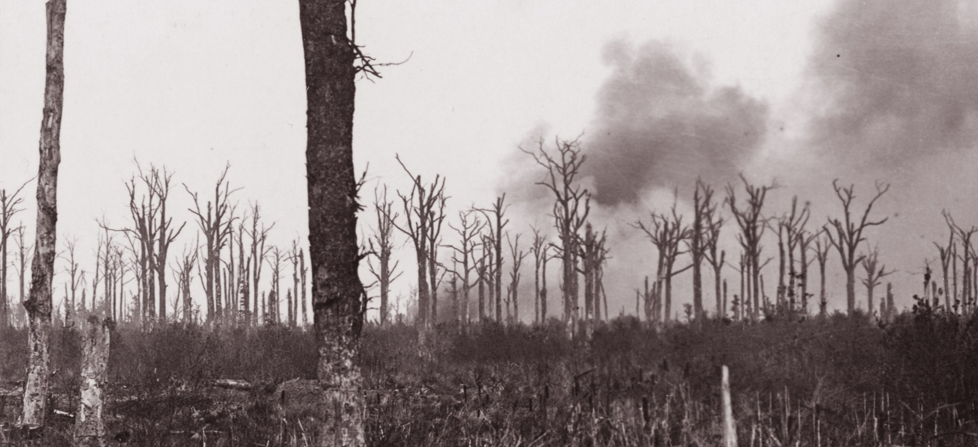

Hughes wrote on a number of occasions about the way in which the First World War overshadowed his childhood, and of its wider impact on the Calder Valley where he spent the first eight years of his life. He explored this theme in poems such as ‘Six Young Men’ and ‘Bayonet Charge’, and wrote movingly throughout his career about the impact that the conflict had upon his parents’ generation.

Hughes’s father William (1894–1981) served in the Lancashire Fusiliers, joining up in Rochdale in September 1914 and fighting first at Gallipoli and later in France. Many of the men in the Calder Valley and across the region joined up with friends in so-called ‘Pals Battalions’ early in the war, and the massive casualty rates which followed decimated the communities that they had left behind. In a file of autobiographical notes and fragments at the British Library, Hughes wrote of the continuing impact that could still be felt in the 1930s: ‘The big, ever-present, overshadowing thing was the First World War, in which my father and my Uncles fought, and which seemed to have killed every other young man my relatives had known.’

Further light is shed on Hughes’s feelings about the war by a draft letter in the Archive which Hughes wrote to Geoff Moorhouse, the author of Hell’s Foundations (1992), a book about the Lancashire Fusiliers at Gallipoli. The letter (a shortened version of which was later sent to Moorhouse) provides an insight into both William Hughes’s military service and his son’s feelings about the war. Hughes’s sentiments would doubtless chime with those of others whose relatives had served in the conflict. He explained to Moorhouse that although he was close to his father he did not feel able to speak to him about the war: ‘I never questioned him directly. Never. I can hardly believe it now, but I didn’t. He managed to convey the horror so nakedly that it fairly tortured me when he did speak about it.’
Extracts from Simon Armitage on the poetry of World War One
Source: https://www.radiotimes.com/news/2014-11-08/simon-armitage-on-the-poetry-of-world-war-one/

The first world war poets Wilfred Owen, Siegfried Sassoon, Robert Graves and Rupert Brooke were the bloggers of their day, says Simon Armitage. They revealed a different war to the one being reported through mainstream sources – a war, as we know now, of unimaginable slaughter and suffering. ‘What is astonishing about those poems is they run counter to every expectation,’ says Armitage. ‘They are blasphemous, they are treacherous, they are radical and they are unpatriotic. They are everything that you wouldn’t expect for the time and that is what makes them so extraordinary.’

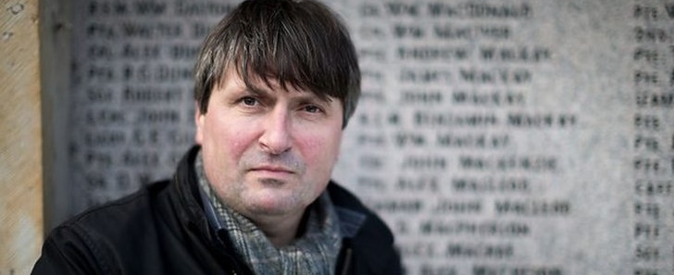

Armitage, the Yorkshire-born poet, playwright, author and songwriter, says his own knowledge of the war is shaped ‘and probably skewed’ by those poets. ‘They were like the social networkers of their day. Their poems were undercutting all the official formal news sources. What you got in The Times was quite different from what you were hearing from Wilfred Owen or Siegfried Sassoon.’ And, of course, the imprint they left was huge. So, Armitage admits a slight trepidation in offering his own poetic commentary on the war, using as his inspiration the stories of people whose lives were either ended or profoundly changed by it.

One was Edith Appleton, a nurse who worked on the Western Front and whose diaries helped inform the scripts of the BBC1 drama The Crimson Field broadcast earlier this year. Appleton, who lived to be 80, addressed the diary entries to her mother and was unsparing in the detail she shared. But she juxtaposes those brutally illustrative accounts of men with minds and bodies obliterated by battle, with descriptions of off-duty swims on the Normandy coast close to where she was stationed. It was that paradox Armitage has sought to represent in his poem Sea Sketch (reproduced below), one of seven he’s written for the Culture Show special.

‘What really interested me was not just the journal entries, but the drawings that were in and amongst them — all these really charming sketches of Étretat where she used to go to swim on her days off. It seemed to me that she was trying to find repose and even bliss only a few miles away from where she was witnessing and dealing with all this terror. That just seemed to me to be an untold story.’

Other subjects include a Lincolnshire mother who lost five of her eight sons to the war and a navigator shot down and taken prisoner, but who tunnelled his way out to freedom. Armitage’s enduring concern has been to honour the memory of those whose life stories he is exhuming. ‘I am really pleased with them. There was a lot of pressure to put them together quite quickly and I think it provoked or produced something in me that I wasn’t quite expecting. I think there is a sincerity to the work; they are poems that wear their heart on their sleeve.’
Extracts from Wearing a poppy was a pledge of peace and now it serves to sanitise war
Source: https://www.theguardian.com/commentisfree/2016/nov/03/wearing-poppy-pledge-peace-sanitise-war-remembrance

When the poppy was first adopted as the symbol of remembrance, it was shortly after the end of the first world war when almost every family in the land still felt the raw grief of the time. The poppy represented mourning and regret, and served as a pledge that war must never happen again. Arguably this original meaning became subverted. By the 1930s, those alarmed at the militarism that had become associated with the Cenotaph rituals started wearing white poppies to reinforce the peace pledge. By 1939, the world was at war again. Another generation signed up, though this time reluctantly, knowing they had to defeat an unprecedented evil, unleashed by the unresolved issues of the first world war that was spreading across Europe. When remembrance customs continued after 1945, they were little changed – except that on the war memorials up and down the country, a new list of names had been added.
Over the decades, as the memory of both wars began to fade, the poppy began to take on a subtle new meaning. To many people it had become a patriotic duty to wear one, a symbol of pride in the sacrifices of the armed services. Indeed, all those who had ever worn a military uniform had become ‘heroes’, and the dead were described euphemistically as ‘having fallen’.

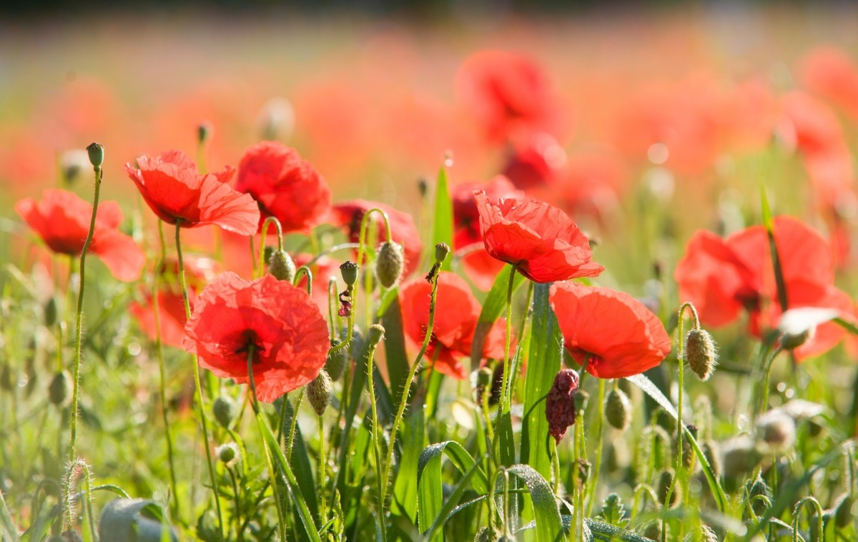

In an utterly unintended way the remembrance customs now serve to sanitise war and even to make the military option a respectable political option. Judged from the perspective of those first wearers of the poppy – that the red flower should be a declaration of hope that wars should never happen again – the poppy has been a sad failure. What an irony it will be if at 11 o’clock on Remembrance Sunday, British troops on war exercises find themselves wearing poppies and listening to The Last Post as they face Russian troops across eastern Europe.
Today, millions still wear the poppy every autumn, but millions choose not to. It has become a cause of social division as each year the debate is rehearsed as to what the poppy really symbolises, and under what circumstances it is appropriate to display it. The debate this year about whether the England and Scotland football teams should wear poppy armbands illustrates how passionately the arguments are felt and how increasingly polarised views have become.
Extracts from Don McCullin and Giles Duley in conversation
Source: https://www.theguardian.com/artanddesign/2019/feb/03/don-mccullin-giles-duley-photography-retrospective-tate-interview

When are about to die, Sir Don McCullin observes, ‘they often look up’, searching for ‘one last chance that maybe somebody can save [them].’ Condemned prisoners glance skyward in Goya’s paintings, he notes, as did some of the doomed souls he encountered on his assignments, such as in the killing fields of Lebanon in 1976. In the pictures from Beirut that appear in a new exhibition of Sir Don’s work at Tate Britain in London, a woman wails for her murdered family. Gunmen crouch in a ruined ballroom.

Sir Don couldn’t hide, and neither can his viewers. Looking at him, his subjects seem also to be gazing through and beyond his black-and-white images. What, he asks, could he say to that starving boy? His work is an accusation – against the perpetrators of the cruelty he intimately chronicled, against his audience and against himself.

In 1970 his camera took a bullet for him as he zigzagged through a Cambodian paddy field; a week later he was wounded by a mortar, crawling away to evade the Khmer Rouge. (‘Did I do this?’ he asks in momentary wonderment.) In 1972 he spent four days in a Ugandan prison, where every morning Idi Amin’s lorries would take corpses to the Nile to feed to the crocodiles: ‘I thought I’d had it.’ Charles Glass, a foreign correspondent and friend, says Sir Don ‘will endure any amount of discomfort and suffering to get a picture.’ He complained, Mr Glass says, only when pettifogging officials barred the path to his destination. Some wounds didn’t heal. Feeling ‘more elated and more blessed’ for surviving, he sensed he was becoming a war junkie. ‘Every two or three years,’ he recalls, ‘I’d have a kind of breakdown.’ Now, at 83, stories tumble out of him, like the one about a man with a blown-off face he took to hospital in Salvador in 1982, whose ‘eyes were screaming’. Or about the company of marines he saw ‘chewed up’ in Hue. ‘I think about it every bloody day,’ he says. ‘My head is overcrowded with memory.’

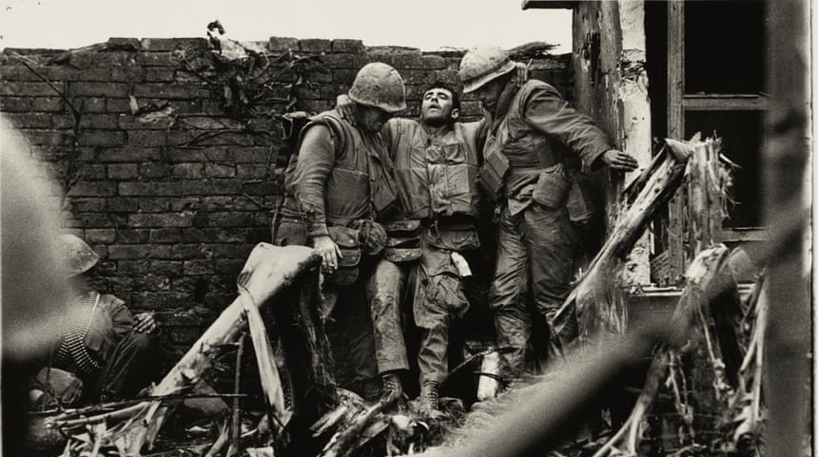

He blames politicians: ‘90% of the things I went and photographed was because they bollocksed up.’ That goes equally for the struggling English towns that he documented between foreign jobs. His close-up portrait of a homeless Irishman in London’s East End, wild hair framing a haunted visage, is as wrenching in its way as his battlefields. Cities are ‘where the real truth is,’ he reckons. Even his glowering English landscapes seem suffused with threat. For him, the Roman ruins he photographed in North Africa are imbued with the hardship of the slaves who built them.
Extracts from Hunt for next poet laureate still on as Imtiaz Dharker says no to job
Source: https://www.theguardian.com/books/2019/may/03/hunt-next-poet-laureate-imtiaz-dharker-carol-ann-duffy

The acclaimed poet Imtiaz Dharker has turned down the poet laureateship, the highest honour in British poetry, citing a need to focus on her writing – and despite reports that she was set to be named as the next holder of the position. ‘I had to weigh the privacy I need to write poems against the demands of a public role.’ Dharker, who was born in Pakistan and grew up in Glasgow, said. ‘It was a huge honour to be considered for the role of poet laureate and I have been overwhelmed by the messages of support and encouragement from all over the world.’ Although it was reported by the Sunday Times last week that Dharker was due to be announced as laureate this month, the Guardian understands that no formal offer has been made to or accepted by any candidate for the laureateship, and that the selection process is still under way, with Dharker giving way to other contenders on Friday.

The expert panel’s shortlist of potential successors was believed to include Dharker, who is widely studied for GCSE and A-level and who reads to more than 25,000 students each year through the Poetry Live! schools programme. Other contenders are rumoured include Daljit Nagra, Simon Armitage, Lemn Sissay, Alice Oswald and Jackie Kay – although Kay, who is Scottish makar, has effectively said she is not an option for the role. She told the Guardian last November: ‘I don’t think the powers that be would want to combine the two.’

Wendy Cope and Benjamin Zephaniah have both emphatically ruled themselves out. Cope said: ‘If it’s a competition, it is one that many poets have no interest in winning.’ Zephaniah said: ‘I have absolutely no interest in this job. I won’t work for them. They oppress me, they upset me, and they are not worthy.’ Armitage has been more positive, writing in the Guardian that ‘the laureateship should be the highest office in poetry and that the laureate should be the guardian of those ideals’. Nagra said on Friday he had not yet been approached.

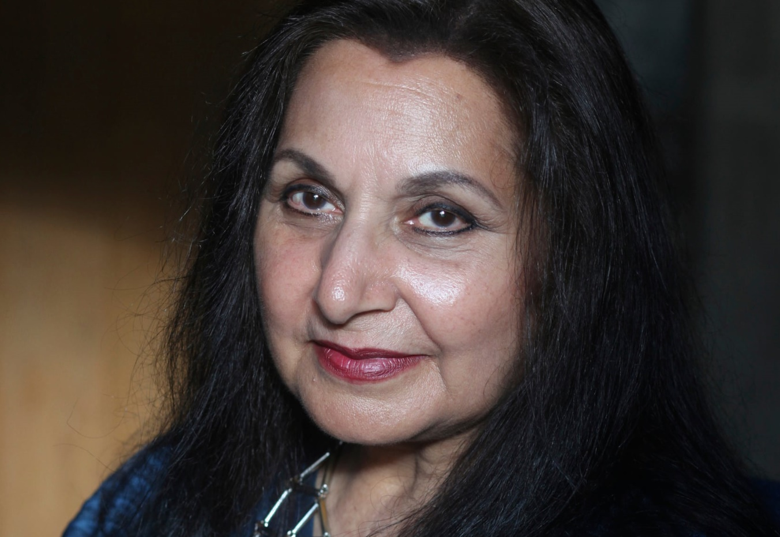

Extracts from Biography of Carol Rumens
Source: https://literature.britishcouncil.org/writer/carol-rumens

Described by Anne Stevenson as a writer ‘who retains her feminine voice but extends her sympathies beyond feminism’, Carol Rumens is perhaps the only contemporary female poet to have drawn obvious inspiration from the works of that most caricatured of male poets, Philip Larkin, whom she has admiringly described as ‘the great musician of his generation’
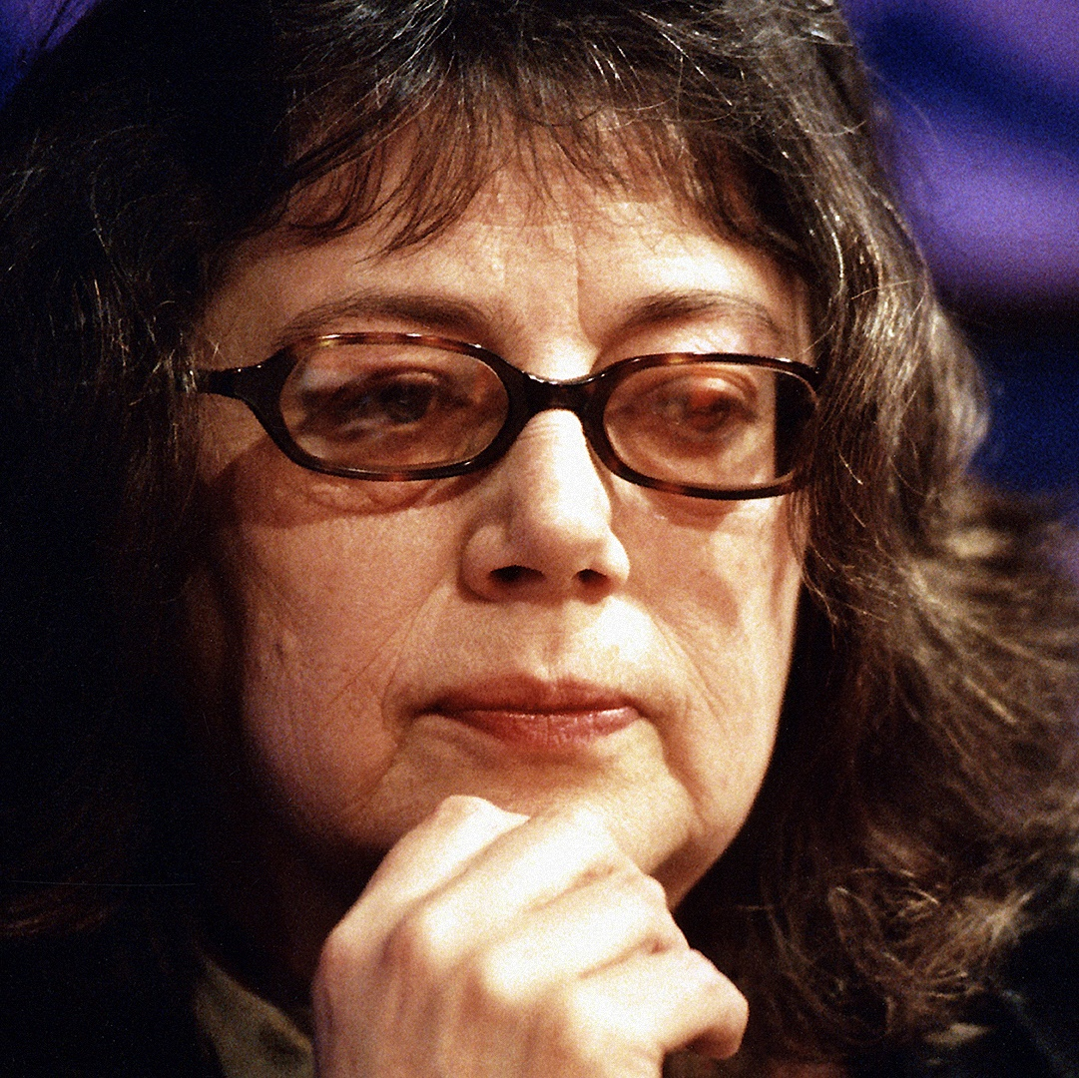

Born in 1944 in Forest Hill, South London, Rumens lived for a number of years in Belfast before moving to Bangor, South Wales, and is currently Professor of Creative Writing at the University of Hull. She has also travelled widely in Russia and Eastern Europe. As with Larkin reflecting on his time in Belfast as emphasising ‘the importance of elsewhere’ – a place that served to reaffirm his Englishness – Rumens has found foreign customs, cultures and languages the source of much poetic inspiration, but one which has arguably provoked a more complex, liberated response.
Extracts from Close readings of John Agard’s ‘Checking Out Me History’
Source: https://www.bl.uk/windrush/articles/close-readings-of-john-agards-checking-out-me-history-flag-and-half-caste

When I think of John Agard’s poetry I think of the political complexities of his work. The kind of political poetry I enjoy in Agard’s verse is the complex poetics that speak back to the source of power. This type of poetry addresses an institution or a powerful individual who has set in motion a culture that creates problems for individuals. The voice of such a poem, if high art is being created, will not simply wag a finger but will use a range of tones to explore why power was enforced in such a way and what effect it has had on the speaker, or its effect on the mass of people the speaker is representing.

Born in 1949 in what was then British Guiana, Agard moved to Britain in the late 1970s. It’s hard to see his poetry as separate from his background. He is a poet who has experienced the effects of empire both in Guyana where he spent his first two decades, and in the source of imperial power in the motherland, Britain, where he has lived for the past four decades. He has a strong Caribbean accent and he reads his work with brio, with gusto and with an energetic delivery. He stresses certain words, often holding on to a syllable for a few seconds or speeding up and glossing over words for the sake of the rhythm. This creates the impression, for me anyway, that he’s attacking the English language by refreshing the sounds of words, by placing these words in unconventional verse forms, often from the Caribbean and by using phonetics and slang that takes us away from standard English and from the Oxford English Dictionary. In addition, his syntax is often his own and represents his own natural spoken voice. When reading an Agard poem, we are constantly aware that we are not hearing a typical English poet from an elite background, but instead we are inhabiting the vowels of a minority ethnic. This deliberate refusal to mimic the voice of the national poetics is itself a Political act; it is the assertion of the Caribbean voice placed on a par with the standard voice of British poets. Agard’s poetry is published in Britain by the esteemed publisher, Bloodaxe, and this ensures that his poetry is read and heard alongside the white British poets who are his peers.

‘Checking Out Me History’ opens with an emphatic address, ‘Dem tell me’, which is repeated in the second line. From the outset, we are in the world of accusation, of a central powerbase inculcating minority ethnics. ‘Dem’ and ‘me’, with the upper case opening for each line, seems to give greater authority or menace to this collective pronoun ‘Dem’. The opening word ‘Dem’, and the smaller closing word ‘me’, of each line offers a divide, a sharp contrast which is played out in the poem. The poet feels blinded from his own identity; the white-owned historical narrative has ‘Bandage up me eye with me won history/ Bind me to me own identity’. This is a shocking idea, that someone should feel blinded, deliberately denied knowledge of his own ancestors and role models. The poem could continue a list approach by telling us what the poet has been taught – Lord Nelson, Christopher Columbus, Florence Nightingale, Robin Hood and so on. Instead, Agard uses the poem as an opportunity to educate his readership cheekily. This is the politics of subversion because Agard recommends an alternative history, such as ‘Shaka de great Zulu’ or incidents such as the one between ‘de Caribs and de Arawaks’. The poem interlaces outrage with a celebration of great world heroes. The strong and unusual rhymes and rhythms are closer to the Caribbean voice than the standard English voice, and help to emphasise the speaker’s need to honour heroic figures similar to himself.

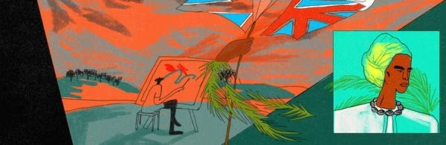
Extracts from The last kamikaze
Source: https://www.theguardian.com/world/2015/aug/11/the-last-kamikaze-two-japanese-pilots-tell-how-they-cheated-death

Hisao Horiyama first learned how he was due to die from a simple slip of white paper. On it were written three options: to volunteer willingly, to simply volunteer, or to say no. But as a 21-year-old airman caught in the thick of Japan’s faltering war with the allies, he knew there was only one choice. Without hesitation, he agreed to fly his plane into the side of a US warship. With that one act of destruction, he would end his life and the lives of many others, in the name of his emperor as a member of an elite, and supposedly invincible, group of young men whose sacrifice would deliver victory to Japan: the kamikaze. Horiyama was a young soldier in an artillery unit of the Japanese imperial army when he was drafted into the air force. It was late 1944, and the tide of war was turning against Japan. In the newly formed kamikaze, Tokyo’s military leaders envisioned a dedicated unit of ideologically conditioned warriors willing to die a glorious death for their empire.

As a devoted subject of the emperor, Horiyama longed for his moment of glory. ‘We finished our training and were given a slip of white paper giving us three options: to volunteer out of a strong desire, to simply volunteer, or to decline,’ Horiyama, now 92, told the Guardian at his home in Tokyo. A model fighter plane sits on a bookcase in the living room of the apartment he shares with his wife. In one corner are cardboard boxes stuffed with black-and-white photographs of kamikaze pilots, veterans’ newsletters, journals and newspaper cuttings.

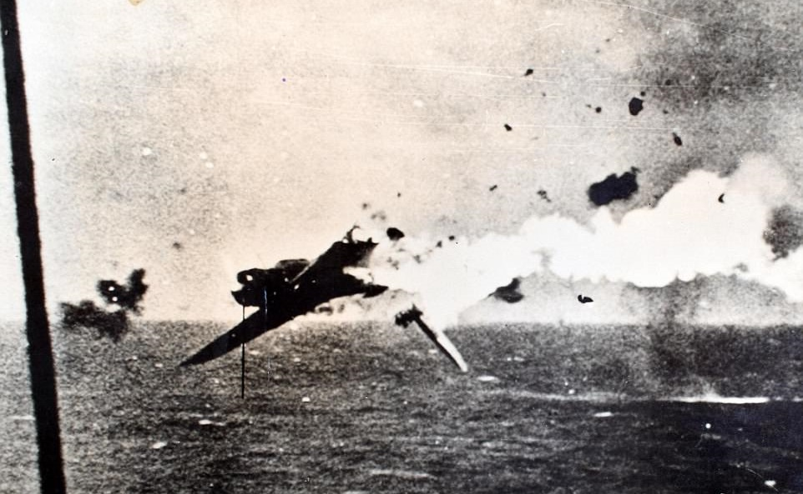

By January 1945 more than 500 kamikaze planes had taken part in suicide missions, and many more followed as fears rose of an impending US-led invasion of the Japanese mainland. By the end of the war, more than 3,800 pilots had died. Although there are still disputes over their effectiveness, suicide missions sank or caused irreparable damage to dozens of US and allied ships. For the suicide attacks to succeed, the air force and navy needed a new crop of young pilots, many of them taken from other parts of the military and from Japan’s best universities.
‘We didn’t think too much [about dying],’ Horiyama said. ‘We were trained to suppress our emotions. Even if we were to die, we knew it was for a worthy cause. Dying was the ultimate fulfilment of our duty, and we were commanded not to return. We knew that if we returned alive that our superiors would be angry.’

