**De Aston**

**English Department**

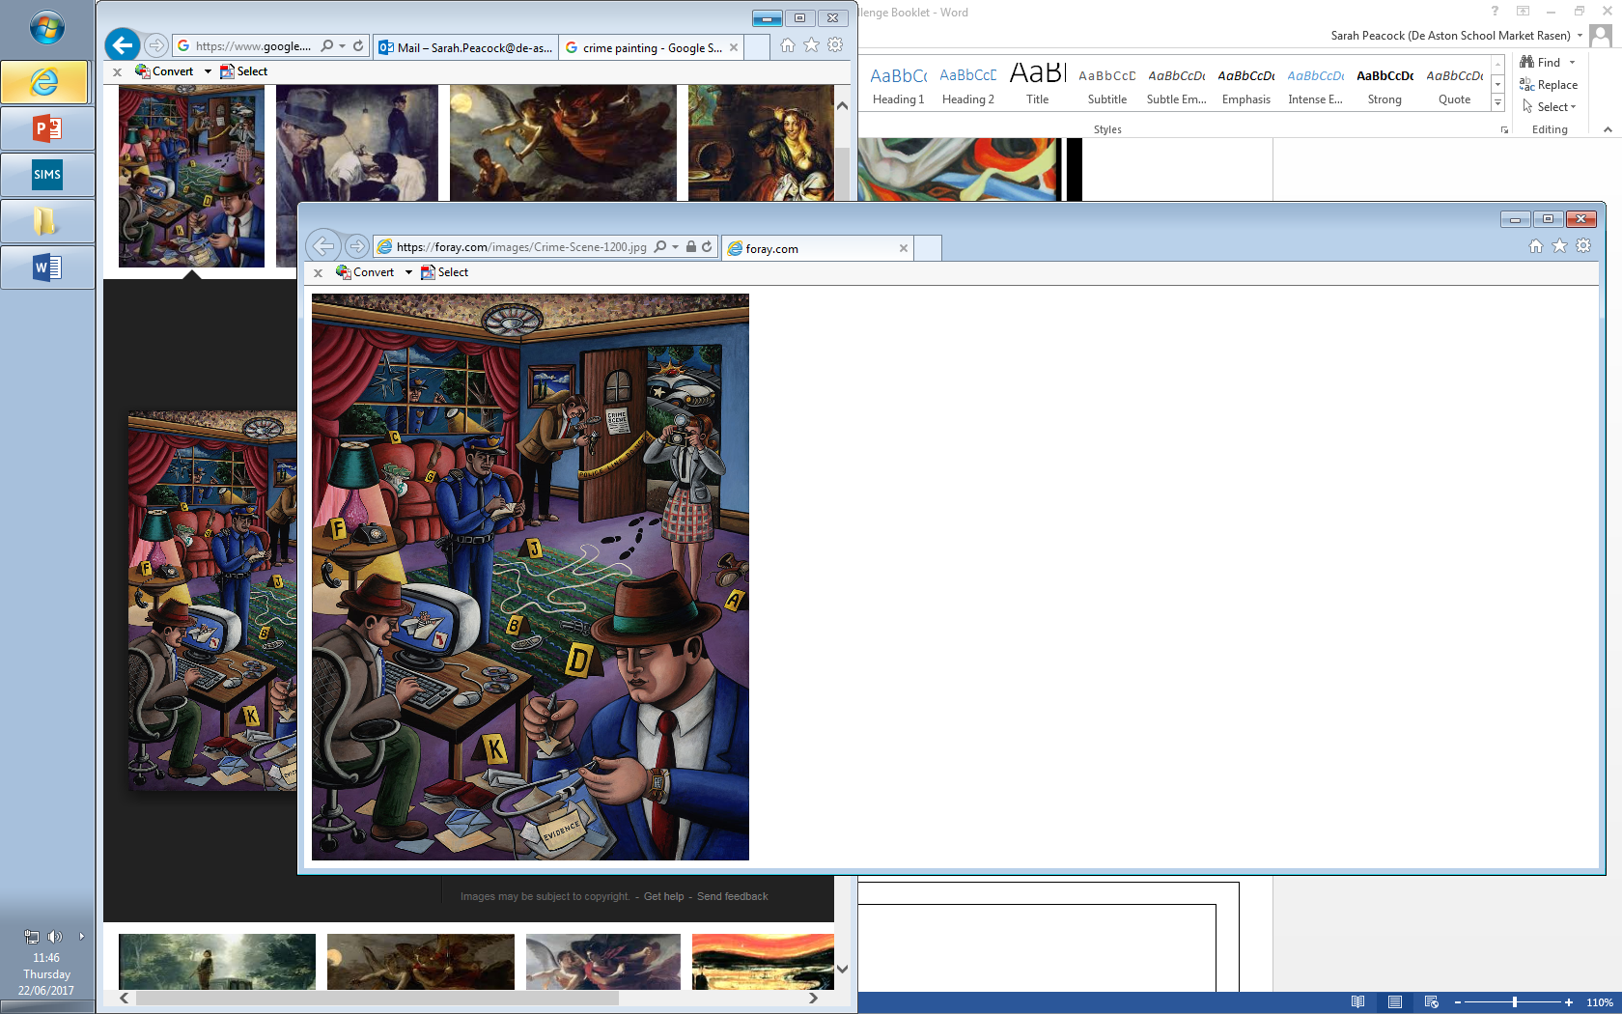

**Year 13: Crime Revision**

**Challenge Tasks**

**Name:**

**Week Two:**

Revisit Atonement and track the following themes: guilt/atonement, misunderstanding, innocence, war, setting, social class and identity.

For each, assign quotations to them from your key quotation booklet.

**Week Three:**

Revisit Brighton Rock and track the following themes: setting, class, good vs. evil, sexuality and religion.

For each, assign quotations to them from your key quotation booklet.

**Week One:**

Revise the crime fiction timeline and pay close attention to the following: detective fiction, golden age, hardboiled, noir fiction, postmodern crime.

Summarise each genre and choose one extract from each genre – conduct an unseen analysis of the extract.

**Week Four:**

Revisit the crime poetry and track the following themes: victims, criminals, criminal psyche, setting, femininity and violence.

For each, assign quotations to them from your key quotation booklet.

**Week Five:**

Remind yourself of the criticism for each text – refresh your memories and ideas by looking at reviews of the text.

**Week Six:**

Analyse as much Unseen Crime as possible – seek out a range of extracts and analyse hem for significant crime elements.

* the type of the crime text itself, whether it is detective fiction, a post-modern novel, a revenge tragedy, an account of a life lost to crime
* the settings that are created as backdrops for criminal action and for the pursuit of the perpetrators of crime: both places and times will be significant here
* the nature of the crimes and the criminals, the criminals’ motives and actions
* the inclusion of violence, murder, theft, betrayal
* the detection of the criminal and the investigation that leads to his or her capture or punishment
* how far there is a moral purpose and restoration of order
* guilt and remorse, confession and the desire for forgiveness
* the creation of the criminal and their nemesis, the typical detective hero
* the sense that there will be a resolution and the criminal will be punished
* the victims of crime and the inclusion of suffering
* the central motifs of love, money, danger and death
* punishment, justice, retribution, injustice, accusation, the legal system, criminal trials and courtroom dramas, imprisonment, death
* the structural patterning of the text as it moves through a series of crises to some sense of order
* the specific focus on plotting
* the way that language is used in the world that is created; there may be use of a criminal register, legal register, police register
* the way that crime writing is used to comment on society, particularly the representation of society at particular historical periods
* ultimately, how crime stories affect audiences and readers, creating suspense, repugnance, excitement and relief.



For more resources, including literacy support, visit www.deastonenglish.com