**De Aston**

**English Department**



**Year 12 GCSE: Language Paper1**

**Challenge Tasks**

**Name:**

**The Secret History by Donna Tartt**

The snow in the mountains was melting and Bunny had been dead for several weeks before we came to understand the gravity of our situation. He'd been dead for ten days before they found him, you know. It was one of the biggest manhunts in Vermont history – state troopers, the FBI, even an army helicopter; the college closed, the dye factory in Hampden shut down, people coming from New Hampshire, upstate New York, as far away as Boston.

It is difficult to believe that Henry's modest plan could have worked so well despite these unforeseen events. We hadn't intended to hide the body where it couldn't be found. In fact, we hadn't hidden it at all but had simply left it where it fell in hopes that some luckless passer-by would stumble over it before anyone even noticed he was missing. This was a tale that told itself simply and well: the loose rocks, the body at the bottom of the ravine with a clean break in the neck, and the muddy skidmarks of dug-in heels pointing the way down; a hiking accident, no more, no less, and it might have been left at that, at quiet tears and a small funeral, had it not been for the snow that fell that night; it covered him without a trace, and ten days later, when the thaw finally came, the state troopers and the FBI and the searchers from the town all saw that they had been walking back and forth over his body until the snow above it was packed down like ice.

**Week One:**

Q1 - Read paragraph one of the story. List four things you learn about Bunny’s death. [4 marks].

Q2 – How does the writer use language to describe what happened to the body? [8 marks]

**Week Two:**

Q3 - You now need to think about the whole of the Source.

This text is from the opening of a novel.

How has the writer structured the text to interest you as a reader? You could write about:

• what the writer focuses your attention on at the beginning

• how and why the writer changes this focus as the Source develops

* any other structural features that interest you. [**8** **marks]**

**Week Three:**

After reading this opening, a student observed that "The start of the novel suggests the rest wil be violent and bloody."

To what extent do you agree? In your response, you could:

• write about your own impressions of the characters

• evaluate how the writer has created these impressions

• support your opinions with references to the text.

**20 marks**

**Week Four:**

Write the opening of a story that begins with the lines: "Where do they go? There is nowhere in the world where they belong."

Remember to use descriptive language devices, paragraphs and SPAG.

**Week Five:**

Write the middle part of a story that involves a place that has been damaged by war.

Remember to use descriptive language devices, paragraphs and SPAG.



**Week Six:**

Write a description inspired by this image.

Remember to use descriptive language devices, paragraphs and SPAG.

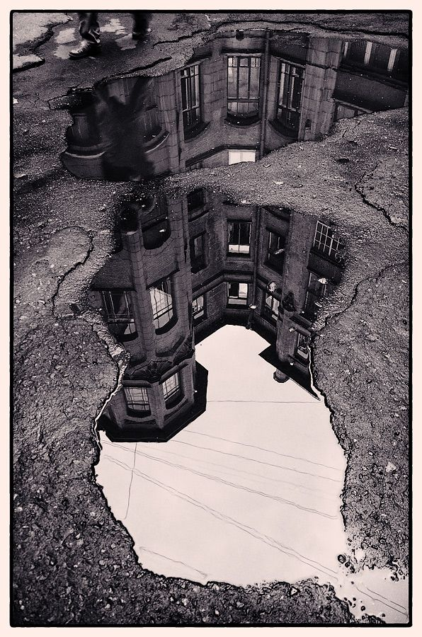

**Final challenge:**

Read as much fiction as you can. Ask your teacher for some recommendations.

Educate and inform yourself.

For more resources, including literacy support, visit www.deastonenglish.com