**De Aston**

**English Department**

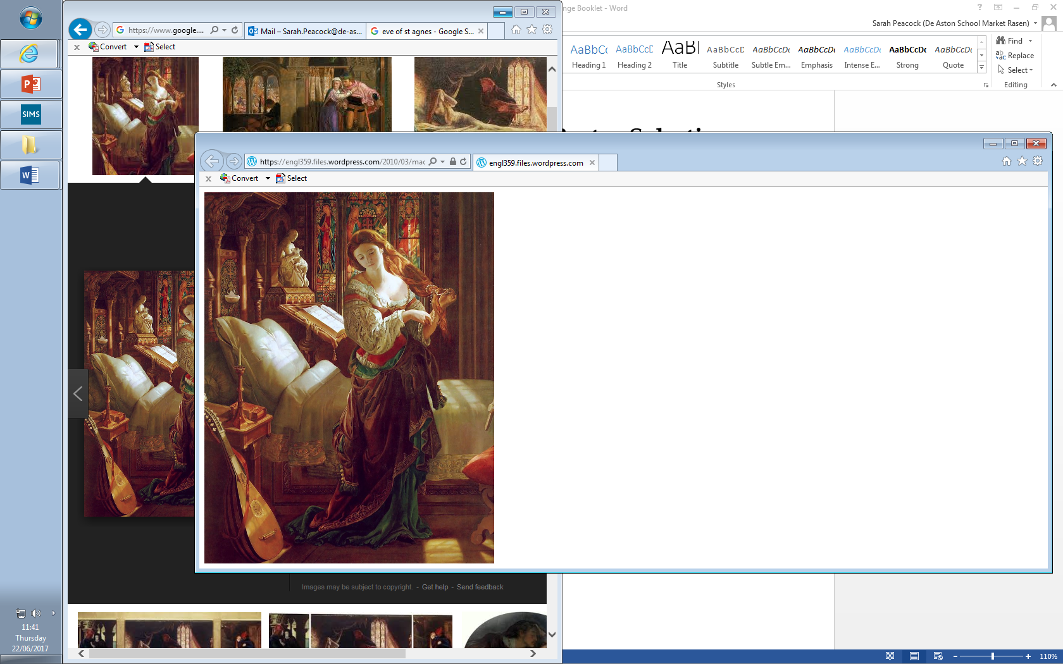

**Year 13: Keats Revision**

**Challenge Tasks**

**Name:**

**Week Two:**

Select five quotations from each of the poems and annotate them for language devices.

Learn them and revise them!

Consider: tragic victims/heroes, setting, fate, inevitability to help.

**Week Three:**

Using your learnt quotations from last week, plan an essay response to the following question:

‘The protagonist’s loss of identity is often the most harrowing aspect of the tragic experience.’

To what extent do you agree with this view in relation to the two texts you have studied?

Challenge: plan for DOAS too! It’s a good way to revise.

**Week One:**

Conduct a feminist reading of each of Keats’ poems – consider the portrayal and treatment of female characters in each of his poems and write a brief commentary for each poem using quotations to support your ideas:

* Belle Dame
* Lamia
* Madeleine
* Isabella

**Week Four:**

Using your learnt quotations, plan an essay response to the following question:

‘Tragedies are ultimately pessimistic and leave us with little hope’

To what extent do you agree with this view in relation to the two texts you have studied?

Challenge: plan for DOAS too! It’s a good way to revise.

**Week Five:**

Using your learnt quotations, plan an essay response to the following question:

‘Women are reduced to victimhood in tragedies’

To what extent do you agree with this view in relation to the two texts you have studied?

Challenge: plan for DOAS too! It’s a good way to revise.

**Week Six:**

Using your learnt quotations, plan an essay response to the following question:

‘Tragedies delight in depicting overwhelming suffering’

To what extent do you agree with this view in relation to the two texts you have studied?

Challenge: plan for DOAS too! It’s a good way to revise.



For more resources, including literacy support, visit www.deastonenglish.com