**De Aston**

**English Department**

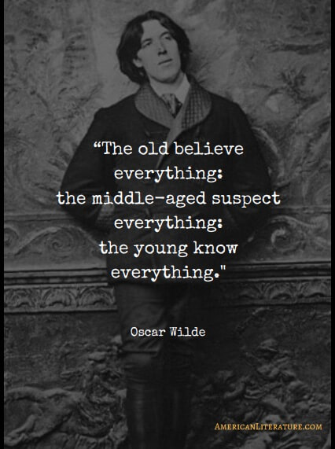

**Year 9: Victorian Class Reader**

**Challenge Tasks**

**Name:**

**Week Two:**

Gothic writing often contains stock characters and settings. This week, choose a challenge task:

**Hard** – create your own Victorian gothic villain and write two paragraphs describing them;

**Harder** – create your own Victorian gothic villain and write two paragraphs about their backstory;

**Hardest** – create your own Victorian gothic villain and write two paragraphs about their backstory and why you think they would make a good character in a gothic story.

**Week Three:**

Now you know all about Dorian Gray, choose a challenge!

**Hard** – Write a diary entry as Dorian Gray describing a typical day in his life.

**Harder** – You find the portrait! Describe what it looks like in your own words!

**Hardest** – Imagine you are Dorian’s friend. Write him a letter giving him some good advice.

**Week One:**

This week you will have learnt about the Victorian era. Choose one of the tasks below to demonstrate your understanding of the Victorian period. You can work individually or with a partner.

* A rap or poem about the Victorian time;
* A diary entry about a day in the life of a Victorian (be clear which class they belong to);
* Create a textbook page about Victorian London explaining exactly what life would have been like then for both rich and poor.

Be creative but be prepared to justify your choices and how they show your understanding of this era.

**Week Four-Six:**

Now it’s time for some project work. This project will take you two weeks to complete. With a partner or on your own, choose a task below.

1. Create a timeline for Oscar Wilde’s life.
2. Write your own story set during Victorian times – it must feature a painting of some description.
3. Write a monologue delivered by a Victorian prisoner in jail for a crime they don’t believe deserved a prison sentence.

**Additional challenge tasks:**

Make sure you understand what each of these words means and show your understanding by trying to use them in your classwork. Then learn how to spell them – be ready for a spelling test in the last week of term.

**Hard:**

1. protagonist 2. Connotation 3. Superficial 4. Society 5. Negative

**Harder:**

1. Consequence 2. Philosophy 3. Fundamental 4. Purification 5. Discord

**Hardest:**

1. omniscient 2. Sardonic 3. Illegitimacy 4. Perpetual 5. Depravity

**Final challenge:**

Finally, challenge yourself to read one of the classic Victorian texts, such as *Jane Eyre* by Charlotte Bronte, *Bleak House* by Charles Dickens, *The Time Machine* by H.G Wells or *Sherlock Holmes* by Arthur Conan Doyle.

**Bonus week:**

Read the extract below from *Wuthering Heights* and complete the ‘all’ question and one more of the questions below:

**All:** list four things you learn about Mr Heathcliffe.

**Hard:** what genre is the text and how do you know?

**Harder:** how does the writer use language to interest the reader?

**Hardest:** To what extent is Mr Heathcliffe portrayed as a welcoming character?

Chapter 1:

1801. - I have just returned from a visit to my landlord - the solitary neighbour that I shall be troubled with. This is certainly a beautiful country! In all England, I do not believe that I could have fixed on a situation so completely removed from the stir of society. A perfect misanthropist's heaven: and Mr. Heathcliff and I are such a suitable pair to divide the desolation between us. A capital fellow! He little imagined how my heart warmed towards him when I beheld his black eyes withdraw so suspiciously under their brows, as I rode up, and when his fingers sheltered themselves, with a jealous resolution, still further in his waistcoat, as I announced my name. 'Mr. Heathcliff?' I said.

A nod was the answer.

'Mr. Lockwood, your new tenant, sir. I do myself the honour of calling as soon as possible after my arrival, to express the hope that I have not inconvenienced you by my perseverance in soliciting the occupation of Thrushcross Grange: I heard yesterday you had had some thoughts - '

'Thrushcross Grange is my own, sir,' he interrupted, wincing. 'I should not allow any one to inconvenience me, if I could hinder it - walk in!'

The 'walk in' was uttered with closed teeth, and expressed the sentiment, 'Go to the Deuce:' even the gate over which he leant manifested no sympathising movement to the words; and I think that circumstance determined me to accept the invitation: I felt interested in a man who seemed more exaggeratedly reserved than myself.

When he saw my horse's breast fairly pushing the barrier, he did put out his hand to unchain it, and then sullenly preceded me up the causeway, calling, as we entered the court, - 'Joseph, take Mr. Lockwood's horse; and bring up some wine.



For more resources, including literacy support, visit www.deastonenglish.com