**De Aston**

**English Department**

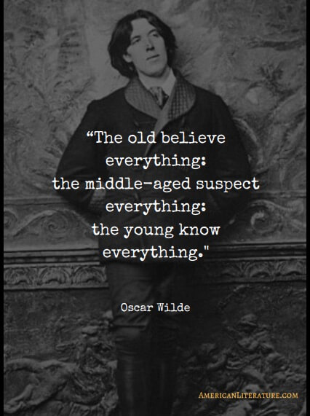

**Year 9: Victorian Class Reader**

**Challenge Tasks**

**Name:**

**Week Four:**

Some have argued that Dorian Gray is a villain; others describe him as an anti-hero. An anti-hero is a central character who lacks heroic attributes. A villain is a character whose evil actions are central to the plot. Which of these terms do you think best describes Dorian Gray? Write two paragraphs explaining your answer.

**Week Three:**

The Picture of Dorian Gray incorporates many Gothic elements: the devil, a curse, supernatural elements, a secret room, violence, an anti-hero and the doppelganger.

**Hard** – for each element, write a sentence explaining its role in the novel;

**Harder** – plan your own story that includes all these elements;

**Hardest** – write your own short story (no more than one side of A4) that includes all these elements.

**Week Two:**

Gothic writing often contains stock characters and settings. This week, choose a challenge task:

**Hard** – create your own Victorian villain and write two paragraphs describing them;

**Harder** – create your own Victorian villain and write two paragraphs about their backstory;

**Hardest** – create your own Victorian villain and write two paragraphs about their backstory and explain what their role would be in a gothic story.

**Week One:**

This week you have begun to read the Picture of Dorian Gray, and met the characters Dorian, Henry and Basil. This week your task is to write a diary entry in role as one of these characters. Remember a diary entry mainly focuses on thoughts and feelings, so you should recount the events of the day but also explain your thoughts and feelings about the other characters.

**Week Five:**

At various points in the novel, Dorian regrets his actions and wants to be good again. Imagine you are Dorian’s friend and he writes to you asking for advice. Write your reply, advising him on how he can make up for his past misdeeds and how he can behave more morally in the future.

**Week Six:**

Imagine you see the portrait just before Dorian destroys it – at this point it is at its most gruesome. Remember that the portrait is of Dorian himself, and every time he has behaved badly in his real life, the portrait has grown more ugly to reflect this. Write a description of the portrait, aiming to use similes, metaphors and personification. It can also be effective to zoom in on particular details.

For inspiration, see: <https://www.artic.edu/artworks/93798/picture-of-dorian-gray>

**Bonus week:**

Read the extract below from *Wuthering Heights* and complete the ‘all’ question and one more of the questions below:

**All:** list four things you learn about Mr Heathcliffe.

**Hard:** what genre is the text and how do you know?

**Harder:** how does the writer use language to interest the reader?

**Hardest:** To what extent is Mr Heathcliffe portrayed as a welcoming character?

Chapter 1:

1801. - I have just returned from a visit to my landlord - the solitary neighbour that I shall be troubled with. This is certainly a beautiful country! In all England, I do not believe that I could have fixed on a situation so completely removed from the stir of society. A perfect misanthropist's heaven: and Mr. Heathcliff and I are such a suitable pair to divide the desolation between us. A capital fellow! He little imagined how my heart warmed towards him when I beheld his black eyes withdraw so suspiciously under their brows, as I rode up, and when his fingers sheltered themselves, with a jealous resolution, still further in his waistcoat, as I announced my name. 'Mr. Heathcliff?' I said.

A nod was the answer.

'Mr. Lockwood, your new tenant, sir. I do myself the honour of calling as soon as possible after my arrival, to express the hope that I have not inconvenienced you by my perseverance in soliciting the occupation of Thrushcross Grange: I heard yesterday you had had some thoughts - '

'Thrushcross Grange is my own, sir,' he interrupted, wincing. 'I should not allow any one to inconvenience me, if I could hinder it - walk in!'

The 'walk in' was uttered with closed teeth, and expressed the sentiment, 'Go to the Deuce:' even the gate over which he leant manifested no sympathising movement to the words; and I think that circumstance determined me to accept the invitation: I felt interested in a man who seemed more exaggeratedly reserved than myself.

When he saw my horse's breast fairly pushing the barrier, he did put out his hand to unchain it, and then sullenly preceded me up the causeway, calling, as we entered the court, - 'Joseph, take Mr. Lockwood's horse; and bring up some wine.

**Additional challenge tasks:**

Make sure you understand what each of these words means and show your understanding by trying to use them in your classwork. Then learn how to spell them – be ready for a spelling test in the last week of term.

**Hard:**

1. protagonist 2. Connotation 3. Superficial 4. Society 5. Negative

**Harder:**

1. Consequence 2. Philosophy 3. Fundamental 4. Purification 5. Discord

**Hardest:**

1. omniscient 2. Sardonic 3. Illegitimacy 4. Perpetual 5. Depravity

**Final challenge:**

Finally, challenge yourself to read one of the classic Victorian texts, such as *Jane Eyre* by Charlotte Bronte, *Bleak House* by Charles Dickens, *The Time Machine* by H.G Wells or *Sherlock Holmes* by Arthur Conan Doyle.



For more resources, including literacy support, visit www.deastonenglish.com