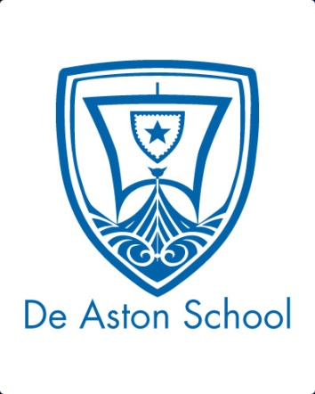**De Aston**

**English Department**

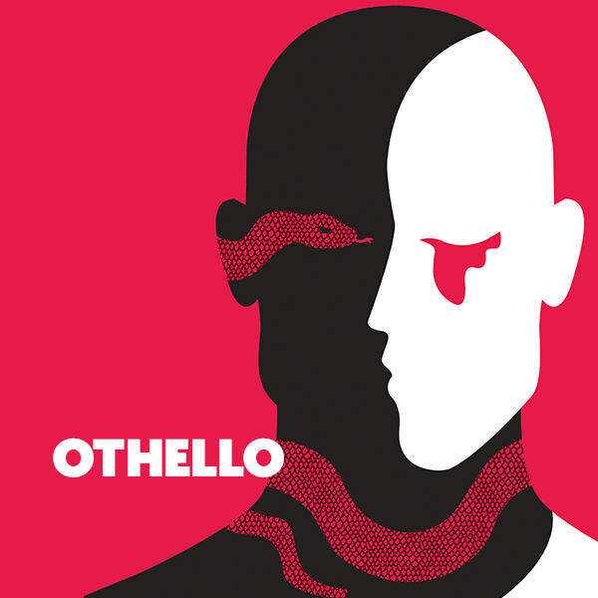

**Year 12: Othello**

**Academic Excellence Booklet**

**Activity 1 – A.C. Bradley**

a. Bradley believes that Hamlet would have dealt with Iago – research the play Hamlet and note down how it fits the tragic hero mould. Then engage with A.C. Bradley’s hypothesis – would Hamlet have dealt with Iago?

b. Bradley also believes that Iago possesses a ‘heroic villainy’ – what do you believe he means by this statement and do you agree?

c. Bradley discusses at length the latent homosexuality in the text – do you believe Iago is motivated by sexual rejection or desire for Othello?

d. Bradley identifies one of Othello’s tragic flaws to be his belief in his own myth – how is this evident in the play?

**Activity 2 – Bloom**

1. Famously, Bloom called the play ‘Othello’s tragedy but Iago’s play’ – what do you believe he means by this and do you agree?
2. While Bradley discusses the latent homosexuality in the play, Bloom believes that Iago possesses a quasi-religious worship of the war god Othello – how is this view evident in the play?

**Activity 3 - Race**

1. Research race in Shakespearean plays, particularly the tragedies – what other representations are there and how are they portrayed?
2. Othello’s race is mentioned a lot in the play, namely by the protagonist himself. Track how race is described in the following ways in the play and then judge which one you believe to be the most significant:

* Physically
* Visually
* Psychologically
* Symbolically
* Morally
* Religiously

**Activity 4 - Leavis**

1. Leavis believed ‘Othello is responsible for own downfall’ as Iago targets existing flaws such as Othello’s predisposition to jealousy and his tendency to be self-obsessed. To what extent do you agree?

**Activity 5 – Zeitgeist**

1. Shakespeare often used the cultural and social beliefs of his day to produce his plays, meaning they were zeitgeist (of the time). As a result, research and then answer how the play demonstrates the following views in 16th/17th century England: Xenophobia, miscegenation, promiscuity, gender.



For more resources, including literacy support, visit www.deastonenglish.com