De Aston
English Department

Year 12: Language Paper 1
Academic Excellence Booklet

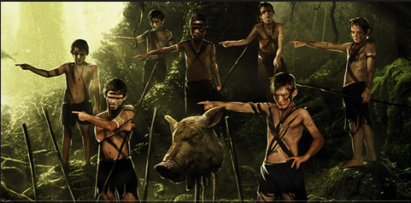
Do now: Lord of the Flies!
by William Golding (1954)
In the midst of a raging war, a plane evacuating a group of schoolboys from Britain is shot down over a deserted tropical island. Two of the boys, Ralph and Piggy, discover a conch shell on the beach, and Piggy realizes it could be used as a horn to summon the other boys. Once assembled, the boys set about electing a leader and devising a way to be rescued. They choose Ralph as their leader, and Ralph appoints another boy, Jack, to be in charge of the boys who will hunt food for the entire group.
Ralph, Jack, and another boy, Simon, set off on an expedition to explore the island. When they return, Ralph declares that they must light a signal fire to attract the attention of passing ships. The boys succeed in igniting some dead wood by focusing sunlight through the lenses of Piggy’s glasses. However, the boys pay more attention to playing than to monitoring the fire, and the flames quickly engulf the forest. A large swath of dead wood burns out of control, and one of the youngest boys in the group disappears, presumably having burned to death.
- When was book written?
- The book is set in Britain during what?
- Name the 2 boys who find the shell:
- What does Ralph declare they must do?
- What happens because the boys aren’t concentrating?
- TRICKY: Line 7 what does ‘assembled’ mean?
- TRICKY: Line 15 what does ‘presumably’ mean?
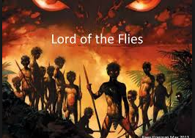
TASK 2: The opening paragraph of
The boy with the fair hair lowered himself down the last few feet of rock and began to pick his way towards the lagoon. Though he had taken off his school sweater and trailed it now from one hand, his grey shirt stuck to him and his hair was plastered to his forehead. All round him the long scar, smashed among the creepers and broken trunks, was a bath of heat. He was clambering heavily among the creepers when a bird, a vision of red and yellow, flashed upwards with a witch-like cry; and this cry was echoed by another.
"Lord of the Flies" by William Golding (1954)
Can you identify the word type, sentence type or other feature in each example?
Tip 1: Use your glossary card to help you!
Tip 2: find the word/quote in the text to help you identify what it is
boy
his school sweater
plastered
trailed
a bath of heat
heavily
when a bird, a vision of red and yellow, flashed upwards
with a witch-like cry;
creepers
the long scar
TASK 3: The opening paragraph of
The boy with the fair hair lowered himself down the last few feet of rock and began to pick his way towards the lagoon. Though he had taken off his school sweater and trailed it now from one hand, his grey shirt stuck to him and his hair was plastered to his forehead. All round him the long scar, smashed among the creepers and broken trunks, was a bath of heat. He was clambering heavily among the creepers when a bird, a vision of red and yellow, flashed upwards with a witch-like cry; and this cry was echoed by another.
2. Look at paragraph and list 4 things about the island location:
1. ……………………………………………………………………………………………………………….
2. ……………………………………………………………………………………………………………..
3. …………………………………………………………………………………………………………………..
4. ……………………………………………………………………………………………………………………..
3. What’s the temperature? How can you tell? ……………………………………………………………………..
. ………………………………………………………………………………………………………………………………………….
4. Look at the lines carefully – do you think the boy is having a good time? Why or why not?
………………………………………………………………………………………………………………………………………………
5. Does the location sound much like Britain (the boy is British)? Yes, no, why?………………
………………………………………………………………………………………………………………………………………………
6. Are there any words that make the location sound unwelcoming / not enjoyable?.............
…………………………………………………………………………………………………………………………………………….
7.Do you think the boy has a decent chance of surviving on this island? Yes, no, why?
...........................................................................................................................................................................................................................................................................................

Question 2 example: How does the writer use language to present the island location to us?
Please read my Level 2 answer – this would be awarded 3 marks (out of 8):
The writer presents the location as hot, tropical and uncomfortable for the boy. It says he “lowered” himself and begin to “pick” his way along. These words make it sound as if he is moving slowly. The things described sound very different to Britain too such as the “bird, a vision of red and yellow, flashed upward with a witch-like cry.”
This is what the answer is missing to raise it to Level 3, worth 5-6 marks:
Terminology to add: verbs nouns simile
LO (This suggests…) bits to add and complete:
He’s moving slowly- this might suggest the island is …….
“Witch-like” suggests the bird sounds/makes the boy feel.. ….
Reader response bit to add and complete:
This makes me understand that the island is….
This makes me imagine….
This makes me wonder if…..

Can you re-write and extend my answer, adding and completing the missing parts?
………………………………………………………………………………………………………………………………………………………………….
……………………………………………………………………………………………………………………………………………………………………
………………………………………………………………………………………………………………………………………………………………….
………………………………………………………………………………………………………………………………………………………………….
…………………………………………………………………………………………………………………………………………………………………..
………………………………………………………………………………………………………………………………………………………………….
………………………………………………………………………………………………………………………………………………………………..
……………………………………………………………………………………………………………………………………………………………….
………………………………………………………………………………………………………………………………………………………………
………………………………………………………………………………………………………………………………………………………………….
……………………………………………………………………………………………………………………………………………………………………
………………………………………………………………………………………………………………………………………………………………….
………………………………………………………………………………………………………………………………………………………………….
……………………………………………………………………………………………………………………………………………………………………
………………………………………………………………………………………………………………………………………………………………….

This is the Level 3, 6 mark, answer as I would write it – how similar are yours and my attempts? Highlight any parts of yours and my answers that are the same/similar.
The writer presents the location as hot, tropical and uncomfortable for the boy. It says he “lowered” himself and begin to “pick” his way along. These verbs make it sound as if he is moving slowly this might suggest he isn’t used to nature like this and the island seems difficult and dangerous to cope with. The nouns described sound very different to Britain too such as the “bird, a vision of red and yellow, flashed upward with a witch-like cry.” The bird is brightly-coloured which makes me imagine a beautiful tropical bird, but the simile “witch-like” suggests the bird sounds so strange the boy is scared of it, because witches are things we link with evil and the supernatural. These features make me understand the island is terrifyingly different for the British school-boys who probably don’t know how they’ll survive on it.

Self-evaluation:
Did you add in the terminology in the right places, the same as me?
Did you make a “this suggests…” (LO) that made sense with the quote?
Did you add a “this makes me feel/understand/imagine/wonder” about the island (QR)?

What part of this activity did you find trickiest? (This will tell me which part of the question to help you with until you are confident!)

EXTENSION: Question 3 practice: How does the writer use structure to interest the reader? Read this – the first whole page of Lord of the Flies
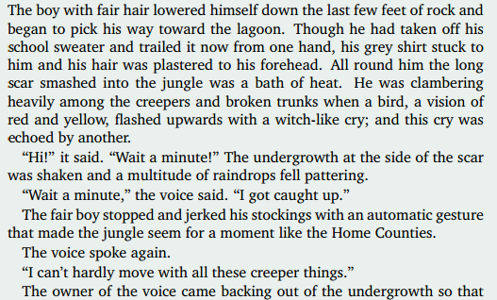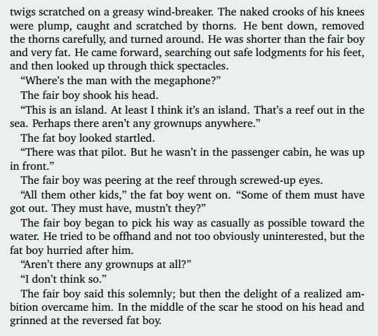
Now see the question on the next page –

Question 3: How has the writer used structure to interest the reader?
- The start: The first paragraph describes who, doing what? . …………………………………
………………………………………………………………………………………………………………………………………….
- In that first paragraph, the island is presented as a unfamiliar (strange) place for the boy and as quite unnerving/scary for him. Give me 1 quote to use as evidence for this:
……………………………………………………………………………………………………………………………………
- The middle section of the extract is a conversation where the ‘fat boy’ talks much more than the other boy and he is described as ‘scratched’ and covered in ‘thorns.’
How does this part further show the island is quite an unusual and scary place for the boys? …………………………………………………………………………………………………………………………
……………………………………………………………………………………………………………………………………….
- The ‘fat boy’ and the ‘fair boy’ seem different in this section – the ‘fat boy’ talks a lot and follows the more quiet ‘fair boy’ even though he doesn’t ask him to. As a reader, what do you think might happen/wonder/expect about these two characters as the story goes on? …………………………………………………………………………………………………………
……………………………………………………………………………………………………………………………….
……………………………………………………………………………………………………………………………….
- At the end of this opening page the boys realised that there aren’t any ‘grown-ups at all’ and they ‘grin’ at each other. How is this a suspenseful way to end the opening page? How might this realisation have a big impact on the boys and what they do next? ………………………………………………………………………………………………………………………..
……………………………………………………………………………………………………………………………………
…………………………………………………………………………………………………………………………………
………………………………………………………………………………………………………………………………

If you ask yourself the same kind of questions when you read whatever extract you get in an exam, and put your answers into sentences, you will achieve high marks in this question!

Question 4 practice:

One reader of Lord of the Flies said “It’s interesting to put young adult characters in a new, strange place with no adults. This sets up a story where anything could happen.”

To what extent do you agree with this? Using quotes from the text, explain some reasons why you agree.

I agree that creating a story where teenagers are put into a new, strange place with no adults is an interesting idea. Firstly, …………………………………………………………………..
……………………………………………………………………………………………………………………………………
…………………………………………………………………………………………………………………………………
………………………………………………………………………………………………………………………………
……………………………………………………………………………………………………………………………………
…………………………………………………………………………………………………………………………………
………………………………………………………………………………………………………………………………
……………………………………………………………………………………………………………………………………
…………………………………………………………………………………………………………………………………
………………………………………………………………………………………………………………………………
……………………………………………………………………………………………………………………………………
…………………………………………………………………………………………………………………………………
………………………………………………………………………………………………………………………………
……………………………………………………………………………………………………………………………………
…………………………………………………………………………………………………………………………………
………………………………………………………………………………………………………………………………
……………………………………………………………………………………………………………………………………
…………………………………………………………………………………………………………………………………
………………………………………………………………………………………………………………………………
……………………………………………………………………………………………………………………………………
…………………………………………………………………………………………………………………………………
………………………………………………………………………………………………………………………………
……………………………………………………………………………………………………………………………………
…………………………………………………………………………………………………………………………………
……………………………………………………………………………………………………………………………………………………………………………………………………………………………………………………………………
As long as you make logical points with reference to the text you will get marks here. (Remember you don’t actually have to agree deep down with the statement, just agree to answer the question!)

Question 5 practice:

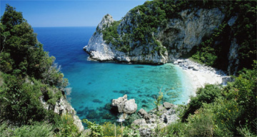
Write a description using this image as inspiration:

OR write the beginning of a narrative based on the idea of crashing onto a deserted island.
…………………………………………………………………………………………………………………………………
………………………………………………………………………………………………………………………………
……………………………………………………………………………………………………………………………………
…………………………………………………………………………………………………………………………………
………………………………………………………………………………………………………………………………
……………………………………………………………………………………………………………………………………
…………………………………………………………………………………………………………………………………
………………………………………………………………………………………………………………………………
……………………………………………………………………………………………………………………………………
…………………………………………………………………………………………………………………………………
………………………………………………………………………………………………………………………………
……………………………………………………………………………………………………………………………………
…………………………………………………………………………………………………………………………………
………………………………………………………………………………………………………………………………
……………………………………………………………………………………………………………………………………
…………………………………………………………………………………………………………………………………
………………………………………………………………………………………………………………………………
……………………………………………………………………………………………………………………………………
…………………………………………………………………………………………………………………………………
………………………………………………………………………………………………………………………………
……………………………………………………………………………………………………………………………………
…………………………………………………………………………………………………………………………………
………………………………………………………………………………………………………………………………………………………………………………………………………………………………………………………………………………………………………………………………………………………………………………………………………
………………………………………………………………………………………………………………………………
……………………………………………………………………………………………………………………………………
…………………………………………………………………………………………………………………………………
………………………………………………………………………………………………………………………………
……………………………………………………………………………………………………………………………………
…………………………………………………………………………………………………………………………………
………………………………………………………………………………………………………………………………
……………………………………………………………………………………………………………………………………
…………………………………………………………………………………………………………………………………
………………………………………………………………………………………………………………………………
……………………………………………………………………………………………………………………………………
…………………………………………………………………………………………………………………………………
………………………………………………………………………………………………………………………………
……………………………………………………………………………………………………………………………………
…………………………………………………………………………………………………………………………………
………………………………………………………………………………………………………………………………
……………………………………………………………………………………………………………………………………
…………………………………………………………………………………………………………………………………
………………………………………………………………………………………………………………………………
……………………………………………………………………………………………………………………………………
…………………………………………………………………………………………………………………………………
……………………………………………………………………………………………………………………………………
…………………………………………………………………………………………………………………………………
………………………………………………………………………………………………………………………………
……………………………………………………………………………………………………………………………………
…………………………………………………………………………………………………………………………………
………………………………………………………………………………………………………………………………
……………………………………………………………………………………………………………………………………
…………………………………………………………………………………………………………………………………
………………………………………………………………………………………………………………………………
……………………………………………………………………………………………………………………………………
…………………………………………………………………………………………………………………………………

