Year 7: Independent Learning Timetable
This timetable is planned for x3 hours a week of English. Do feel free to email teachers highlighted work to mark:
7E and 7S – Elizabeth.Masterman@de-aston.lincs.sch.uk
7A and 7N – Marrianne.Laine@de-aston.lincs.sch.uk
7O and 7D – Georgina.Clark@de-aston.lincs.sch.uk
7T – Chloe.Mead@de-aston.lincs.sch.uk
Misc. or technical issues – Sarah.Peacock@de-aston.lincs.sch.uk
Week 1 – w.b. 23/3/20 | Lesson 1: Imagery and Metaphors  In the lyrics below, Nat King Cole sings about the end of a relationship using personification and metaphors.  - Label three places that he uses personification, and three places he uses a metaphor.  "Stardust" – Nat King Cole  And now the purple dusk of twilight time  Steals across the meadows of my heart  High up in the sky the little stars climb  Always reminding me that we're apart  You wander down the lane and far away  Leaving me a song that will not die  Love is now the stardust of yesterday  The music of the years gone by  Sometimes I wonder why I spend  The lonely night dreaming of a song  The melody haunts my reverie  And I am once again with you  When our love was new  And each kiss an inspiration  But that was long ago  Now my consolation  Is in the stardust of a song  Write a paragraph explaining the effect of the personification and/or the metaphors. Make sure you use evidence from the song, and think about the connotations of individual words.  If you can, have a go at writing the next verse of the song.
Lesson 2:
“Imagine” – John Lennon
Imagine there's no countries
It isn't hard to do
Nothing to kill or die for
And no religion, too
Imagine all the people
Living life in peace
You, you may say I'm a dreamer
But I'm not the only one
I hope someday you will join us
And the world will be as one

- In this famous song, John Lennon talks about his wish for our world. What do you think his wish is? Use evidence from the text.

- John Lennon talks directly to the listener, by saying ‘you’. How does this make the listener feel? Use evidence from the text.

Choose a world issue that you feel strongly about (poverty, recycling, animals close to extinction) and write a 10-line verse for the second half of this song. Begin with ‘Imagine’. Explain, after writing your verse, how you used language to impact the listener.

Lesson 3:
- From your studies of Alice in Wonderland, answer the following question: Alice in Wonderland is all about the loss of innocence. To what extent do you agree?
Plan your answer before starting, considering both sides of the argument. Make sure you have a good understanding of the word ‘innocence’. Do you think Alice matures in the text?
(In your answer you should use the key words: surrealism, etiquette, protagonist, identity. Also, use evidence from the text. The full text of Alice in Wonderland can be found easily online.)
Send your written answer to your teacher.

Week 2 – w.b. 30/3/20 | Lesson 1: Open up the booklet called ‘Year 7 English Booklet’ and complete activities 1 and 2.  Lesson 2: Open up the booklet called ‘Year 7 Booklet 2’ and complete the activities on pages 2 and 3. Send this work to your teacher.  Lesson 3: Imagine you are in the crowd at a carnival. Describe what you can hear, see and how you feel. Make sure you check your SPAG and write in paragraphs.  Aim to use the following words in your writing: flamboyant, raucous, vivid, illuminated, applaud, jubilant, gleeful, electrifying.
Week 3 – w.b. 20/4/20 | Lesson 1: Open up the booklet called ‘Year 7 English Booklet’ and complete activities on pages 5-6.  Lesson 2: Open up the booklet called ‘Year 7 Booklet 2’ and complete the activities on page 4. Send this work to your teacher.  Lesson 3: Imagine you are selling a tropical island. Write a persuasive speech selling the island using personal pronouns, emotive language, facts/statistics, rhetorical questions and alliteration.  Aim to use the following words in your writing: utopian, superlative, incomparable, unrivalled, unsurpassed, tranquil, serene, captivating, enticing, beguiling, mesmerising. Send this work to your teacher.
Week 4 – w.b. 27/4/20 | Lesson 1: Open up the booklet called ‘Year 7 English Booklet’ and complete activities on page 7. Send this work to your teacher.  Lesson 2: Read the following poem and identify which words show the theme of change. Then write one paragraph answering the question: How does the poet use language to show change?  The Summer season gradually fades away,  Nature's way of bidding a humble farewell to all.  A change is seen as the leaves fade in unison  As the beautiful Autumn season comes to call.  September - the sounds in the garden are quiet now,  The song birds are no longer to be found.  Flying high up in the cloudy sky,  Many feathered friends are southward bound.  October - the trees are covered with tantalizing colors  Of red and gold and yellow and even brown,  And crimson, too, in a multitude of fashion  The leaves come wafting down.  November - fringed with frost and nippy cold,  The fading days of Autumn are everywhere.  A quiet state of melancholy days  With signs of a changing season in the air.  December - All of a sudden the winds of winter blow,  The falling snow begins to pile high.  We are delighted for the bounty Autumn has provided,  Uttering words of thank you - with an appreciative sigh.  Lesson 3: Explain your opinion on reading. Use the following phrases/words in your opinion writing: in my opinion, it could be suggested that, it is my belief, one argument could be, an opposing argument could be, moreover, furthermore, additionally, conversely, on the contrary, in conclusion.
Week 5 – w.b. 4/5/20 | Lesson 1: Open up the booklet called ‘Year 7 English Booklet’ and complete activities on page 8.  Lesson 2: Open up the booklet called ‘Year 7 Booklet 2’ and complete the activities on pages 5 and 6. Send this work to your teacher.  Lesson 3: You are going to write an advice piece to Year 6 about starting secondary school. Use personal pronouns, discourse markers and powerful language. Also challenge yourself to use some of our key words from last week.
Week 6 – w.b. 11/5/20 | Lesson 1: Open up the booklet called ‘Year 7 English Booklet’ and complete activities on pages 9-11. Send this work to your teacher.  Lesson 2: Open up the booklet called ‘Year 7 Booklet 2’ and complete the activities on page 7.  Lesson 3: Explain your opinion on the following topic: ‘British police should be armed with guns at all times’ – write a piece explaining whether you agree or disagree with this statement and why. Send this work to your teacher.
Week 7 – w.b. 18/5/20 | Lesson 1: Open up the booklet called ‘Year 7 English Booklet’ and complete activities on page 12.  Lesson 2: Open up the booklet called ‘Year 7 Booklet 2’ and complete the activities on page 8. Aim to then write the opening of a short story using at least three of these structural devices. Send this work to your teacher.  Lesson 3: The World is about the end – write its final story. Challenge yourself to use metaphor, religious imagery and the words inexplicable and apocalypse.
Week 8 – w.b. 1/6/20 | Lesson 1: Open up the booklet called ‘Year 7 English Booklet’ and complete activities on pages 13-14.  Lesson 2: Open up the booklet called ‘Year 7 Booklet 2’ and complete the activities on pages 9-10. When reading the articles, look up words you don’t know and then write a summary of each article.  Lesson 3: Start a short story with the line ‘No, I don’t believe in magic’. Challenge yourself to use personification, tripling and the words deception and mysticism. Send this work to your teacher.
Week 9 – w.b. 8/6/20 | Lesson 1: Open up the booklet called ‘Year 7 English Booklet’ and complete activities on page 15. Now try to use some of the new vocabulary in your own piece of creative writing. Send this work to your teacher.  Lesson 2: Open up the booklet called ‘Year 7 Booklet 2’ and complete the activities on page 12. Send this work to your teacher.  Lesson 3: ‘The place itself seemed to shudder at its own existence’ – write a short opening, using this sentence as inspiration. Use pathetic fallacy, personification, a one sentence paragraph, 3 verb start sentence and the word ‘macabre’ in your work.
Week 10 – w.b. 15/6/20 | Lesson 1: Open up the booklet called ‘Year 7 English Booklet’ and complete activities on pages 16. Send this work to your teacher.  Lesson 2: Open up the booklet called ‘Year 7 Booklet 2’ and complete the activities on page 13. Send this work to your teacher.  Lesson 3: Describe a winter scene – aim to use personification, anaphora, semi-colon, and the word ‘crystalline’
Week 11 – w.b. 22/6/20 | Lesson 1: Open up the booklet called ‘Year 7 English Booklet’ and complete activities on pages 17 and 18.  Lesson 2: Open up the booklet called ‘Year 7 Booklet 2’ and complete the activities on page 14. Send this work to your teacher.  Lesson 3: You’re on a school trip, camping in the woods, only everyone has disappeared… Write about this scenario using polysyndeton (using and, but, or repetitively), hypophora (asking a question and then answering it) and the word ‘incongruous’ (when something doesn’t match the surroundings). Send this work to your teacher.
Week 12 – w.b. 29/6/20 | Lesson 1: Open up the booklet called ‘Year 7 English Booklet’ and complete activities on page 19. Send this work to your teacher.  Lesson 2: Open up the booklet called ‘Year 7 Booklet 2’ and complete the activities on page 16. Send this work to your teacher.  Lesson 3: Write a film script entitled ‘The Mist’ – use stage directions and realistic dialogue. If you can, perform and film it!
Week 13 – w.b 6/7/20 | Lesson 1: Open up the booklet called ‘Year 7 English Booklet’ and complete activities on pages 20 and 21.  Lesson 2: Open up the booklet called ‘Year 7 Booklet 2’ and complete the activities on pages 17-18. Send this work to your teacher.  Lesson 3:  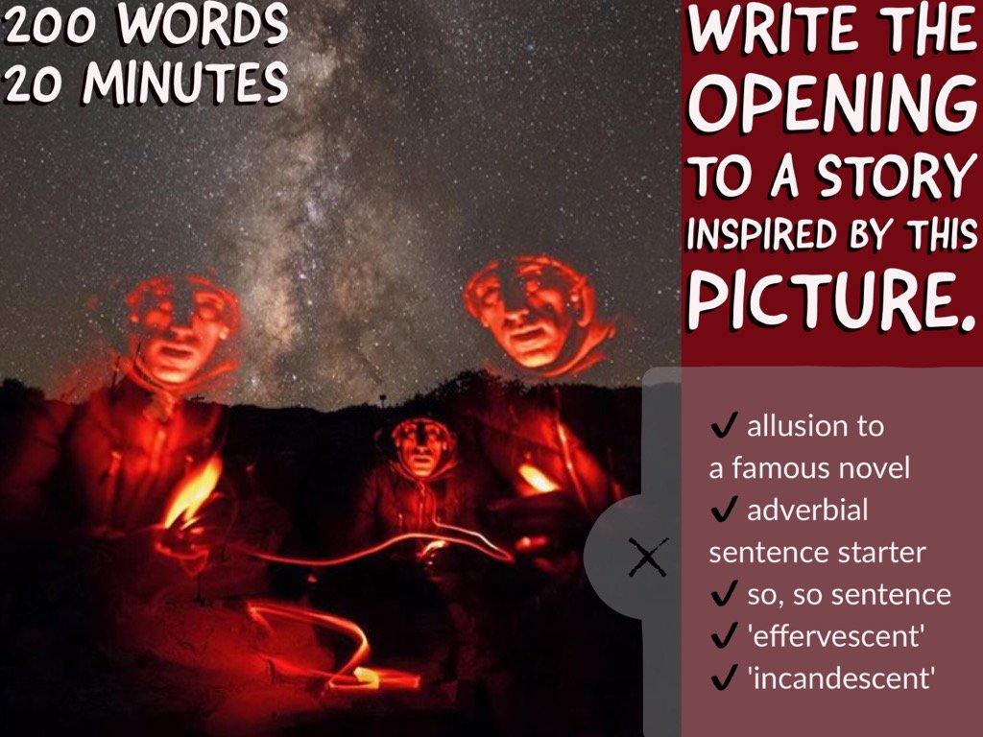  Once written, annotate your work explaining why you chose to use certain words or techniques. What did you want the reader to feel?
Week 14 – w.b. 13/7/20 | Lesson 1: Open up the booklet called ‘Year 7 English Booklet’ and complete activities on pages 22-23.  Lesson 2: Open up the booklet called ‘Year 7 Booklet 2’ and complete the activities on pages 19-21. Send this work to your teacher.  Lesson 3: Write a diary entry reflecting on the last few months and what you are looking forward to in the summer.

