**De Aston**

**English Department**

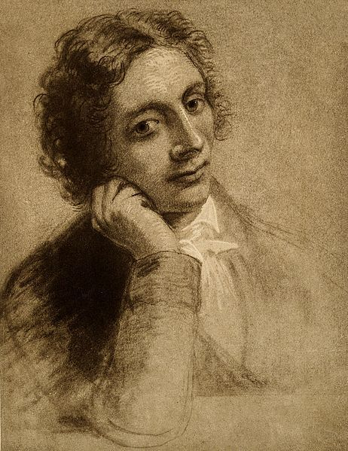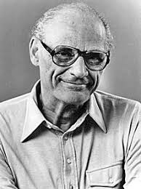

**Year 12: DOAS/Keats**

**Academic Excellence Booklet**

**Activity 1 – DOAS and its critics**

a. Corrigan (1969) discusses how *On the other hand, there appeared a growing trend among many of those who approached this play to condemn Willy Loman out of hand, believing his actions to be the root of his destruction and knowing society to be free of any guilt*. What are your views on this statement?

b. Taylor is a key critic for DOAS – he argues that ‘Wlly Loman is the embodiment rather than the victim of the American Dream’ – do you believe this is the case?

c. Miller, when discussing his own play, described America as ‘hope, even when it doesn’t work…American is promises’ – how is this view communicated in the play?

d. Finally, Richard Foster labelled Willy as a ‘pathetic bourgeois barbarian’ – take each word in turn and discuss how this presentation is shown in the play.

**Activity 2 – Miller**

1. Famously, Miller discussed tragedy as the ‘consequence of a man’s total compulsion to evaluate himself justly’ – to what extent is this true of Keats and DOAS?

**Activity 3 - Language**

**Consider how the language helps to shape our interpretation of Willy. Does the language used help to make Willy into a tragic hero? Or does it contradict this interpretation?**

**Consider these aspects of Aristotle’s definition of tragedy:**

**+ The character must occupy a "high" status position but must ALSO embody nobility**

**and virtue as part of his innate character**.

**+ Though the tragic hero is pre-eminently great, he is not perfect. An audience should**

**be able to identify with him.**

Does the language Willy uses impact on our view of his status and virtue?

Does the language Willy uses impact on whether we can identify with him or not?

**Activity 4 - Keats**

1. Hopkins discussed how Keats’ poetry represented a world of ‘experiment, division and uncertainty’ – take each one of these words in turn and discuss how they are presented in Keats and DOAS.

**Activity 5 – Religion**

1. Keats was writing in the time of the Enlightenment which meant a move towards more agnostic or atheist beliefs, indeed, his friend Shelley produced a pamphlet on atheism. Silver, in 1998, discussed how Keats’ poems detail how ‘mortality is just under the surface…we are mortal but with no divine shoulder to lean on’ – how are these two views demonstrated in both Keats and DOAS?



For more resources, including literacy support, visit www.deastonenglish.com