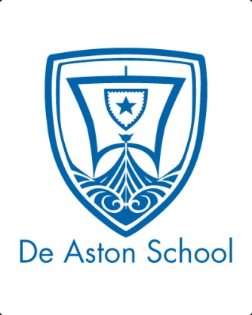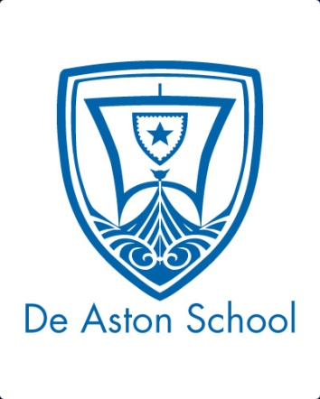**De Aston**

**English Department**

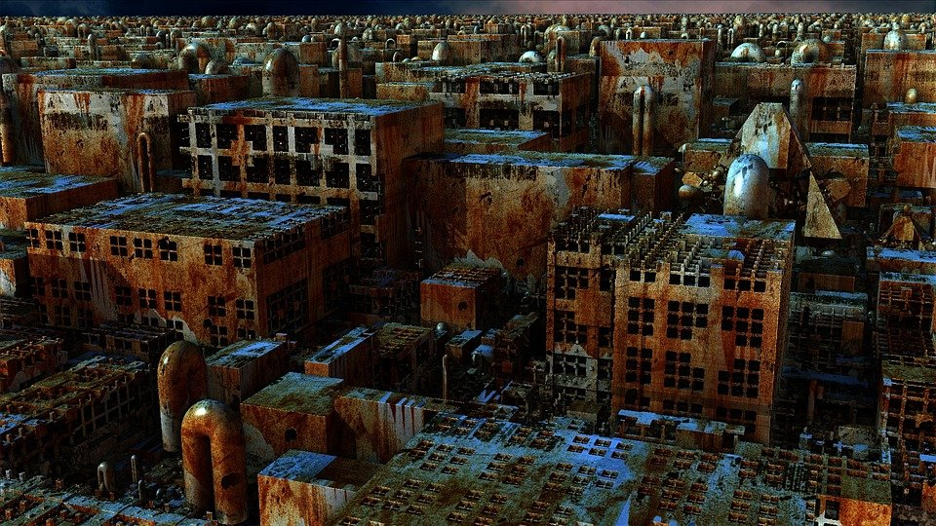

**Year 8: Dystopian Worlds**

**Academic Excellence Booklet**

The role of the Academic Excellence Booklet is for you to complete these tasks over the next six weeks. These activities are purposely designed to challenge you, so don’t worry if you find them difficult. You’re meant to! Learning happens when people have to think hard. That being said, your English teacher is a specialist, so ask any of us for help, anytime!

1. **Inspirations**

Many writers of dystopian fiction are inspired by the world around us. Research the work of Suzanne Collins, Scott Westerfeld, Michael Grant and H.G.Wells and research what they were inspired by. Write about the inspirations of each author and discuss how these could be linked to modern society.

1. **Imagined dystopias.**

A futuristic, imagined universe in which oppressive societal control and the illusion of a perfect society are maintained through corporate, bureaucratic, technological, moral, or totalitarian control. Dystopias, through an exaggerated worst ‐ case scenario, make a criticism about a current trend, societal norm, or political system.

1. **Debate and discussion**

Consider for and against for the following topics:

* Is a utopia ever achievable?
* Why would writers ever want to write dystopian literature?

1. **Tabula Rasa**

The final idea about human nature is that human beings are neither basically good nor basically evil but are like a blank sheet of paper. This doctrine is called tabula rasa (Latin for “blank tablet”). We are neither good nor evil but entirely defined by our environment: our economic, social, historical circumstances.

What do you think are the strengths and weaknesses of these three doctrines?

* Human beings are essentially good
* Human beings are essentially evil (original sin)
* Human beings are neither essentially good nor evil, but are formed by their environment (tabula rasa)

How does the idea of tabula rasa fit with utopian or dystopian literature?



For more resources, including literacy support, visit www.deastonenglish.com