De Aston
English Department

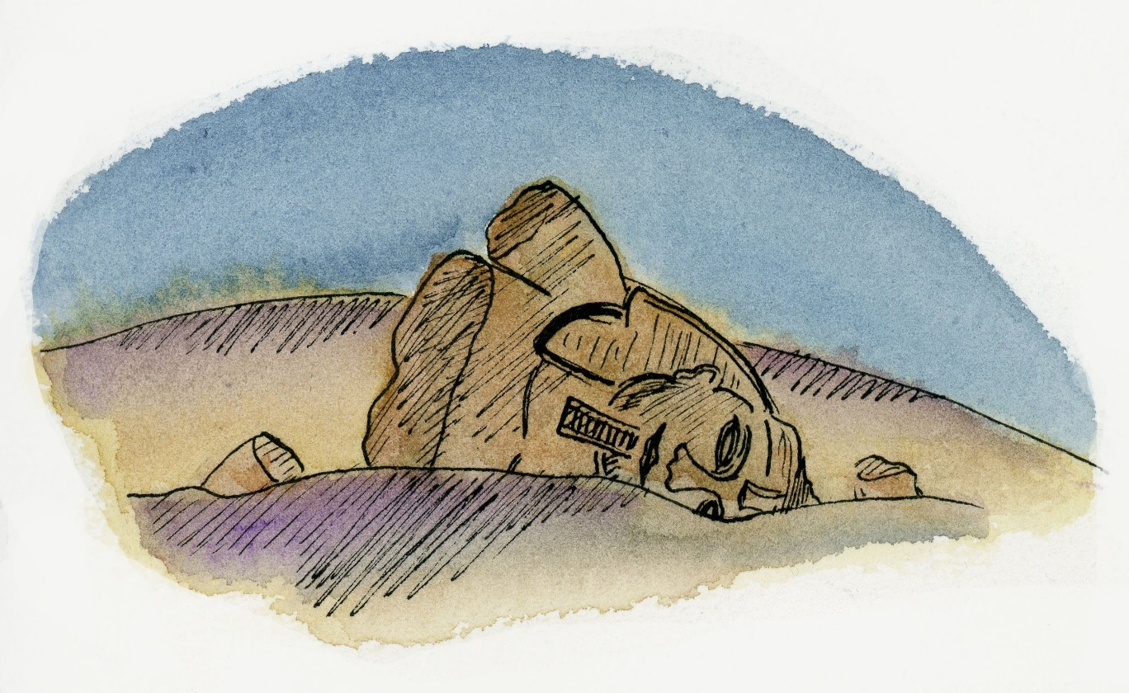

Year 11: Power and Conflict
Academic Excellence Booklet

The role of the Academic Excellence Booklet is for you to complete these tasks over the next six weeks. These activities are purposely designed to challenge you, so don’t worry if you find them difficult. You’re meant to! Learning happens when people have to think hard. That being said, your English teacher is a specialist, so ask any of us for help, anytime!

- Hitting the Assessment Objectives

It is important that you are absolutely clear on the skills that you need to demonstrate when responding to poetry. Using FLIRTS will help to guide the structure and content of your response however, you must have an understanding of the relevant assessment objectives used by the examiner.

AO1: Read and respond to texts, textual references (including quotes) to support interpretations (inference). Maintain a critical style (evaluate).
AO2: Analysis of language, form and structure using relevant subject terminology where appropriate.
AO3: Show understanding of the relationships between texts (e.g. Romanticism) and the context (time period) in which they were written.

Task:

Read through the example response below. Your task is to identify how this candidate shows a strong understanding of the poems, maintains articulate and fluent writing style and also draws effectively on poetic and historical terms.

Use 3 different coloured highlighters to identify where the candidate ‘hits’ each assessment objective.

SAMPLE ANSWER:

Question: Compare how poets present ideas about conflict in Exposure and in one other poem from the collection you have studied.

The ideas about conflict shown in ‘Exposure’ are overwhelmingly depressing. Owen paints a picture of the First World War as endless, treacherous and deadly – not through battle, but lack of protection from the ‘merciless iced east winds’, creating vivid imagery of one of the coldest winters in memory. Here, Owen uses sibilance to recreate the sounds of the winds hissing through the trenches, the sensory of sound paired with the adjective ‘merciless’ personifying the winter wind and characterising them as malevolent.

‘Remains’ is about a more zeitgeist form of conflict, presenting warfare in an urban context. Armitage’s soldier describes the harrowing side effects of a war incident, which conveys not only the context of conflict itself is hard to bear, but the lasting psychological impact after the event, alluding to PTSD. Armitage uses repetitive content phrased in different way to present this internal conflict. In the second stanza, Armitage finds four ways to express that three of them were responsible, from listing: ‘myself and somebody else and somebody else’, to insisting on their similarities with the cliché ‘three of a kind’. This repetition mirrors the way the incident repeats itself constantly in the soldier’s mind. It is also worthy to note that up to this point in the poem, the viewpoint is in the form of plural first person, an attempt to share the responsibility and build justification amongst the ‘three’ soldiers who are all of the ‘same mind.’ However, the focus soon shifts to the lasting effects of this incident on the individual, the viewpoint turning to that of first person singular. Therefore, this structural device used by Armitage makes it pellucid that the soldier may share the physical responsibility of the killing but he cannot disperse the psychological after effects, they are his own.

- End-stopped line and Enjambment
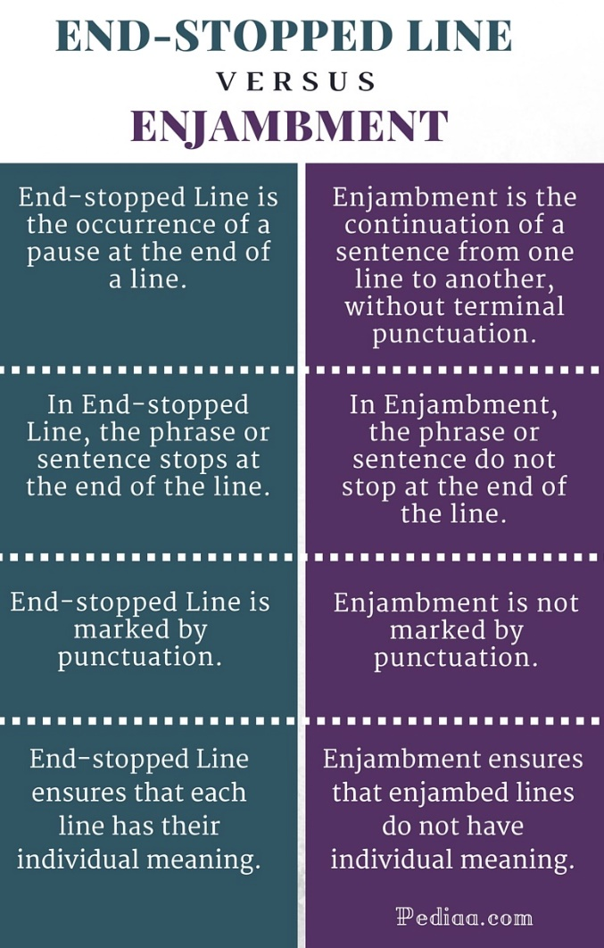
Task: Look at the following section taken from My Last Duchess and respond to the following questions.

Q1: How does the poets use of caesura in this section of the poem reveal the speaker’s emotions as he reflects on his relationship with his last duchess?

Q2: How does the poets use of caesurae and enjambment convey the poem’s tone and mood?

Q3: Look at the last line of the section printed below.
How does the poets use of an interrogative and end-stopped line add to the revelation of character in this dramatic monologue?

Half-flush that dies along her throat.” Such stuff
Was courtesy, she thought, and cause enough
For calling up that spot of joy. She had
A heart—how shall I say?— too soon made glad,
Too easily impressed; she liked whate’er
She looked on, and her looks went everywhere.
Sir, ’twas all one! My favour at her breast,
The dropping of the daylight in the West,
The bough of cherries some officious fool
Broke in the orchard for her, the white mule
She rode with round the terrace—all and each
Would draw from her alike the approving speech,
Or blush, at least. She thanked men—good! but thanked
Somehow—I know not how—as if she ranked
My gift of a nine-hundred-years-old name
With anybody’s gift. Who’d stoop to blame
This sort of trifling?

- Mood and Tone
Mood is the feeling created by the poet for the reader.
Tone is the feeling displayed by the author toward the subject of the poem. Mood and tone often depend on one another to get across what the author is trying to portray.
Examples:
Words that can describe the mood of a poem might be: patriotic, romantic, realistic, optimistic, pessimistic, melancholic, mournful, sorrowful.
Words that can describe the tone of a poem might be: patriotic, serious, humorous, jocund, bitter, playful, exuberant, despondent.

Task: You are now going to compare the mood and tone conveyed in the poems Charge of the Light Brigade and Bayonet Charge. Write to SQuAD paragraphs in response to the following question:
Compare how the tone and mood of the poem reflects its historical context.
Consider:
- The poet’s personal was experiences and responsibilities
- Attitudes to war – patriotism and glorified war propaganda
- The nature of the specific battle e.g. weather conditions and preparation

- Romanticism
The first 3 poems of the Power and Conflict cluster are all written by Romantic poets/writers. This gives you an example of how poems can be similar with regards to their context and key messages.
To define romantic, it is the idealistic over practical migration, choosing passion over order and form. Your task is to respond to the following question using your prior knowledge and the definition above.

Focussing on Ozymandias, The Prelude and London, which poem(s) in your opinion best represents the motives of the period of Romanticism and the thinking of Romantic poets?
AO1: Remember to use quotations to support your interpretations
AO2: Remember to identify the techniques used by the poets to reveal their thoughts
AO3: Remember to show your understanding of the relationship (connections) between the poems and the context (exactly why is Romanticism?)

- Vocabulary – R is for Recap!
The vocabulary that you choose to use when analysing/responding to poems gives the examiner a clear indication of how well you know the poems and it can also help you to achieve as many marks as possible for AO1.
Task: Look at the following words listed below and find out of the definitions for any that are new to you or you are unsure of.
Your task is to write a summary (blurb style piece) of the 15 poems in the Power and Conflict cluster. You are aiming to use all 20 of the key words below.

Hard: Include all words giving a brief overview on the content of each poem.
Harder: Including the above, also show your knowledge of context (AO3).
Hardest: Including both of the above, also show you knowledge of form. (E.g. The cluster begins with ‘Ozymandias, the unconventional sonnet and narrative framework…)

Romanticism | Rhetorical Question
Revolution | Reminder
Repression | Reminiscent
Regret | Remains
Rustic | Recounted
Revelation | Reflection
Rhythm | Responsibility
Repetition | Revolt
Retrospective | Rendition
Relate | Reiterate

For more resources, including literacy support, visit www.deastonenglish.com

