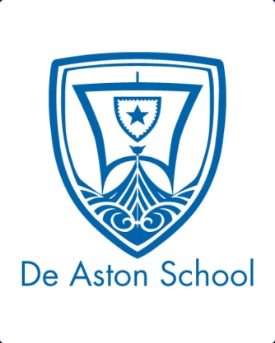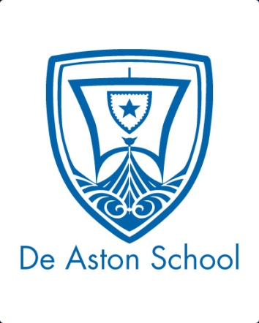**De Aston**

**English Department**

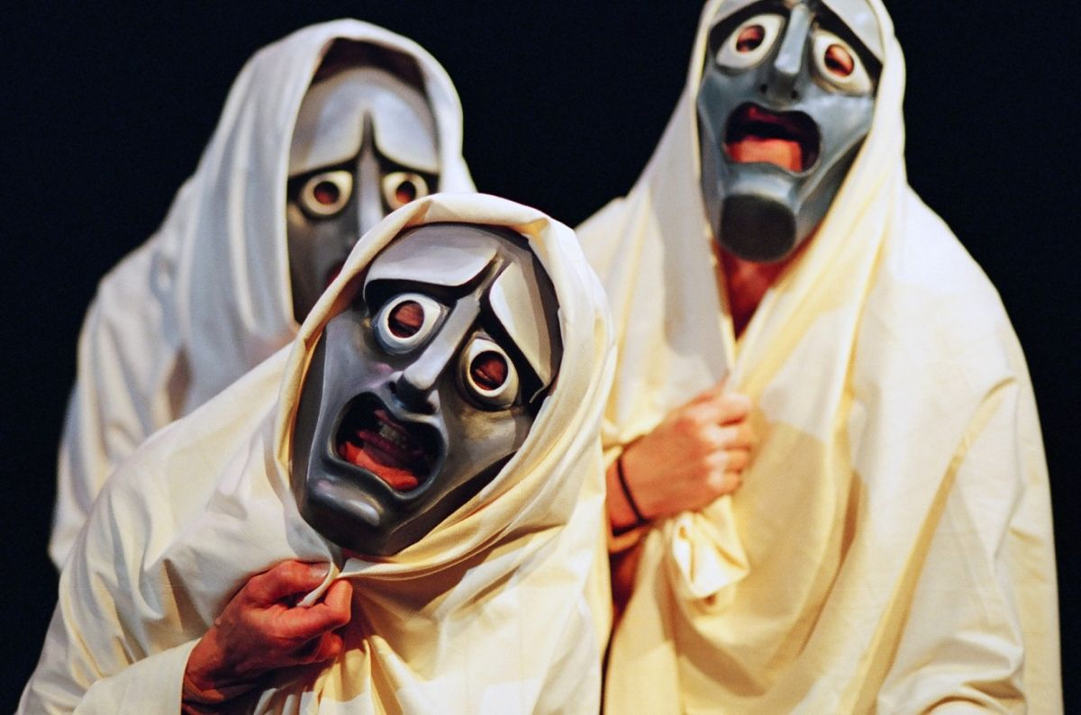

**Year 12: Poetry and Tragedy**

**Academic Excellence Booklet**

**Activity 1 – Aristotle on Poetry**

Read ‘The Origin and Development of Poetry’ by Aristotle. Answer the following comprehension questions to show your understanding:

1. What is Aristotle’s theory on why humans enjoy poetry (he gives two reasons)?
2. Aristotle defines two sorts of writers of poetry – how did they differ? What types of poems did they write? What did these two types later become known as?
3. Why as iambic metre also known as ‘lampooning’ measure?
4. Homer wrote both comedic and tragic poetry – give examples of each.
5. What does he suggest was the first example of a tragic poem? And what were the first examples of comedic poetry?
6. What stages does he identify in the transition from poetry to drama?

**Activity 2 – Types of Poetry**

Read the information on types of poetry, and then:

1. Write your own definition for each of the following terms: lyrical poetry, narrative poetry, dramatic poetry.
2. Read the 3 poems that follow the information. What type of poem is each one? Explain your answers.
3. Find at least 2 more examples of each type of poetry.
4. What type of poetry are the poems we have studied by Keats? Justify your answer.

**Activity 3 – Homer’s The Odyssey**

Read the summary of ‘The Odyssey’, by Homer, and then:

1. Identify elements of classical tragedy, using your key terminology (e.g. protagonist, antagonist, peripetia, agon, hamartia, hubris, anagnorisis).
2. What type of poem is this: lyric, narrative or dramatic? Explain your answer.
3. Explore the relationship between this, one of the earliest examples of tragic poetry, and the Keats poems that you have studied.

**Activity 4 – Boccaccio’s ‘The Decameron’**

Read the extract from Boccaccio’s ‘The Decameron’: this is the story which inspired Keats’ poem ‘Isabella, or the Pot of Basil’. Then:

1. Identify elements of classical tragedy, using your key terminology (e.g. protagonist, antagonist, peripetia, agon, hamartia, hubris, anagnorisis).
2. Note down any differences you notice between this version and Keats’ poem. Why do you think Keats made these changes? Do you think they enhance the tragedy of the tale?
3. Do you think the poetic form of Keats’ version heightens the tragedy? Explain your answer.

**Activity 5 – Telling stories through verse**

Read the extract ‘Telling stories through verse’, taken from the AQA English Literature B A/AS Level Student Book. Given that narrative verse had fallen out of popularity by the time Keats was writing, why do you think he chose to write in verse form, rather than prose?

* Reread the 4 poems and for each one try to identify 5 poetic techniques* that are used, and consider how it helps to emphasise the tragedy of the story.

*Examples of poetic techniques you could explore are: rhyme, rhythm, alliteration, assonance, consonance, onomatopoeia, line length, end-stopping, caesura, enjambment. Avoid techniques related to imagery, such as simile, metaphor and personification as these are arguably just as common in prose as they are in verse.

*Note that it is not enough to just be able to identify these techniques in the poems. You must be able to explain their effects and link this to the concept of tragedy.*

**Activity 6 – ‘Metaphorical’ death**

Does tragedy have to end in the death of the protagonist, or indeed of any of the characters? Can it end with some other kind of death – the death of an ideal, a principle or a way of life?

* What ‘metaphorical’ deaths can you identify in each of the Keats poems you have studied?



For more resources, including literacy support, visit www.deastonenglish.com