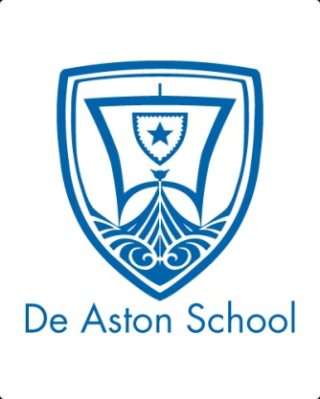
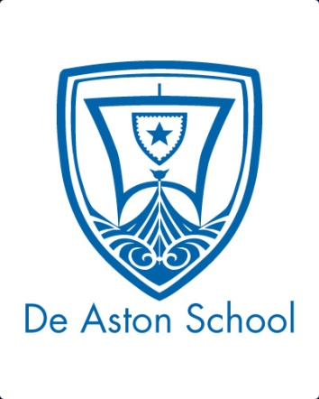
De Aston
English Department
Year 10: Power and Conflict Poetry Part 2
Challenge Tasks
(You should be spending 1-2 hours each week on these challenges)

Name:
Week Five-Seven: Consolidation Dual Coding
What is Dual Coding? Dual coding is when you use a combination of pictures/visuals and words to help you learn material.
Why Should I do it? By transferring the material from a visual form into words, or from words into visuals, you are strengthening the connections in your brain around the material itself. You are also giving yourself multiple formats to remember things in – the words might act as a memory hook for the visuals, or you might remember the visuals and that will trigger the memory of the words.
For further information, see here:
https://churchillhead.com/2017/02/09/how-to-revise-4-dual-coding/
TASK: Continue with your revision tool, but for these two weeks, dual code all the poems you have studied this far.

Week Two:
Read all of the poems: reread all those you have studied so far and read any you haven’t studied yet. Which poem do you think is most effective in exploring the theme of power or conflict? Why? Write a speech to convince the rest of the class that your choice is the best – this is also good practice for the English Language Paper 2 writing task.
Hard – focus on exploring the ideas in the poem;
Harder – explore the ideas in the poem and link these to the language and imagery used;
Hardest – explore the ideas in the poem and link these to the language, imagery and structure used.

Week One:
This task will help to remind you of the poems you studied before half term. Add it to your poetry .
On A3 paper, held portrait, create a table with 16 rows: a header row, plus a row for each poem. Create at least 8 columns, with themes for each heading: power, conflict, war, nature, plus 4 ideas of your own. For each poem, tick any themes that apply – this will help you to easily see points of comparison, so that in the exam it should be easier for you to choose your second poem.

Here’s a list of all the poems to help remind you:
Ozymandias Percy Bysshe Shelley  London William Blake  The Prelude: stealing the boat William Wordsworth  My Last Duchess Robert Browning  The Charge of the Light Brigade Alfred Lord Tennyson  Exposure Wilfred Owen  Storm on the Island Seamus Heaney | Bayonet Charge Ted Hughes  Remains Simon Armitage  Poppies Jane Weir  War Photographer Carol Ann Duffy  Tissue Imtiaz Dharker  The émigree Carol Rumens  Kamikaze Beatrice Garland  Checking Out Me History John Agard

Bonus week:
The poem below is about the theme of powerlessness. Complete the ‘all’ question and one more of the questions below:
All: Explain in your own words what ideas the poet was trying to express about power/conflict.
Hard: Choose three quotes that you think are particularly effective in conveying these ideas and explain why you chose them.
Harder: Choose three quotes that you think are particularly effective in conveying these ideas. Identify any techniques and effective word choices and explore the effect.
Hardest: Choose three quotes that you think are particularly effective in conveying these ideas. Explore the effect of any techniques, effective word choices and structural features.
Nettles
BY VERNON SCANNELL
My son aged three fell in the nettle bed.
'Bed' seemed a curious name for those green spears,
That regiment of spite behind the shed:
It was no place for rest. With sobs and tears
The boy came seeking comfort and I saw
White blisters beaded on his tender skin.
We soothed him till his pain was not so raw.
At last he offered us a watery grin,
And then I took my billhook, honed the blade
And went outside and slashed in fury with it
Till not a nettle in that fierce parade
Stood upright any more. And then I lit
A funeral pyre to burn the fallen dead,
But in two weeks the busy sun and rain
Had called up tall recruits behind the shed:
My son would often feel sharp wounds again.

For more resources, including literacy support, visit www.deastonenglish.com
Extending your vocabulary
You should be trying to expand your vocabulary throughout your studies of English, for example by using a thesaurus when completing extended writing tasks. In addition to this, find out what the following words mean, learn how to spell them and try to use them in your class work:
1. Arduous 2. Effervescent 3. Mediocre 4. Profligate 5. Salacious

Additional challenge:
Look back over the key terms you have learnt or revised in your homework booklets this year and make your own list of key terms that you need to look up again, or that you find tricky to remember:
Hard | Harder | Hardest

Key terms: Linguistic study
The following terms are from the field of linguistics – the scientific study of language. You may find them useful at any point in your English studies. Make sure you understand what each term means and can identify examples in the texts you read.
Hard  accent  colloquialism  dialect  homophone  monosyllabic  polysyllabic  prefix  root/stem word  Standard English  suffix  synonym | Harder  antonym  archaic  etymology  idiolect  Latinate  morpheme  neologism  phoneme  phonetics  phonology  pragmatics  semantics  sociolect | Hardest  deictic  diction  discourse  fricative  glide  graphology  lexeme  orthography  plosive  signifier

Quotes to Learn – You will be tested on them
Week Two – Remains
- ‘probably armed, possibly not’
- ‘I see every round as it rips through his life’
- ‘tosses his guts’ / ‘carted off in the back of a lorry’
- ‘sort of inside out, pain itself, the image of agony’
- ‘End of story, except not really.'
- ‘blood-shadow stays on the street’
- ‘his bloody life in my bloody hands’
- ‘he’s here in my head when I close my eyes’

Quotes to Learn – You will be tested on them
Week Three - Poppies
- ‘steeled the softening of my face’
- ‘All my words flattened, rolled, turned into felt, slowly melting’
- ‘the world overflowing like a treasure chest’
- ‘released a song bird from its cage'
- ‘later a single dove flew from the pear tree’
- ‘The dove pulled freely against the sky, an ornamental stitch’
- ‘I listened, hoping to hear your playground voice catching on the wind’
Quotes to Learn – You will be tested on them
Week One – Bayonet Charge
- ‘running- raw In raw-seamed hot khaki’
- ‘Bullets smacking the belly out of the air’
- ‘The patriotic tear that had brimmed in his eye Sweating like molten iron from the centre of his chest'
- ‘In what cold clockwork of the stars and the nations Was he the hand pointing that second?’
- ‘King, honour, human dignity, etcetera Dropped like luxuries’
- ‘shot-slashed furrows Threw up a yellow hare that rolled like a flame’

Quotes to Learn – You will be tested on them
Week Four – War Photographer
- ‘spools of suffering set out in ordered rows’
- ‘Belfast. Beirut. Phnom Penh. All flesh is grass.’
- ‘Rural England. Home again to ordinary pain'
- ‘to fields which don’t explode beneath the feet of running children in a nightmare heat’
- ‘a half-formed ghost’
- ‘how the blood stained into foreign dust’
- ‘the reader’s eyeballs prick with tears between the bath and pre-lunch beers’
- ‘he stares impassively at where he earns his living and they do not care’

Quotes to Learn – You will be tested on them
Week Five – Tissue
- ‘Paper that lets the light shine through, this is what could alter things’
- ‘If buildings were paper, I might feel their drift, see how easily they fall away on a sigh’
- ‘The sun shines through their borderlines’
- ‘what was paid by credit card might fly our lives like paper kites'
- ‘let the daylight break through capitals and monoliths, through the shapes that pride can make’
- ‘of paper smoothed and stroked and thinned to be transparent, turned into your skin’

Quotes to Learn – You will be tested on them
Week Six – Emigree
- ‘There once was a country… I left it as a child but my memory of it is sunlight-clear’
- ‘the bright, filled paperweight’
- ‘it may be sick with tyrants, but I am branded by an impression of sunlight’
- ‘That child’s vocabulary I carried here like a hollow doll, opens and spills a grammar'
- ‘white plane’ / ‘white streets’
- ‘I comb its hair and love its shining eyes. My city takes me dancing through the city of walls’
- ‘My shadow falls as evidence of sunlight’

Quotes to Learn – You will be tested on them
Week Seven
- ‘Dem tell me Wha dem want to tell me’
- ‘Bandage up me eye with me own history Blind me to me own identity’
- ‘hopeful stream to freedom river’
- ‘a healing star among the wounded a yellow sunrise to the dying’
- ‘But now I checking out me own history I carving out me identity’

