**De Aston**

**English Department**

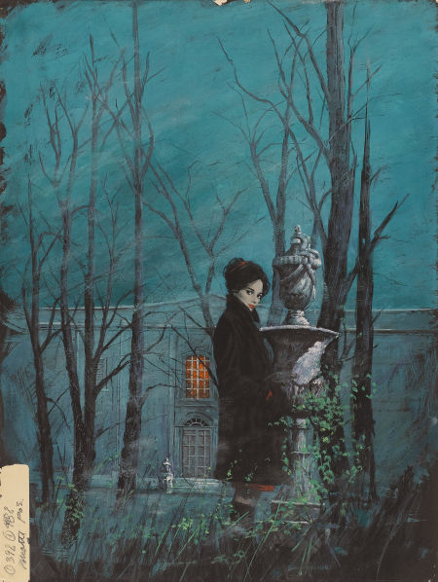

**Year 9: Gothic Class Reader**

**Challenge Tasks**

**Name:**

**Week Two:**

Gothic writing often contains stock characters and settings. This week, choose a challenge task:

**Hard** – make one cube (dice) featuring 6 different gothic locations and another cube containing 6 typical gothic character types;

**Harder** – create a Venn Diagram comparing 2 famous gothic villains;

**Hardest** – write a letter from one famous gothic villain to another explaining why they do what they do. Then write the reply.

**Week Three:**

Paint a picture using gothic imagery. Choose a challenge!

**Hard** – you’ve been digging – describe what you find…perhaps it’s something surprising and unpleasant;

**Harder** – there’s been an outbreak of a new type of rabies at school! Describe your thoughts in a diary entry as you remain locked inside your classroom for your own protection.

**Hardest** – you’ve seen a murder with a supernatural twist! Write a police report telling the story of what you saw.

**Week One:**

This week, you will have learnt about different gothic conventions. Choose one of the tasks below to demonstrate your understanding of the gothic genre. You can work with a partner or in small groups.

* A rap or poem about the gothic;
* A top 10 of gothic songs with a sentence explaining what makes each one gothic;
* Pick ten key words and define them!

Be creative but be prepared to justify your choices and how they show your understanding of this genre.

**Week Four-Six:**

Now it’s time for some project work. This project will take you two weeks to complete.

With a partner or on your own, choose a task below.

1. Create a fact file on a gothic writer of your choice;
2. Script and be prepared to explain a short gothic scene from a play;
3. Create your own Gothic story – how many of the Gothic conventions can you use?

**Additional challenge tasks:**

Make sure you understand what each of these words means and show your understanding by trying to use them in your classwork. Then learn how to spell them – be ready for a spelling test in the last week of term.

**Hard:**

1. Motif 2. Connotation 3. Narrative hook 4. Atmosphere 5. Pathetic fallacy

**Harder:**

1. Unheimlich 2. Sinister 3. Foreshadowing 4. Suspense 5. Superstition

**Hardest:**

1. Penchant 2. Emaciated 3. Quaint 4. Obsequious 5. Taciturn

**Final challenge:**

Finally, challenge yourself to read one of the classic Gothic texts, such as Frankenstein by Mary Shelley or Dracula by Bram Stoker. In your exercise book, tell your teacher what you read and what you thought about it.

**Bonus week:**

Read the extract below and complete the ‘all’ question and one more of the questions below:

**All:** list four things you learn about Mr Utterson’s ‘dreams’.

**Hard:** what genre is the text and how do you know?

**Harder:** how does the writer use language to interest the reader?

**Hardest:** to what extent does the text meet the expectations of the gothic genre?





For more resources, including literacy support, visit www.deastonenglish.com