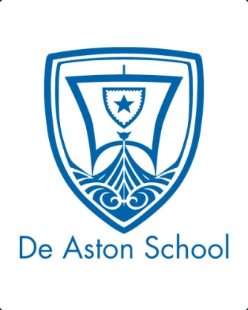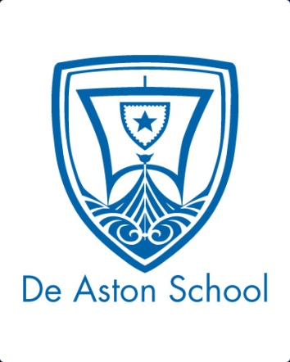**De Aston**

**English Department**

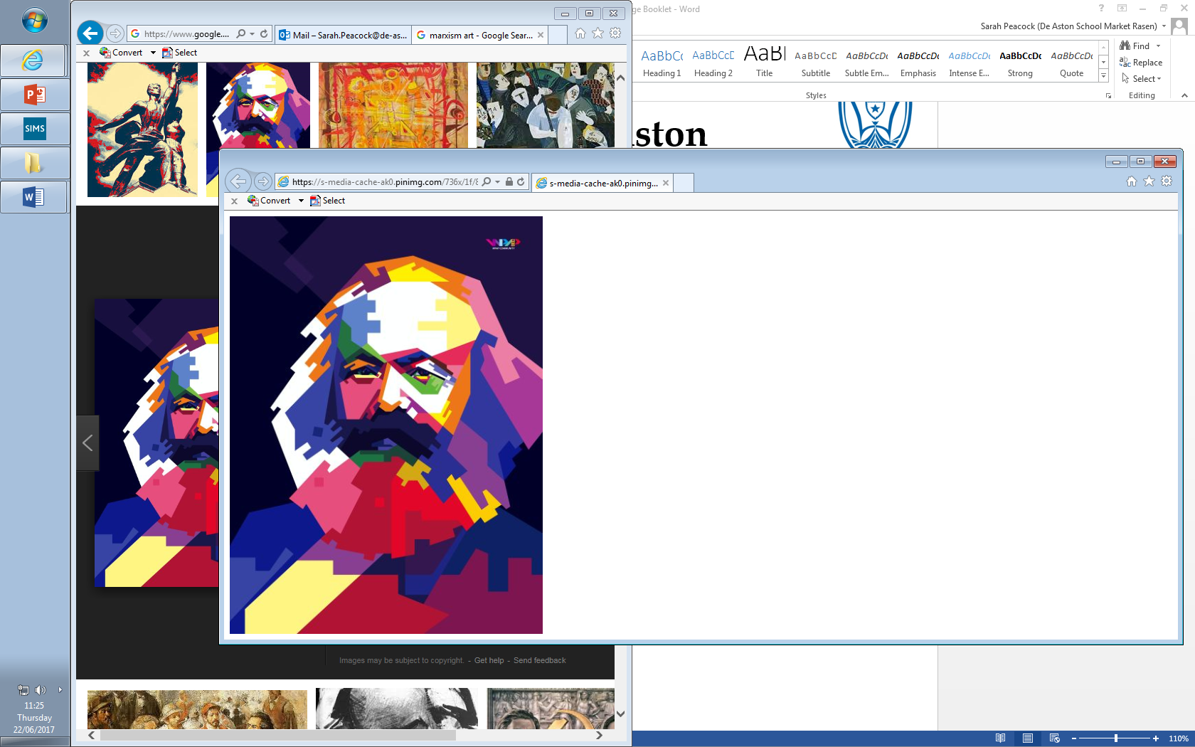

**Year 12: Marxism**

**Challenge Tasks**

**Name:**

**Week Two:**

Read the Guardian article ‘Why Marxism is on the rise again.’

Summarise the writer’s article and then highlight key criticism from the article and explain how you can link it to your study of Fight Club so far.

**Week One:**

Research Marxism Timeline..

Present your research. Ensure your research summaries the theory and tracks the key evnts which developed the Marxist movement.

Finally, give your predictions for Marxism in the future.

**Week Three:**

Read the Guardian article ‘Is Marx still relevant?’

Summarise the writer’s opinion on Marx and his theory and then highlight key criticism from the article and explain how you can link it to your study of Fight Club so far.

**Week Four:**

Read the HuffPost article ‘The Cult of Celebrity.’

Summarise the writer’s article and then highlight key criticism from the article and explain how you can link it to your study of Fight Club so far.

**Week Nine:**

Hard: Research 1990’s America and link to your study of *Fight Club.*

Harder: As above but link to direct quotations from the text.

Hardest: As above but evaluate: which part of the context you researched is most significant to the text?



For more resources, including literacy support, visit www.deastonenglish.com