**De Aston**

**English Department**

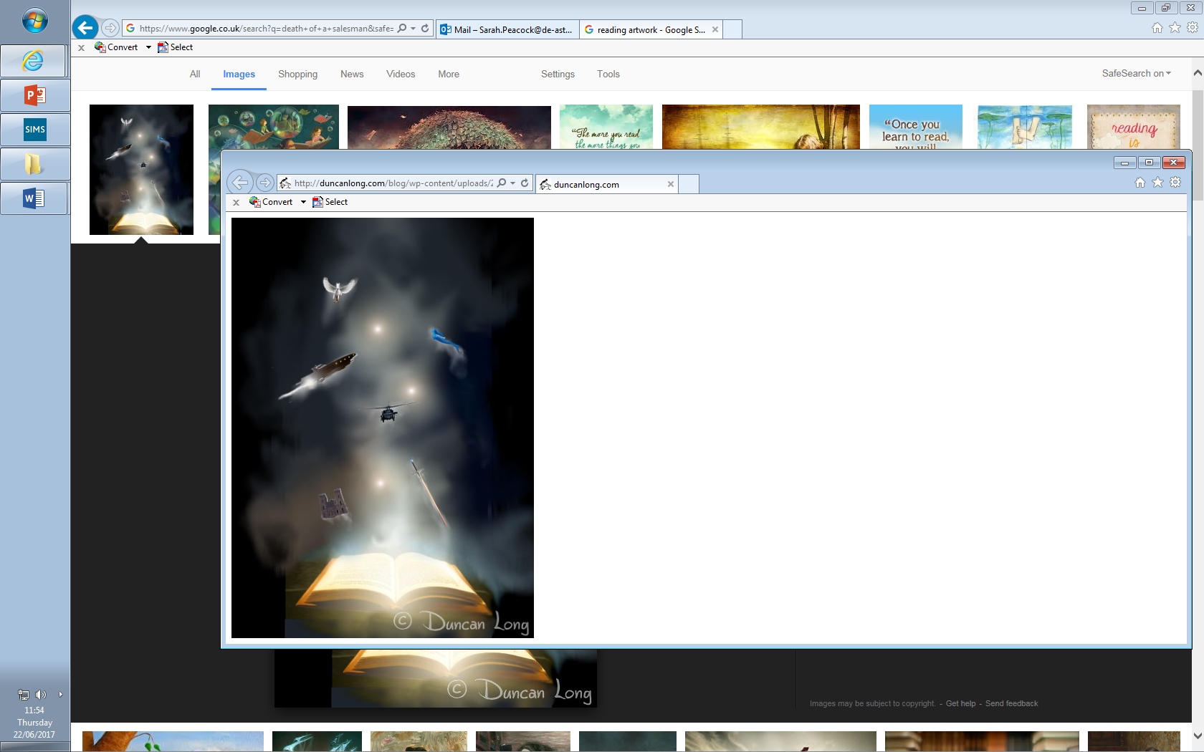

**Year 12 GCSE: Reading and Writing Fiction**

**Challenge Tasks**

**Name:**

*This extract is from ‘Animal Farm’. On a farm run by animals, the pigs are the ruthless leaders. Boxer is an old work horse who has collapsed through old age and exhaustion. The pigs have said that they will arrange to have Boxer taken to a human hospital to recuperate and the other animals believe this. However, when the van arrives to take Boxer away, Benjamin, a donkey and the only animal that can read, sees the writing on the cart’s side and announces to Clover (a horse) and the other animals that the pigs are actually sending Boxer to be slaughtered and turned into glue at the knacker’s yard.*

If he made a good recovery, Boxer might expect to live another three years,

and he looked forward to the peaceful days that he would spend in the corner

of the big pasture1. It would be the first time that he had had leisure to study

and improve his mind. He intended, he said, to devote the rest of his life to

learning the remaining twenty-two letters of the alphabet. 5

However, Benjamin and Clover could only be with Boxer after working hours,

and it was in the middle of the day when the van came to take him away. The

animals were all at work weeding turnips under the supervision of a pig, when

they were astonished to see Benjamin come galloping from the direction of the

farm buildings, braying2 at the top of his voice. It was the first time that they 10

had ever seen Benjamin excited--indeed, it was the first time that anyone had

ever seen him gallop. "Quick, quick!" he shouted. "Come at once! They're taking

Boxer away!" Without waiting for orders from the pigs, the animals broke off work

and raced back to the farm buildings. Sure enough, there in the yard was a large

closed van, drawn by two horses, with lettering on its side and a sly-looking man 15

in a low-crowned bowler hat sitting on the driver's seat. And Boxer's stall3 was empty.

The animals crowded round the van. "Good-bye, Boxer!" they chorused,

"good-bye!"

"Fools! Fools!" shouted Benjamin, prancing round them and stamping the earth with

his small hoofs. "Fools! Do you not see what is written on the side of that van?" 20

That gave the animals pause, and there was a hush. Muriel began to spell out the

words. But Benjamin pushed her aside and in the midst of a deadly silence he read:

"'Alfred Simmonds, Horse Slaughterer and Glue Boiler, Willingdon. Dealer in Hides

and Bone-Meal. Kennels Supplied.' Do you not understand what that means? They

are taking Boxer to the knacker's!"4 25

A cry of horror burst from all the animals. At this moment the man on the box

whipped up his horses and the van moved out of the yard at a smart trot. All the

animals followed, crying out at the tops of their voices. Clover forced her way to

the front. The van began to gather speed. Clover tried to stir her stout limbs to a

gallop, and achieved a canter. "Boxer!" she cried. "Boxer! Boxer! Boxer!" And just 30

at this moment, as though he had heard the uproar outside, Boxer's face, with the

white stripe down his nose, appeared at the small window at the back of the van.

`Boxer!' cried Clover in a terrible voice. `Boxer! Get out! Get out quickly!

They're taking you to your death!'

All the animals took up the cry of `Get out, Boxer, get out!' But the van was 35

already gathering speed and drawing away from them. It was uncertain

whether Boxer had understood what Clover had said. But a moment later his

face disappeared from the window and there was the sound of a tremendous

drumming of hoofs5 inside the van. He was trying to kick his way out. The time

had been when a few kicks from Boxer's hoofs would have smashed the van 40

to matchwood. But alas! his strength had left him; and in a few moments the

sound of drumming hoofs grew fainter and died away. In desperation the animals

began appealing to the two horses which drew the van to stop. `Comrades6,

comrades!' they shouted. `Don't take your own brother to his death!' But the

stupid brutes, too ignorant to realise what was happening, merely set back their 45

ears and quickened their pace. Boxer's face did not reappear at the window.

Too late, someone thought of racing ahead and shutting the five-barred gate;

but in another moment the van was through it and rapidly disappearing down

the road. Boxer was never seen again.

**Week Two:**

**Q3. [AO2]** You now need to think about the whole of the source.

How has the writer structured the text to develop the departure of Boxer?

You could write about:

* What the writer focuses your attention on at the beginning of the text
* how and why the writer changes the focus as the extract develops
* any other structural features that you think help to develop the meeting

**[8 marks]**

**Q4. [AO4]** Focus this part of your answer on the second half of the source, from line 17 to the end.

A teacher having read this text said: “I like how the writer helps my students to feel involved in this moment. It is as if they are at the farm with the animals.”

To what extent do you agree?

* write about your own impressions of the characters
* evaluate how the writer has created these impressions
* support your opinions with quotations from the text. **[20 marks]**

**Week Three:**

Now it’s time to write and embrace your creativity! Find an image of an interesting setting and choose one of the tasks below. You should spend 40 minutes on this homework.

1. Using the image as a stimulus, describe the setting.

Or

1. Tell a story where a strange event happens in the setting in your picture.

Remember to use paragraphs, language devices, varied sentences and vocabulary. Check your SPAG once finished.

**Week One:**

Read the extract above

**Q1. [AO1]** Read again the first part of the source, **lines 1 to 5**.

List **four** things from this part of the text about Boxer. **[4 marks]**

Q2: Look in detail at the extract from lines 6-16.

How does the writer use **language** here to show us what Benjamin felt about Boxer being taken away?

You could include the writer’s choice of:

* words and phrases
* language features and techniques
* sentence forms. **[8 marks]**



For more resources, including literacy support, visit www.deastonenglish.com