De Aston
English Department

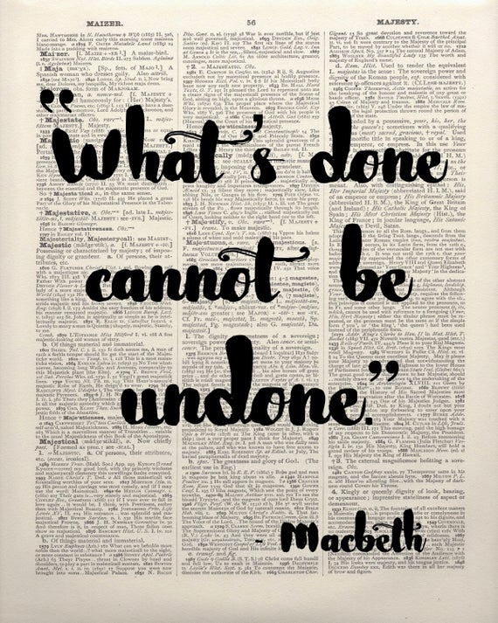
Year 11: Macbeth
Academic Excellence Booklet

The role of the Academic Excellence Booklet is for you to complete these tasks over the next six weeks. These activities are purposely designed to challenge you, so don’t worry if you find them difficult. You’re meant to! Learning happens when people have to think hard. That being said, your English teacher is a specialist, so ask any of us for help, anytime!

- Theme

Shakespeare’s bloodthirsty tragedy Macbeth is a play of many glaring themes; three of the most obvious being ambition, deception and duality. Throughout the play, key events demonstrate how ambition and deception become notorious in the play’s reputation. Using the quotations and points of analysis below, write a SQuAD paragraph responding to the following questions:

Question A: How does Shakespeare present the themes of ambition and deception through the characterisation of Lady Macbeth?
Key word: Duplicitous – deceptive

Quotations: ‘Leave the rest to me’, ‘Look like the innocent flower, But be the serpent under’t.’

Analysis: Lady Macbeth is a well-trained, symbolic ‘fiend’ of a mastered dual persona and corrupted ambition. She has a professional duplicitous nature. Our deuteragonist speaks in instructions shown by Shakespeare’s use of imperative tone. In addition, the frequency of interrogatives when she questions her husband’s milky human kindness and masculinity depicts her as interrogating and intimidating to even a man of Macbeth’s natural violence.

Question B: How does Shakespeare present Macbeth as a powerful yet vulnerable character?

Key words:
Sparagamos – dismemberment of the mind
Panegyric – a speech with the purpose of praise
Eponymous – (of a person) giving their name to something

Quotations: ‘Speak I charge you’, ‘Stars hide your fires, let not light see my black and deep desires’, ‘Turn hellhound’.

Analysis: Macbeth likes to believe he is in control of what and when the witches talk to him, shown through his imperative ‘speak’. However, unlike the Wayward sisters he does not ask his wife to speak, but perhaps wishes his ‘fiend like queen’ would be silenced as she is potentially the most poisonous catalyst of his sinful acts and sparagamos. It is unconventional to believe Macbeth was ever certain about his act of treason due to his panegyric about Duncan’s ‘meek’ and ‘great’ office. Is the eponymous title justified or questionable? Who breaks more codes of natural order, Macbeth or his wife?
Moreover, Macbeth’s power has always been achieved through his natural capability of violence, something we see him to be of ‘golden opinions’ for at the beginning of the play. However, it is clear that the ambitions and violence of our archetype warrior are key instruments to his repositioning on the Great Chain of Being.

- Corruption vs Transparency.

The Gun Power Plot (AO3).
Shakespeare and the Gunpowder Plot: In November, 1605, high treason was on the mind of every English subject. A small group of angry Catholics, fed up with ongoing persecution at the hands of the Protestant monarchy, hatched an elaborate plot to blow King James I and his government to smithereens. The most notorious conspirator, Guy Fawkes, was discovered in the cellar, match in hand, ready to ignite twenty barrels of gunpowder "all at one thunderclap."
While the conspirators suffered the ultimate punishment of being disemboweled and beheaded in front of the cheering masses, Shakespeare would likely have been only a few miles away, holed up in his estate in Stratford, piecing together tales about different Scottish kings from old history books. Change after change was made until the play became a perfect propaganda machine that seemed to clear Shakespeare of any suspicion.
A master of details, Shakespeare wove direct references to the Gunpowder plot right into Macbeth. To commemorate the discovery of the heinous scheme, King James had a medal created picturing a snake hiding amongst flowers. Lo and behold, we find a nod to the medal right in the play when Lady Macbeth tells her husband to ‘look like the innocent flower, But be the serpent under’t.’

Task: Using the contextual information above, write a SQuAD paragraph in which you consider and explore why Shakespeare decides to present King Duncan as ‘meek’ and ‘so clear in his great office.’

Consider (or research):
- Macbeth’s panegyric in his soliloquy in Act 1, Scene 7.
- The Divine Right of Kings
- The Knights’ Code of Chivalry
- The Great Chain of Being (Natural Order).

3.Mastering a Critical, Exploratory, Conceptualised Response.
Read the information below regarding Assessment Objective One.
AO1 Read, understand and respond to texts. Students should be able to:
• maintain a critical style and develop an informed personal response
• use textual references, including quotations, to support and illustrate interpretations.

- AO1 is worth 12 marks in the exam, therefore, it is extremely important that you know what you need to do in order to meet and demonstrate the skills required by this assessment objective. One of the ways you can do this is ‘think out of the box.’ Remember, all candidates will have been exposed to the same information that you have therefore, it is your ‘personal ideas’ about the text that will make you stand out. Think: ‘How can I really impress the examiner?’

- In addition to a judicious range of textual references, exploring relevant critical philosophy will help you to reach Level 6.

Task: Read the following quotations from the Philosophers Machiavelli and Bacon and then answer the following questions applying their philosophy to the character Macbeth.

- Niccolò Machiavelli was an Italian politician and philosopher of the renaissance. In literature, a Machiavellian character is one who is cunning, scrupulous and scheming.
Quotations:
‘It is better to be feared than to be loved, if you cannot be both.’
“One must be a fox to recognise traps and a lion to frighten wolves… when it comes to being a ruler, the ends justify the means.”
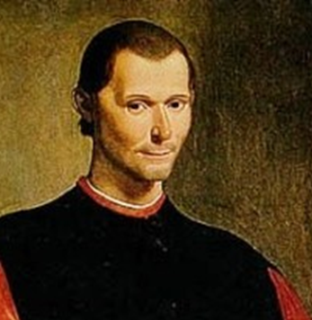
Question: How does Shakespeare’s portrayal of Macbeth support Machiavelli’s philosophy about being a ruler? Use quotations from the play to support your answer.

- Francis Bacon was a famous Renaissance philosopher. His writing gives us Historical Context as it offers a window into thought of the seventeenth century.
Quotation:
“In superstition, wise men follow fools… without a veil, it is a deformed thing, that destroys and corrupts”
Question: How does Bacon’s philosophy support Shakespeare’s portrayal of Macbeth as a tragic hero? How can we link it to the theme of supernatural in the play? Use quotations from the play to support your answer.

4.Vocabulary
Using the following word bank, write an introduction to Shakespeare’s play summarising important events, roles of key characters and themes.
For example: In Shakespeare’s proto-gothic tragedy ‘Macbeth’, we see the plays tragic hero experience the full cycle of the rise to and fall from power. Through the device of a soliloquy, our protagonist’s panegyric reveals…
- Proto-gothic Tragedy
- Tragic hero
- Panegyric
- Anagnorisis
- Hamartia
- Hubris
- Soliloquy
- Unheimlich
- Regicide
- Supernatural
- Psychomachia
- Transgressive
- Nihilism
- Phantasmagoria
- Metaphysical
- Kenoma
- Duality

5.Analysing the Eponymous title ‘Macbeth.’

Key Words:

Eponymous: giving the name of a thing (or person) to something else.
Cataclysmic: large scale – violent.

Due to Lady Macbeth’s cataclysmic role in the play, some critics say that the play should be given the eponymous title ‘Lady Macbeth.’ Indeed, without our deuteragonist’s instruction ‘leave all the rest to me’, we have to question whether Macbeth would have committed treason without the plan and manipulation provided by his ‘fiend like queen.’

Task: reflecting on your reading of the play, respond to the following question.

Question: To what extent do you agree that ‘Macbeth’ is in fact Lady’s Macbeth’s play and Macbeth’s tragedy?

For more resources, including literacy support, visit www.deastonenglish.com

