De Aston
English Department

Year 11: An Inspector Calls
Academic Excellence Booklet
The role of the Academic Excellence Booklet is for you to complete these tasks over the next six weeks. These activities are purposely designed to challenge you, so don’t worry if you find them difficult. You’re meant to! Learning happens when people have to think hard. That being said, your English teacher is a specialist, so ask any of us for help, anytime!

- Characters as a Dramatic Device
It is vital that you can evaluate the importance and effect of each of the characters’ functions in the play. Priestley uses each character as a device to allow the play to have momentum, increasing tension and hopefully, achieve a lasting emotional and mental impact on the audience. The following text will help you to understand how Priestley uses Gerald as a Deux ex Machina in order to give the play an unexpected twist!

Key Word: Deus ex Machina
an unexpected power or event saving a seemingly hopeless situation, especially as a contrived plot device in a play or novel.

Task: Once you have read the extract respond to the following question in one SQuAD paragraph. Use the quotation cited in the text.

Question: How does Priestley use Gerald as a dramatic device and how would a contemporary audience respond to him?

- Vocabulary
You need to develop a bank of ambitious, subject specific vocabulary that you can use when responding the play.
Task 1: Find and write down the definitions to each word listed below.
Task 2: Using all of the key words below, write a summary of the play.
For example:
In Priestley’s moralistic allegory, he presents the audience with a bourgeoisie family, the Birlings, in order to show the conflict and suffering inflicted upon the proletariat due to the selfish nature of a capitalist society.

- Moralistic allegory
- Socialism
- Capitalism
- Bourgeoisie
- Proletariat
- Androcentric
- Dramatic irony
- Fabian society
- Patriarchal
- Misogynistic
- Seven deadly sins
- Coup de theatre
- Deus ex Machina
- Moral epiphany
- Omniscient

3.The Seven Deadly Sins

When analysing the key characters of the play, it can be said that Priestley has deliberately characterised them in way that makes them symbolic of at least one of the Seven Deadly Sins.

Task: Using the images below, decide which character represents each sin(s) and write a brief summary explaining each of your choices, showing your knowledge of the text.

Task: Now reflect on your choices and use them to inform your opinion in response to the following question. Write your response using SQuAD.

Question: An Inspector Calls is a play about responsibility. In your opinion, is the death of Eva Smith a case of individual responsibility, collective, or both?

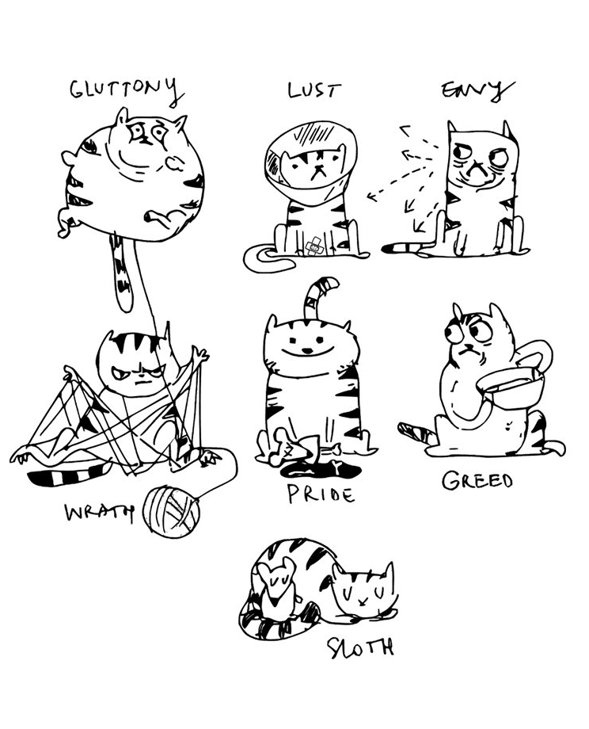

- The Importance of the Play’s Ending.
Discussing the effect of stage directions is an easy way for you to show a secure, detailed knowledge and understanding of the play. Throughout, the stage directions teach us a lot about the characters and atmosphere.
It has been said that the end of the play is the most important part as it leaves the audience with the underlying message that the desperate need and significance of social change cannot be ignored.
Read the following extract taken from the end of Act 3 and then respond to the following questions.

Sheila: No, because I remember what he said, how he looked, and what he made me feel. Fire and blood and anguish. And it frightens me the way you talk, and I can’t listen to any more of it.
Eric: And I agree with Sheila. It frightens me too.
Mr Birling: Well go to bed then, and don’t stand there being hysterical.
Mrs Birling: They’re over-tired. In the morning they’ll be as amused as we are.
Gerald: Everything’s alright now, Sheila. [Holds up the ring.] What about this ring?
Sheila: No, not yet. It’s too soon. I must think.
Birling [pointing to Eric and Sheila]: Now look at the pair of them – the famous younger generation who know it all. And they can’t even take a joke –
[The telephone rings sharply. There is a moment’s complete silence. BIRLING goes to answer it.]
Yes?... Mr Birling speaking… What? – Here –
[But obviously the other person has rung off. He puts the telephone down slowly and looks in a panic-stricken fashion at the others.]
Birling: That was the police. A girl has just died – on her way to the Infirmary – after swallowing some disinfectant. And a police inspector is on his way here – to ask some – questions –
[As they stare guiltily and dumbfounded, the curtain falls.]

- How does Sheila’s speech show the transformation of her character is complete?
- How do the stage directions reveal Priestley’s closing message?
- How does the punctuation used in Birling’s lines reveal his state of mind?

For more resources, including literacy support, visit www.deastonenglish.com

