**De Aston**

**English Department**

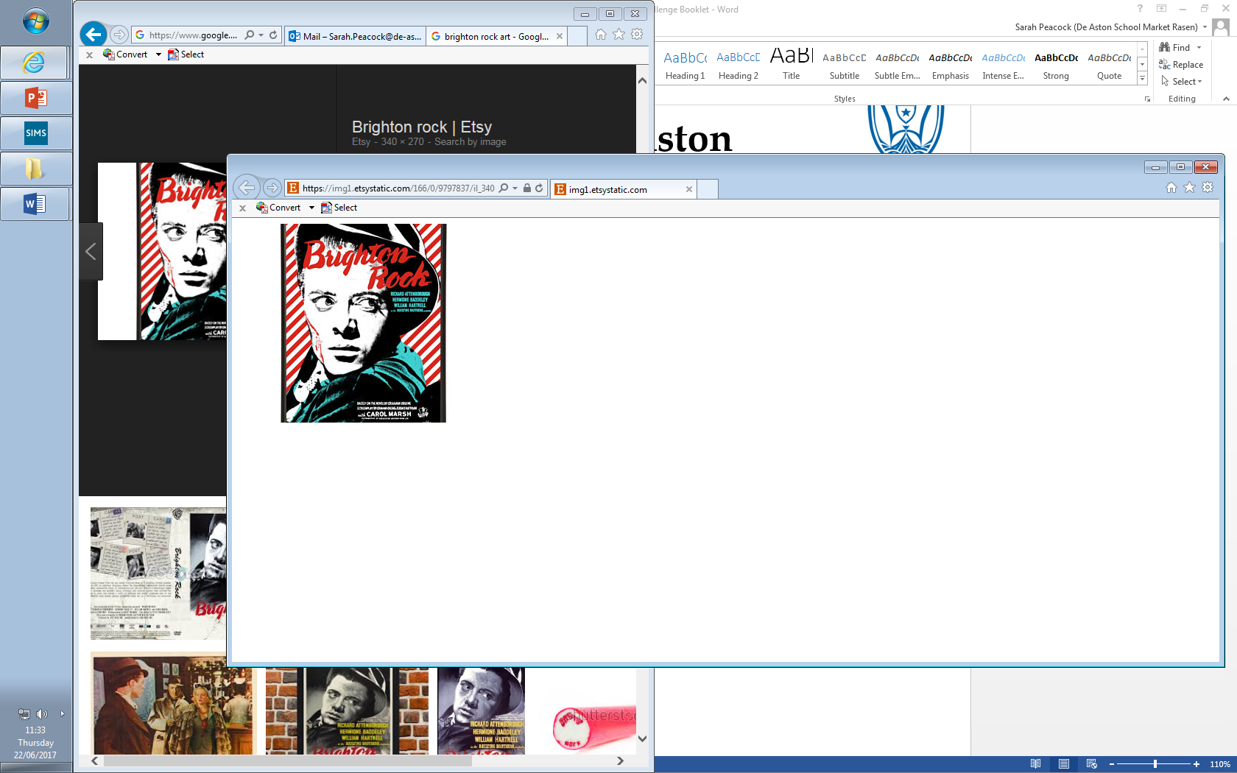

**Year 12/13: Brighton Rock**

**Challenge Tasks**

**Name:**

**Week Three:**

So far, how does the novel conform to the crime genre? Include also ideas about how it subverts the crime genre.

**Week Two:**

Now you have read Ch1, you will have seen an in-depth description of Brighton.

Sketch or find a photo of Brighton as you imagine it from the text.

Label it with quotations from the text.

After this task, write a paragraph analysing the setting. What does it reveal about the rest of the text? Challenge yourself by also considering what language/structural devices Greene uses in his description of Brighton.

**Week One:**

Research the historical context of Brighton Rock, looking closely at pre-WW2 Britain. Pay close attention to the following elements of context:

* Class divisions
* Gender divisions
* Attitudes to religion
* Seaside towns.

**Week Four:**

Hard: How have characters been presented so far?

Evaluate the language used to describe characters – is it effective? What language devices are used?

Ensure you have read the novel over summer!



For more resources, including literacy support, visit www.deastonenglish.com