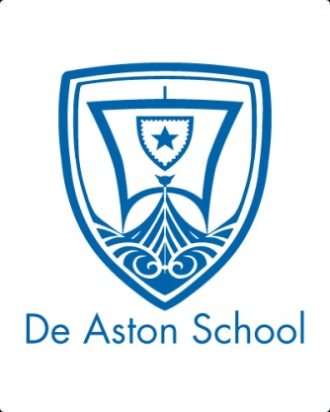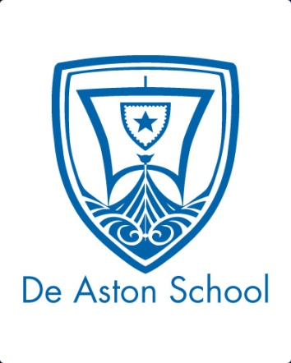**De Aston**

**English Department**

[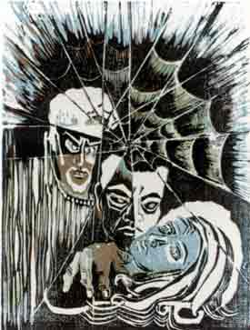](http://www.google.co.uk/url?sa=i&rct=j&q=&esrc=s&source=images&cd=&cad=rja&uact=8&ved=0ahUKEwjMvNbJndHUAhXIaVAKHXVNDHkQjRwIBw&url=http://shakespeare-art-museum.com/Prints/wc06.html&psig=AFQjCNGuTYl2lSIEwaQ3LXxcKjuR2iOuoA&ust=1498213253110784)

**Year 12: Othello**

**Challenge Tasks**

**Name:**

**Week Three:**

Hard: Look at artistic representations of the play. Choose one and comment on its representation.

Harder: As above but analyse the image – what small details reveal something about the story?

Hardest: As above but evaluate which painting you think is most successful in portraying *Othello* and why.

**Week Two:**

Now you are understanding the genre of tragedy further, choose a task.

Hard: Recreate a section of the play in first person from the perspective of a character in the play. How will you use language devices, vocab and sentence structure to create their voice?

Harder: Plan a modernised version of Othello. Where would you set it? What roles would the characters have?

Hardest: Create an extract from your own Greek/Shakespearean tragedy.

**Week Four:**

Hard: Research the Seven Deadly Sins – how are they shown in Othello?

Track the presentation of sin in the play and then evaluate which sin is the most significant.

**Week One:**

Hard: Research the context of Elizabethan England focusing on Society and Class, Religion, Crime and Punishment, Marriage, Race and Gender.

Present your research and then evaluate which section of context will be most significant to *Othello.*

**Week Five:**

Hard: Read The Evening Standard’s article ‘Othello’s military significance’ and write down key points about the military setting in Othello.

Harder: As above but explain your links to the play.

Hardest: As above but evaluate how significant the military setting is to Othello.

**Week Six:**

Summarise your reading of the novel so far in 100 words or fewer.

**Week Nine-Ten:**

In terms of your revision for this unit, track the following in the text. You can present your revision how you wish (collage, cue cards, PPT etc…). Each element should include quotes.

* Plot
* Characters
* Themes
* Context
* Language, structure and form
* Links to tragedy elements
* Criticism

**Week Eight:**

Hard: Visit this website: <http://www.shakespeare-online.com/plays/othello/othelloessay2.html> - summarise what you learn.

Harder: As above but also note down key quotes for criticism.

Hardest: As above but evaluate the essay’s ideas. To what extent do you agree?

**Week Seven:**

Hard: Go on YouTube and watch the RSC video: ‘Is Othello a racist play?’ – summarise the arguments for and against this statements as raised in the video.

Harder: As above but include your own views as well.

Hardest: As above but evaluate the quality of argument. Which did you think was significant?

**Week Six:**

Hard: Google the British Library’s ‘Critical Approaches to Othello’ and summarise the article.

Harder: As above but link the ideas to the play.

Hardest: As above but also evaluate which critical approach you think is the most successful.



For more resources, including literacy support, visit www.deastonenglish.com