**De Aston**

**English Department**

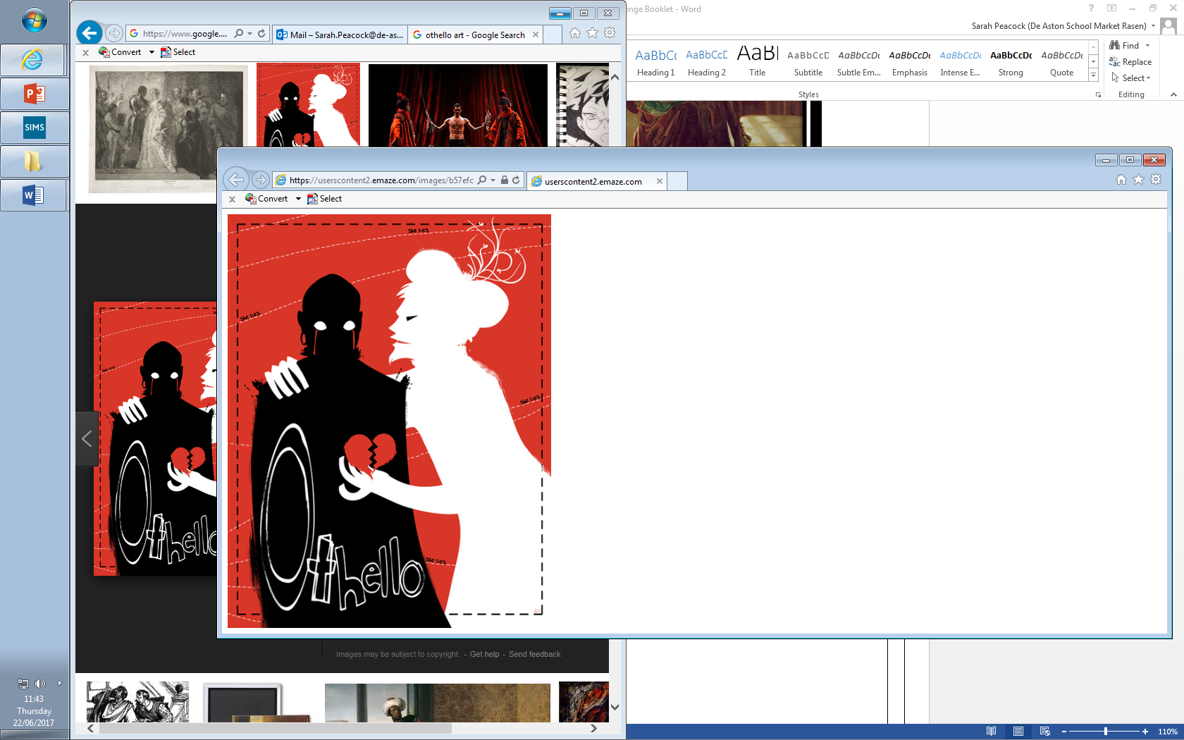

**Year 13: Othello Revision**

**Challenge Tasks**

**Name:**

**Week One-Two (plan one week and write the next!):**

Explore the significance of this extract in relation to the tragedy of the play as a whole. Remember to include in your answer relevant analysis of Shakespeare’s dramatic methods.

**IAGO**

O, sir, content you;  
I follow him to serve my turn upon him:  
We cannot all be masters, nor all masters  
Cannot be truly follow'd. You shall mark  
Many a duteous and knee-crooking knave,  
That, doting on his own obsequious bondage,  
Wears out his time, much like his master's ass,  
For nought but provender, and when he's old, cashier'd:  
Whip me such honest knaves. Others there are

Who, trimm'd in forms and visages of duty,  
Keep yet their hearts attending on themselves,  
And, throwing but shows of service on their lords,  
Do well thrive by them and when they have lined their coats  
Do themselves homage: these fellows have some soul;  
And such a one do I profess myself. For, sir,  
It is as sure as you are Roderigo,  
Were I the Moor, I would not be Iago:  
In following him, I follow but myself;  
Heaven is my judge, not I for love and duty,  
But seeming so, for my peculiar end:  
For when my outward action doth demonstrate  
The native act and figure of my heart  
In compliment extern, 'tis not long after  
But I will wear my heart upon my sleeve  
For daws to peck at: I am not what I am.

**Week Three-Four (plan one week and write the next!):**

Explore the significance of this extract in relation to the tragedy of the play as a whole. Remember to include in your answer relevant analysis of Shakespeare’s dramatic methods.

**OTHELLO**

Her father loved me; oft invited me;  
Still question'd me the story of my life,  
From year to year, the battles, sieges, fortunes,  
That I have passed.  
I ran it through, even from my boyish days,  
To the very moment that he bade me tell it;  
Wherein I spake of most disastrous chances,  
Of moving accidents by flood and field  
Of hair-breadth scapes i' the imminent deadly breach,  
Of being taken by the insolent foe  
And sold to slavery, of my redemption thence  
And portance in my travels' history:  
Wherein of antres vast and deserts idle,  
Rough quarries, rocks and hills whose heads touch heaven  
It was my hint to speak,--such was the process;  
And of the Cannibals that each other eat,  
The Anthropophagi and men whose heads  
Do grow beneath their shoulders. This to hear  
Would Desdemona seriously incline:  
But still the house-affairs would draw her thence:



**Week Five-Six (plan one week and write the next!):**

Explore the significance of this extract in relation to the tragedy of the play as a whole. Remember to include in your answer relevant analysis of Shakespeare’s dramatic methods.

**BRABANTIO**

I pray you, hear her speak:  
If she confess that she was half the wooer,  
Destruction on my head, if my bad blame  
Light on the man! Come hither, gentle mistress:  
Do you perceive in all this noble company  
Where most you owe obedience?

**DESDEMONA**

My noble father,  
I do perceive here a divided duty:  
To you I am bound for life and education;  
My life and education both do learn me  
How to respect you; you are the lord of duty;  
I am hitherto your daughter: but here's my husband,

And so much duty as my mother show'd  
To you, preferring you before her father,  
So much I challenge that I may profess  
Due to the Moor my lord.

**BRABANTIO**

God be wi' you! I have done.  
Please it your grace, on to the state-affairs:  
I had rather to adopt a child than get it.  
Come hither, Moor:  
I here do give thee that with all my heart  
Which, but thou hast already, with all my heart  
I would keep from thee. For your sake, jewel,  
I am glad at soul I have no other child:  
For thy escape would teach me tyranny,  
To hang clogs on them. I have done, my lord.

For more resources, including literacy support, visit www.deastonenglish.com