**De Aston**

**English Department**

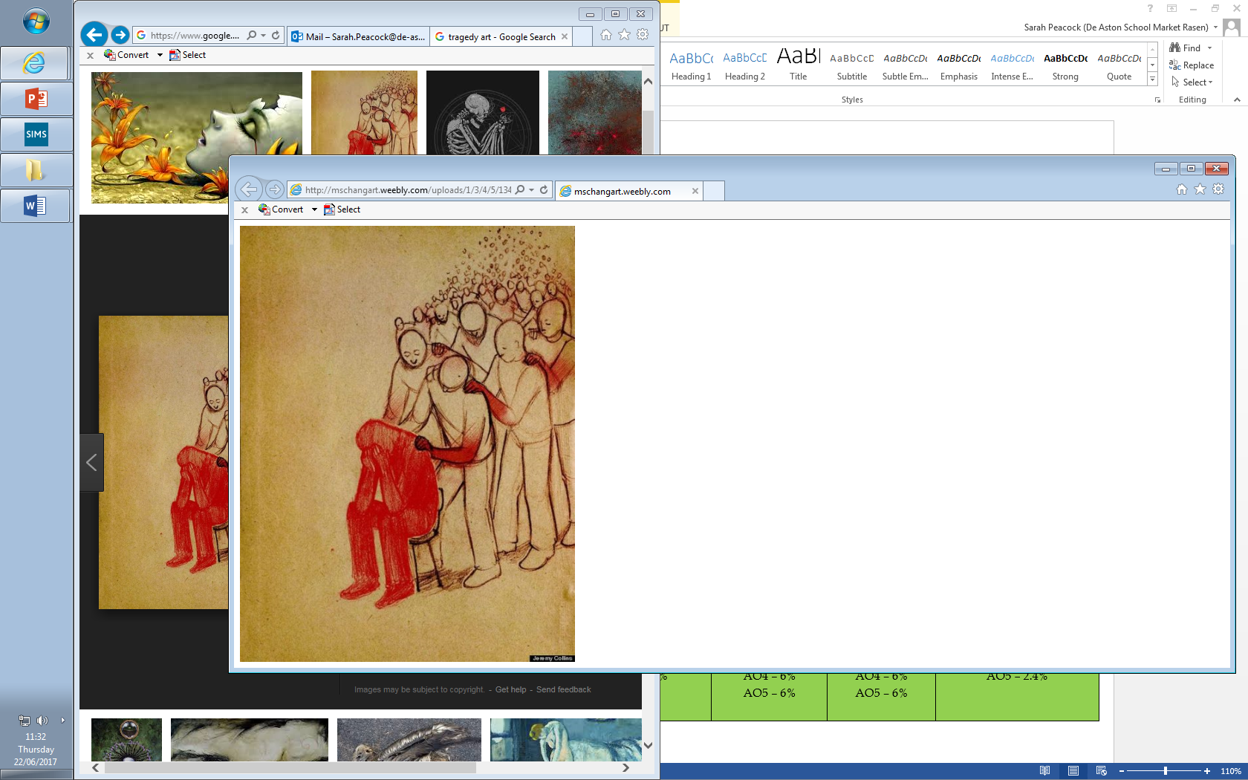

**Year 12: Tragedy Revision**

**Challenge Tasks**

**Name:**

**Week Two:**

Create a set of questions on the tragedy texts ready to ask a partner next lesson. Ensure you know the answers! Make sure your questions are specific and analytical.

Top tip: use how/why or to what extent question stems.

**Week One:**

Review key tragedy terminology and write the definitions next to the key words. Next, link each term to the texts you have studied.

Finally, consider the influence of Greek and Shakespearean tragedy on each text studied.

**Week Three:**

Choose an extract from Othello – highlight and annotate it for significant tragedy elements as well as language and structural devices too.

End by writing three paragraphs which evaluate the significance of the tragedy elements.

**Week Four:**

Create an exam question for Othello and briefly write a short essay plan as to how you would answer it. Ensure you link to quotations, language, structure context and critical concepts.

**Week Six:**

Create an exam question for DOAS/Keats and briefly write a short essay plan as to how you would answer it. Ensure you link to quotations, language, structure context and critical concepts.



For more resources, including literacy support, visit www.deastonenglish.com