Remote Learning Booklet

English Language
Year 10

Name: _________________________________
Teacher: _______________________________
English Group: _____________

The resources in this booklet will help you continue to prepare for your GCSE in English Language. Work through the activities in order so that you build your skills as you work. For some of the activities, there are answers in the back of this booklet. If an activity has answers, you will see an icon like this next to the activity itself:
Don’t look at the answers until you’ve had a go at the task yourself, though! Some of these activities are designed to relate specifically to the exam skills. Others are designed to help develop your reading skills – which are really important when it comes to all of your exams!
‘1984’: George Orwell
Task One: Pre Reading
Read the following two quotations from ‘1984’ by George Orwell. The opening sentence, which is the first sentence below, immediately creates an impact. Annotate the quotations. How does Orwell create impact at the start of the novel? What is the effect of the name ‘Victory Mansions’? What does it make you think of?

It was a bright cold day in April,
and the clocks were striking thirteen.

Victory Mansions

Looking at the images below, what predictions can you make about the extract you are going to read? Make a mindmap in the space underneath the images.
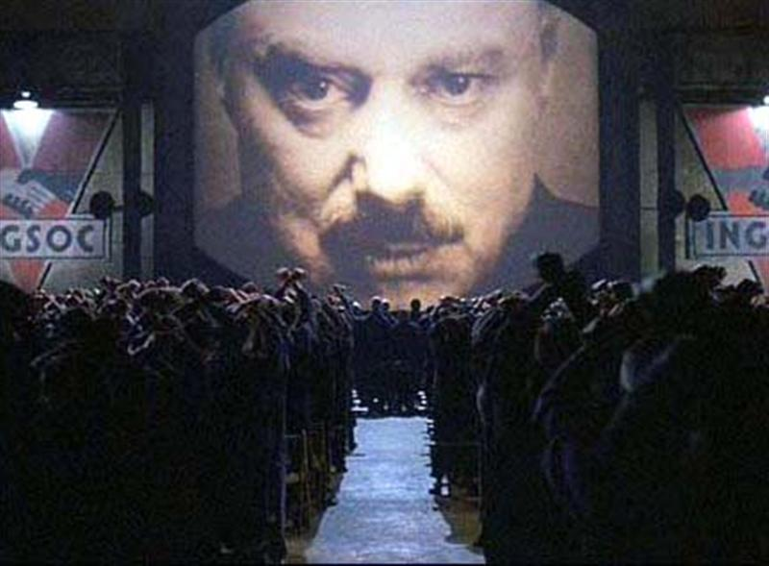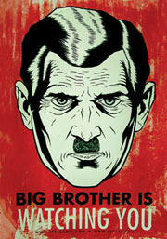

This is the description of the extract which you might find at the top of the extract in an exam paper. Read it and highlight what you consider to be the most important information.
The story takes place in an imagined future, the year 1984, when much of the world has fallen victim to perpetual war, omnipresent government surveillance and propaganda. Great Britain, known as Airstrip One, has become a province of a superstate named Oceania that is ruled by the Party who employ the Thought Police to persecute individuality and independent thinking. Big Brother, the leader of the Party, enjoys an intense cult of personality despite the fact that he may not exist. The protagonist, Winston Smith, is a diligent and skillful rank-and-file worker and Party member who secretly hates the Party and dreams of rebellion.
There are some difficult words in this summary. Do you know what they mean? Could you work out what they mean from the context of the sentence in which they appear?
Perpetual ______________________________________________________________
Omnipresent ___________________________________________________________
Surveillance ____________________________________________________________
Propaganda ____________________________________________________________
Province _______________________________________________________________
Persecute ______________________________________________________________
Cult of personality _______________________________________________________
Diligent ________________________________________________________________

Using the tasks you have completed so far, predict what you think the extract is going to be about.
I think this extract will be about _________________________________________________
___________________________________________________________________________
___________________________________________________________________________
___________________________________________________________________________

Task Two: Reading

Read the extract. Highlight two sentences in each paragraph which you deem to be the most important. Down the left-hand side, add a title for each paragraph. On the right-hand side, summarise what each paragraph is saying in two or three bullet points. One has been done for you so you can see what your work should look like.
Bullet Point Paragraph Summary
Winston goes home in the windy weather.
Paragraph Titles
It was a bright cold day in April, and the clocks were striking thirteen. Winston Smith, his chin nuzzled into his breast in an effort to escape the vile wind, slipped quickly through the glass doors of Victory Mansions, though not quickly enough to prevent a swirl of gritty dust from entering along with him.
Everything seems odd – ‘clocks were striking thirteen’.
Windy – seems an unfriendly place. Doesn’t seem very victorious!
The hallway smelt of boiled cabbage and old rag mats. At one end of it a coloured poster, too large for indoor display, had been tacked to the wall. It depicted simply an enormous face, more than a metre wide: the face of a man of about forty-five, with a heavy black moustache and ruggedly handsome features. Winston made for the stairs. It was no use trying the lift. Even at the best of times it was seldom working, and at present the electric current was cut off during daylight hours. It was part of the economy drive in preparation for Hate Week. The flat was seven flights up, and Winston, who was thirty-nine and had a varicose ulcer above his right ankle, went slowly, resting several times on the way. On each landing, opposite the lift-shaft, the poster with the enormous face gazed from the wall. It was one of those pictures which are so contrived that the eyes follow you about when you move. BIG BROTHER IS WATCHING YOU, the caption beneath it ran.
Inside the flat a fruity voice was reading out a list of figures which had something to do with the production of pig-iron. The voice came from an oblong metal plaque like a dulled mirror which formed part of the surface of the right-hand wall. Winston turned a switch and the voice sank somewhat, though the words were still distinguishable. The instrument (the telescreen, it was called) could be dimmed, but there was no way of shutting it off completely. He moved over to the window: a smallish, frail figure, the meagreness of his body merely emphasized by the blue overalls which were the uniform of the party. His hair was very fair, his face naturally sanguine, his skin roughened by coarse soap and blunt razor blades and the cold of the winter that had just ended.
Outside, even through the shut window-pane, the world looked cold. Down in the street little eddies of wind were whirling dust and torn paper into spirals, and though the sun was shining and the sky a harsh blue, there seemed to be no colour in anything, except the posters that were plastered everywhere. The blackmoustachio'd face gazed down from every commanding corner. There was one on the house-front immediately opposite. BIG BROTHER IS WATCHING YOU, the caption said, while the dark eyes looked deep into Winston's own. Down at streetlevel another poster, torn at one corner, flapped fitfully in the wind, alternately covering and uncovering the single word INGSOC. In the far distance a helicopter skimmed down between the roofs, hovered for an instant like a bluebottle, and darted away again with a curving flight. It was the police patrol, snooping into people's windows. The patrols did not matter, however. Only the Thought Police mattered.
Behind Winston's back the voice from the telescreen was still babbling away about pig-iron and the overfulfilment of the Ninth Three-Year Plan. The telescreen received and transmitted simultaneously. Any sound that Winston made, above the level of a very low whisper, would be picked up by it, moreover, so long as he remained within the field of vision which the metal plaque commanded, he could be seen as well as heard. There was of course no way of knowing whether you were being watched at any given moment. How often, or on what system, the Thought Police plugged in on any individual wire was guesswork. It was even conceivable that they watched everybody all the time. But at any rate they could plug in your wire whenever they wanted to. You had to live -- did live, from habit that became instinct -- in the assumption that every sound you made was overheard, and, except in darkness, every movement scrutinized.
Winston kept his back turned to the telescreen. It was safer, though, as he well knew, even a back can be revealing. A kilometre away the Ministry of Truth, his place of work, towered vast and white above the grimy landscape. This, he thought with a sort of vague distaste -- this was London, chief city of Airstrip One, itself the third most populous of the provinces of Oceania. He tried to squeeze out some childhood memory that should tell him whether London had always been quite like this. Were there always these vistas of rotting nineteenth-century houses, their sides shored up with baulks of timber, their windows patched with cardboard and their roofs with corrugated iron, their crazy garden walls sagging in all directions? And the bombed sites where the plaster dust swirled in the air and the willow-herb straggled over the heaps of rubble; and the places where the bombs had cleared a larger patch and there had sprung up sordid colonies of wooden dwellings like chicken-houses? But it was no use, he could not remember: nothing remained of his childhood except a series of bright-lit tableaux occurring against no background and mostly unintelligible.
The Ministry of Truth -- Minitrue, in Newspeak -- was startlingly different from any other object in sight. It was an enormous pyramidal structure of glittering white concrete, soaring up, terrace after terrace, 300 metres into the air. From where Winston stood it was just possible to read, picked out on its white face in elegant lettering, the three slogans of the Party:
WAR IS PEACE
FREEDOM IS SLAVERY
IGNORANCE IS STRENGTH
The Ministry of Truth contained, it was said, three thousand rooms above ground level, and corresponding ramifications below. Scattered about London there were just three other buildings of similar appearance and size. So completely did they dwarf the surrounding architecture that from the roof of Victory Mansions you could see all four of them simultaneously. They were the homes of the four Ministries between which the entire apparatus of government was divided. The Ministry of Truth, which concerned itself with news, entertainment, education, and the fine arts. The Ministry of Peace, which concerned itself with war. The Ministry of Love, which maintained law and order. And the Ministry of Plenty, which was responsible for economic affairs. Their names, in Newspeak: Minitrue, Minipax, Miniluv, and Miniplenty.
The Ministry of Love was the really frightening one. There were no windows in it at all. Winston had never been inside the Ministry of Love, nor within half a kilometre of it. It was a place impossible to enter except on official business, and then only by penetrating through a maze of barbed-wire entanglements, steel doors, and hidden machine-gun nests. Even the streets leading up to its outer barriers were roamed by gorilla-faced guards in black uniforms, armed with jointed truncheons.
Winston turned round abruptly. He had set his features into the expression of quiet optimism which it was advisable to wear when facing the telescreen. He crossed the room into the tiny kitchen. By leaving the Ministry at this time of day he had sacrificed his lunch in the canteen, and he was aware that there was no food in the kitchen except a hunk of dark-coloured bread which had got to be saved for tomorrow's breakfast. He took down from the shelf a bottle of colourless liquid with a plain white label marked VICTORY GIN. It gave off a sickly, oily smell, as of Chinese ricespirit. Winston poured out nearly a teacupful, nerved himself for a shock, and gulped it down like a dose of medicine.

Task Three: Post-Reading Questions
Answer the following comprehension questions on what you have just read.
- What building does Winston Smith live in?

- What did the hallway smell of?

- What wasn’t working because of an economy drive?

- What was the slogan on all the posters Winston could see?

- List three ways the writer describes the world outside Winston’s window.

- What or who is Winston watched by?

- Where does Winston work?

- What are the slogans of the party?

- What are the names of the other ‘Ministries’?

- What does the Ministry of Peace do?

Task Four: Analysing Language

In your exam, as you know, you will be expected to closely analyse language. We always talk about ‘saying a lot about a little.’
You’re going to look now at the following question:
How does Orwell use language to describe Winston and the place he lives?
Your could write about:
- Words and phrases
- Language features and techniques
- Sentence forms [8 marks]
This extract is longer than the one you will get in your exam, and so you will probably find lots of things to highlight or write about! You could start by looking again at your paragraph titles and summaries to look for the most relevant language features.
If you struggle to find some good words, phrases, features and techniques, take a look at the resource below and use this to explore Orwell’s use of language. I have given you some prompt questions to help you annotate each quotation in detail.
The hallway smelt of boiled cabbage and old rag mats.

- Given that Winston’s building is called ‘Victory Mansions’, how does this image juxtapose the name?
- What type of imagery is this? Why has Orwell used it?
- What do the smells – ‘boiled cabbage’ and ‘old rag mats’ suggest about the place?

The flat was seven flights up, and Winston, who was thirty-nine and had a varicose ulcer above his right ankle, went slowly, resting several times on the way.

- What is a varicose ulcer? What does it suggest about Winston?
- Why might Winston be moving ‘slowly’?
- How does this image of Winston compare to the fact he is only 39?
On each landing, opposite the lift-shaft, the poster with the enormous face gazed from the wall. It was one of those pictures which are so contrived that the eyes follow you about when you move. BIG BROTHER IS WATCHING YOU, the caption beneath it ran.

- Why do you think Orwell has capitalised the caption?
- These posters are on every landing. What does this suggest? How might this make Winston feel?
- Winston feels as if he is being watched by the poster. What does this suggest about the society Winston lives in?

He moved over to the window: a smallish, frail figure, the meagreness of his body merely emphasized by the blue overalls which were the uniform of the party. His hair was very fair, his face naturally sanguine, his skin roughened by coarse soap and blunt razor blades and the cold of the winter that had just ended.

- What adjectives does Orwell use to describe Winston? What do these suggest about him?
- ‘Sanguine’ means that he looks positive, especially in the face of a bad situation. What does this suggest about Winston?
- ‘Coarse’ and ‘blunt’ are both quite negative words. What impression do you get about how people are able to look after themselves in this society?

Outside, even through the shut window-pane, the world looked cold. Down in the street little eddies of wind were whirling dust and torn paper into spirals, and though the sun was shining and the sky a harsh blue, there seemed to be no colour in anything, except the posters that were plastered everywhere.

- What impression of this place do you get from the windiness Orwell describes?
- The sky is a ‘harsh’ blue. Why do you think Orwell chose the word ‘harsh’?
- The place seems ‘colourless’ apart from the posters. What does this suggest about the society, and the importance in that society of the man on the posters?

Were there always these vistas of rotting nineteenth-century houses, their sides shored up with baulks of timber, their windows patched with cardboard and their roofs with corrugated iron, their crazy garden walls sagging in all directions? And the bombed sites where the plaster dust swirled in the air and the willow-herb straggled over the heaps of rubble; and the places where the bombs had cleared a larger patch and there had sprung up sordid colonies of wooden dwellings like chicken-houses?

- Words like ‘rotting’, ‘patched’ and ‘sagging’ give a very specific impression of the houses. What impression does it give you?
- What does the fact that Winston cannot remember a time when the houses looked like this suggest?
- There are plants growing in the rubble, and people have built shelters where bombed houses once stood. What might this suggest about nature and the people of Airstrip One?
Now, either with your annotated quotes or your annotations on the extract, you are ready to answer the exam-style question. Don’t forget that in order to push your mark up for this question, you must ‘say a lot about a little.’ For example, you can do this by offering an alternative interpretation of a quotation or by zooming in on a key word from that quote.
For example:
In the extract, Winston is described as being “a smallish, frail figure”. This conjures an image for the reader of him being perhaps weak and less able to stand up for himself. In particular, Orwell’s use of the word “frail” supports this view: it suggests that Winston is weak and delicate, and could also suggest that his environment and experiences have made him weak. The reader’s overall impression of Winston from this quotation is that he is not strong or robust. The word “smallish”, however, could suggest that Winston has perhaps once been a man capable of power. He is not “small”, but “smallish”: in comparison to others he is still not the smallest. It is perhaps the case that his environment and situation has reduced Winston to a smaller version of the man he once was.
Write your answer here:
___________________________________________________________________________
___________________________________________________________________________
___________________________________________________________________________
___________________________________________________________________________
___________________________________________________________________________
___________________________________________________________________________
___________________________________________________________________________
___________________________________________________________________________
___________________________________________________________________________
___________________________________________________________________________
___________________________________________________________________________
___________________________________________________________________________
___________________________________________________________________________
___________________________________________________________________________
___________________________________________________________________________
___________________________________________________________________________
___________________________________________________________________________
___________________________________________________________________________
___________________________________________________________________________
___________________________________________________________________________
___________________________________________________________________________
___________________________________________________________________________
___________________________________________________________________________
___________________________________________________________________________
___________________________________________________________________________
___________________________________________________________________________
___________________________________________________________________________
___________________________________________________________________________
___________________________________________________________________________
___________________________________________________________________________
___________________________________________________________________________
___________________________________________________________________________
___________________________________________________________________________
___________________________________________________________________________
___________________________________________________________________________
___________________________________________________________________________
___________________________________________________________________________
___________________________________________________________________________
___________________________________________________________________________
___________________________________________________________________________
___________________________________________________________________________
___________________________________________________________________________
___________________________________________________________________________
___________________________________________________________________________
___________________________________________________________________________
___________________________________________________________________________
___________________________________________________________________________
___________________________________________________________________________
___________________________________________________________________________
___________________________________________________________________________
___________________________________________________________________________
___________________________________________________________________________
___________________________________________________________________________
___________________________________________________________________________
___________________________________________________________________________
___________________________________________________________________________
___________________________________________________________________________
___________________________________________________________________________
___________________________________________________________________________
___________________________________________________________________________
___________________________________________________________________________
___________________________________________________________________________
___________________________________________________________________________
___________________________________________________________________________
___________________________________________________________________________
___________________________________________________________________________
___________________________________________________________________________
___________________________________________________________________________
___________________________________________________________________________
___________________________________________________________________________
___________________________________________________________________________
___________________________________________________________________________
___________________________________________________________________________
___________________________________________________________________________
___________________________________________________________________________
___________________________________________________________________________
You will be familiar with the mark scheme for this question, which I have put below.
AO2
Explain, comment on and analyse how writers use language and structure to achieve effects and influence readers, using relevant subject terminology to support their views.
This question assesses Language ie: Words/Phrases/Language Features/Language Techniques/Sentence Forms
Level | Skills Descriptors
Level 4  Perceptive, detailed analysis  7-8 marks | Shows perceptive and detailed understanding of language:  - Analyses the effects of the writer’s choice of language  - Selects a range of judicious textual detail  - Makes sophisticated and accurate use of subject terminology
Level 3  Clear, relevant explanation  5-6 marks | Shows clear understanding of language:  - Explains clearly the effects of the writer’s choice of language  - Selects a range of relevant textual detail  - Makes clear and accurate use of subject terminology
Level 2  Some understanding and comment  3-4 marks | Shows some understanding of language:  - Attempts to comment on the effect of language  - Selects some appropriate textual detail  - Makes some use of subject terminology, mainly appropriately
Level 1  Simple, limited comment  1-2 marks | Shows simple awareness of language:  - Offers simple comment on the effect of language  - Selects simple reference(s) or textual detail(s)  - Makes simple use of subject terminology, not always appropriately
Level 0  No marks | Nothing to reward

Give yourself a mark out of eight, and write yourself a WWW (what went well) and an EBI (even better if) below:
I am giving my answer _____ marks because ______________________________________
___________________________________________________________________________.
WWW: _____________________________________________________________________
___________________________________________________________________________
___________________________________________________________________________.
EBI: _______________________________________________________________________
___________________________________________________________________________
___________________________________________________________________________.

Task Five: Analysing Structure

Question 3 in your Paper 1 exam paper is all about structural analysis.
What are the key things we ask you to look at when you are considering the structure of a text? Jot them in the box below.
As well as these key features, you might also spot in any extract some of the following techniques. Can you define each technique? Why might a writer use them?
Technique | Definition
Analepsis
Prolepsis
Anaphora

Read again at the extract from ‘1984’. Look at your paragraph headings and summaries, and use those notes and your knowledge of the text to complete the following grid. I have completed the first one to help you:
Place | What happens? | Why?
Beginning | Orwell describes Winston as he arrives at home. | The reader gets to see Winston who appears to be struggling the weather, and wants to know more about him. The opening line is enigmatic and confusing.
End
Shift…
Shift…
Shift…

Now you’ve had a go at planning some ideas, the time has come to write up an answer to the following question. Don’t forget that this question never changes, apart from to tell you where in a story the extract has come from.
This text is from the beginning of a novel.
How has the writer structured the text to interest you as a reader?
You could write about:
- What the writer focuses your attention on at the beginning of the source
- How and why the writer changes this focus as the source develops
- Any other structural features that interest you. [8 marks]
___________________________________________________________________________
___________________________________________________________________________
___________________________________________________________________________
___________________________________________________________________________
___________________________________________________________________________
___________________________________________________________________________
___________________________________________________________________________
___________________________________________________________________________
___________________________________________________________________________
___________________________________________________________________________
___________________________________________________________________________
___________________________________________________________________________
___________________________________________________________________________
___________________________________________________________________________
___________________________________________________________________________
___________________________________________________________________________
___________________________________________________________________________
___________________________________________________________________________
___________________________________________________________________________
___________________________________________________________________________
___________________________________________________________________________
___________________________________________________________________________
___________________________________________________________________________
___________________________________________________________________________
___________________________________________________________________________
___________________________________________________________________________
___________________________________________________________________________
___________________________________________________________________________
______________________________________________________________________________________________________________________________________________________
___________________________________________________________________________
___________________________________________________________________________
___________________________________________________________________________
___________________________________________________________________________
___________________________________________________________________________
___________________________________________________________________________
___________________________________________________________________________
___________________________________________________________________________
___________________________________________________________________________
___________________________________________________________________________
___________________________________________________________________________
___________________________________________________________________________
___________________________________________________________________________
___________________________________________________________________________
___________________________________________________________________________
___________________________________________________________________________
___________________________________________________________________________
___________________________________________________________________________
___________________________________________________________________________
___________________________________________________________________________
___________________________________________________________________________
___________________________________________________________________________
___________________________________________________________________________
___________________________________________________________________________
___________________________________________________________________________
___________________________________________________________________________
___________________________________________________________________________
___________________________________________________________________________
___________________________________________________________________________
___________________________________________________________________________
___________________________________________________________________________
Just as with the language question you have completed, you are familiar with the mark scheme for this question. I have placed a copy below.
AO2
Explain, comment on and analyse how writers use language and structure to achieve effects and influence readers, using relevant subject terminology to support their views.
This question assesses how the writer has structured a text. Structural features can be: at a whole text level eg. Beginnings/endings/perspective shifts; at a paragraph level eg. Topic change/aspects of cohesion; and at a sentence level when judged to contribute to whole structure.
Level | Skills Descriptors
Level 4  Perceptive, detailed analysis  7-8 marks | Shows perceptive and detailed understanding of structural features:  - Analyses the effects of the writer’s choices of structural features  - Selects a range of judicious examples  - Makes sophisticated and accurate use of subject terminology
Level 3  Clear, relevant explanation  5-6 marks | Shows clear understanding of structural features:  - Explains clearly the effects of the writer’s choices of structural features  - Selects a range of relevant examples  - Makes clear and accurate use of subject terminology
Level 2  Some understanding and comment  3-4 marks | Shows some understanding of structural features:  - Attempts to comment on the effect of structural features  - Selects some appropriate examples  - Makes some use of subject terminology, mainly appropriately
Level 1  Simple, limited comment  1-2 marks | Shows simple awareness of structural features:  - Offers simple comment on the effect of structure  - Selects simple reference(s) or example(s)  - Makes simple use of subject terminology, not always appropriately
Level 0  No marks | Nothing to reward

Give yourself a mark out of eight, and write yourself a WWW (what went well) and an EBI (even better if) below:
I am giving my answer _____ marks because ______________________________________
___________________________________________________________________________.
WWW: _____________________________________________________________________
___________________________________________________________________________.
EBI: _______________________________________________________________________
___________________________________________________________________________.
Task Six: To what extent do you agree?

In this question in the exam, you are asked not only to analyse what the writer is doing but also to suggest how far you agree with a statement. This means some juggling of skills, and this is why this question is worth 20 marks!
Let’s start by taking a look at the question.
A student, having read this extract, said: ‘To me, it seems like Winston’s situation is hopeless. It is clear that, regardless of what he does, he is monitored and controlled.’

To what extent do you agree?

In your response, you could:

- Consider your own impressions of Winston’s situation
- Evaluate how the writer presents Winston’s situation
- Support your response with references to the text.

[20 marks]

Our first step is to decide how much we agree with that statement. Generally, my advice has been that you are going to agree, with a slight reservation.
Place your level of agreement on the line below and explain why you agree to that particular extent.
Disagree Neutral Agree

Use the grid below to plan out the quotations you might use and how that quote help you to agree (or slightly disagree!) with the statement. I have given you three quotations. Try to include three of your own!
Quote | How does it help me agree with the statement?
Winston made for the stairs. It was no use trying the lift. | ‘No use’ suggests that Winston doesn’t see the point – he knows the electric will be off. Short sentences could imply that he is almost exhausted by the idea of trying anything new/ different – he is resigned to his fate.
On each landing, opposite the lift-shaft, the poster with the enormous face gazed from the wall. It was one of those pictures which are so contrived that the eyes follow you about when you move.
Down in the street little eddies of wind were whirling dust and torn paper into spirals, and though the sun was shining and the sky a harsh blue, there seemed to be no colour in anything, except the posters that were plastered everywhere.
Now, you can think about putting together your answer to this question. It’s important that in each paragraph you include the following:
- What the writer has done to make you agree/ disagree with the statement
- A well chosen reference to the text
- Detailed analysis of the quotation, demonstrating how that reference helps you to agree/ disagree.
Give it a go in the space below – use notes from your mock exams etc. to help you structure your answer.
___________________________________________________________________________
___________________________________________________________________________
___________________________________________________________________________
___________________________________________________________________________
___________________________________________________________________________
___________________________________________________________________________
___________________________________________________________________________
___________________________________________________________________________
___________________________________________________________________________
___________________________________________________________________________
___________________________________________________________________________
___________________________________________________________________________
___________________________________________________________________________
___________________________________________________________________________
___________________________________________________________________________
___________________________________________________________________________
___________________________________________________________________________
___________________________________________________________________________
___________________________________________________________________________
___________________________________________________________________________
___________________________________________________________________________
___________________________________________________________________________
___________________________________________________________________________
___________________________________________________________________________
___________________________________________________________________________
___________________________________________________________________________
___________________________________________________________________________
___________________________________________________________________________
___________________________________________________________________________
___________________________________________________________________________
___________________________________________________________________________
___________________________________________________________________________
___________________________________________________________________________
___________________________________________________________________________
___________________________________________________________________________
___________________________________________________________________________
___________________________________________________________________________
___________________________________________________________________________
___________________________________________________________________________
___________________________________________________________________________
___________________________________________________________________________
___________________________________________________________________________
___________________________________________________________________________
___________________________________________________________________________
___________________________________________________________________________
___________________________________________________________________________
___________________________________________________________________________
___________________________________________________________________________
___________________________________________________________________________
___________________________________________________________________________
___________________________________________________________________________
___________________________________________________________________________
___________________________________________________________________________
___________________________________________________________________________
___________________________________________________________________________
___________________________________________________________________________
___________________________________________________________________________
___________________________________________________________________________
___________________________________________________________________________
___________________________________________________________________________
___________________________________________________________________________
___________________________________________________________________________
___________________________________________________________________________
___________________________________________________________________________
___________________________________________________________________________
___________________________________________________________________________
___________________________________________________________________________
___________________________________________________________________________
___________________________________________________________________________
___________________________________________________________________________
___________________________________________________________________________
___________________________________________________________________________
___________________________________________________________________________
___________________________________________________________________________
___________________________________________________________________________
___________________________________________________________________________
___________________________________________________________________________
___________________________________________________________________________
___________________________________________________________________________
___________________________________________________________________________
___________________________________________________________________________
___________________________________________________________________________
___________________________________________________________________________
___________________________________________________________________________
___________________________________________________________________________
___________________________________________________________________________
___________________________________________________________________________
___________________________________________________________________________
___________________________________________________________________________
___________________________________________________________________________
___________________________________________________________________________
___________________________________________________________________________
___________________________________________________________________________
___________________________________________________________________________
___________________________________________________________________________
___________________________________________________________________________
___________________________________________________________________________
___________________________________________________________________________
___________________________________________________________________________
___________________________________________________________________________
___________________________________________________________________________
___________________________________________________________________________
___________________________________________________________________________
___________________________________________________________________________
___________________________________________________________________________
___________________________________________________________________________
___________________________________________________________________________
___________________________________________________________________________
___________________________________________________________________________
___________________________________________________________________________
Now you’ve written your answer, it’s time to have a look at the mark scheme. As always, these are the words and descriptions the examiner will have in front of them in the summer which will help them mark your work. You are already familiar with the mark scheme for this question. I have placed a copy below.
AO4
Evaluate texts critically and support this with appropriate textual references
Level | Skills Descriptors
Level 4  Perceptive, detailed evaluation  16-20 marks | Shows perceptive and detailed evaluation:  - Evaluates critically and in detail the effect(s) on the reader  - Shows perceptive understanding of writer’s methods  - Selects a range of judicious textual detail  - Develops a convincing and critical response to the focus of the statement
Level 3  Clear, relevant evaluation  11-15 marks | Shows clear and relevant evaluation:  - Evaluates clearly the effect(s) on the reader  - Shows clear understanding of writer’s methods  - Selects a range of relevant textual references  - Makes a clear and relevant response to the focus of the statement
Level 2  Some evaluation  6-10 marks | Shows some attempts at evaluation:  - Makes some evaluative comment(s) on effect(s) on the reader  - Shows some understanding of writer’s methods  - Selects some appropriate textual reference(s)  - Makes some response to the focus of the statement
Level 1  Simple, limited comment  1-5 marks | Shows simple, limited evaluation:  - Makes simple, limited evaluative comment(s) on effect(s) on reader  - Shows limited understanding of writer’s methods  - Selects simple, limited textual reference(s)  - Makes a simple, limited response to the focus of the statement
Level 0  No marks | Nothing to reward

Give yourself a mark out of twenty, and write yourself a WWW (what went well) and an EBI (even better if) below:
I am giving my answer _____ marks because ______________________________________
___________________________________________________________________________.
WWW: _____________________________________________________________________
___________________________________________________________________________.
EBI: _______________________________________________________________________
___________________________________________________________________________.
Task Seven: Using sensory imagery
The final question, as you know, is all about creative writing. One of the things Orwell does very well is use sensory imagery to help us imagine the environment in which Winston finds himself. Use the tasks below to help you explore writing using sensory imagery.
Imagery: Using the image below, come up with at least five pieces of vocabulary or phrases you could use to describe the setting in the image below.
Visual | Auditory | Olfactory | Gustatory | Tactile

Words to describe atmosphere: | 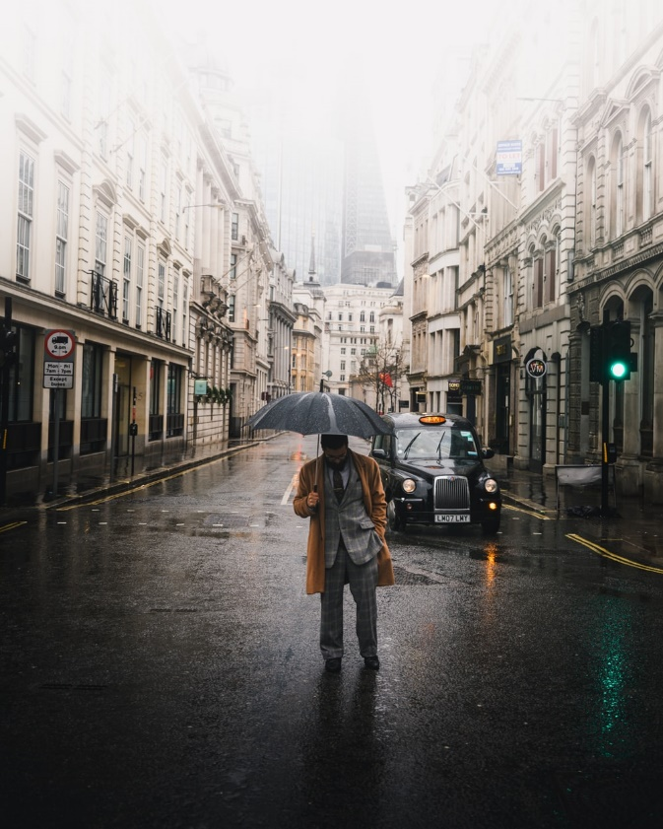 | Who is the character? Note their key features.
What tone are you trying to suggest? How are you going to do this? |  | Why are they there? What information could you withhold, yet suggest?

Plan your response. Remember that you are aiming to present the information to your reader in a carefully planned order – you want to build a sense of intrigue without giving away everything in the piece’s opening moments! You are going to plan and write the opening three paragraphs of your piece.

Paragraph One: Start with a ‘long shot’ and describe the whole scene. Make it as vast and panoramic as you can. Try to create a sense of atmosphere. Think about the five senses – what time of day is it? What is the weather like? Put one or two very distant figures in the shot.

Paragraph Two: Move the ‘camera’ closer – but not too close. Focus on one or both figures and describe them as they appear from about 25-30 metres (you can’t see the detail of their faces but you can see clothes and movements, estimate age, body language etc.)

Paragraph Three: ‘Zoom in‘ closer so we can hear their conversation. Write some intriguing dialogue: a row or arrangements being made for something.

Now, write the first three paragraphs of your descriptive story, beginning with the setting in the picture. Don’t forget that you are going to use lots of powerful imagery to convey a sense of mood, setting and atmosphere. You will also need to use a range of sentence types.

Helpful tips:
- Remember to use a range of sentence types and lengths
- Do not use phrases like ‘they could see..’ or ‘they could smell…’. Show me this through description; don’t just tell me
- Aim to use a range of imagery, as well as simile, metaphor, personification and alliteration
- Remember to use ambitious vocabulary – ie. Instead of ‘the sun rose in the morning sky’, try ‘In the east, the sun has climbed above the cold grey peaks of the mountains and cast a thin yellow warmth across the expanse of dust and gravel’

___________________________________________________________________________
___________________________________________________________________________
___________________________________________________________________________
___________________________________________________________________________
___________________________________________________________________________
___________________________________________________________________________
___________________________________________________________________________
___________________________________________________________________________
___________________________________________________________________________
___________________________________________________________________________
___________________________________________________________________________
___________________________________________________________________________
___________________________________________________________________________
___________________________________________________________________________
___________________________________________________________________________
___________________________________________________________________________
___________________________________________________________________________
___________________________________________________________________________
___________________________________________________________________________
___________________________________________________________________________
___________________________________________________________________________
___________________________________________________________________________
___________________________________________________________________________
___________________________________________________________________________
___________________________________________________________________________
___________________________________________________________________________
___________________________________________________________________________
___________________________________________________________________________
___________________________________________________________________________
___________________________________________________________________________
___________________________________________________________________________
___________________________________________________________________________
___________________________________________________________________________
___________________________________________________________________________
___________________________________________________________________________
___________________________________________________________________________
___________________________________________________________________________
___________________________________________________________________________
___________________________________________________________________________
___________________________________________________________________________
___________________________________________________________________________
___________________________________________________________________________
___________________________________________________________________________
___________________________________________________________________________
___________________________________________________________________________
___________________________________________________________________________
___________________________________________________________________________
___________________________________________________________________________
___________________________________________________________________________
___________________________________________________________________________
___________________________________________________________________________
___________________________________________________________________________
___________________________________________________________________________
___________________________________________________________________________
___________________________________________________________________________
___________________________________________________________________________
___________________________________________________________________________
___________________________________________________________________________
___________________________________________________________________________
___________________________________________________________________________
___________________________________________________________________________
___________________________________________________________________________
___________________________________________________________________________
___________________________________________________________________________
___________________________________________________________________________
___________________________________________________________________________
___________________________________________________________________________
___________________________________________________________________________
___________________________________________________________________________
___________________________________________________________________________
___________________________________________________________________________
___________________________________________________________________________
___________________________________________________________________________
___________________________________________________________________________
___________________________________________________________________________
___________________________________________________________________________
___________________________________________________________________________
___________________________________________________________________________
___________________________________________________________________________
___________________________________________________________________________
___________________________________________________________________________
___________________________________________________________________________
___________________________________________________________________________
___________________________________________________________________________
___________________________________________________________________________
___________________________________________________________________________
___________________________________________________________________________
___________________________________________________________________________
___________________________________________________________________________
___________________________________________________________________________
___________________________________________________________________________
Task 8:
Once you have finished your writing, read it back. Using your piece of writing, can you answer the following question?

How has the writer used language to create a vivid setting?
You could write about:
- Words and phrases
- Language features and techniques
- Sentence forms [8 marks]

If your work is not yet good enough for you to be able to answer this question convincingly, rewrite a paragraph so that it is.
___________________________________________________________________________
___________________________________________________________________________
___________________________________________________________________________
___________________________________________________________________________
___________________________________________________________________________
___________________________________________________________________________
___________________________________________________________________________
___________________________________________________________________________
___________________________________________________________________________
___________________________________________________________________________
___________________________________________________________________________
___________________________________________________________________________
___________________________________________________________________________
___________________________________________________________________________
___________________________________________________________________________
___________________________________________________________________________
___________________________________________________________________________
___________________________________________________________________________
___________________________________________________________________________
___________________________________________________________________________
___________________________________________________________________________
___________________________________________________________________________
___________________________________________________________________________
___________________________________________________________________________
___________________________________________________________________________
___________________________________________________________________________
___________________________________________________________________________
___________________________________________________________________________
___________________________________________________________________________
___________________________________________________________________________
___________________________________________________________________________
___________________________________________________________________________
___________________________________________________________________________
___________________________________________________________________________
___________________________________________________________________________
___________________________________________________________________________
___________________________________________________________________________
___________________________________________________________________________
___________________________________________________________________________
___________________________________________________________________________
___________________________________________________________________________
___________________________________________________________________________
___________________________________________________________________________
___________________________________________________________________________
___________________________________________________________________________
___________________________________________________________________________
___________________________________________________________________________
Answers
Task One
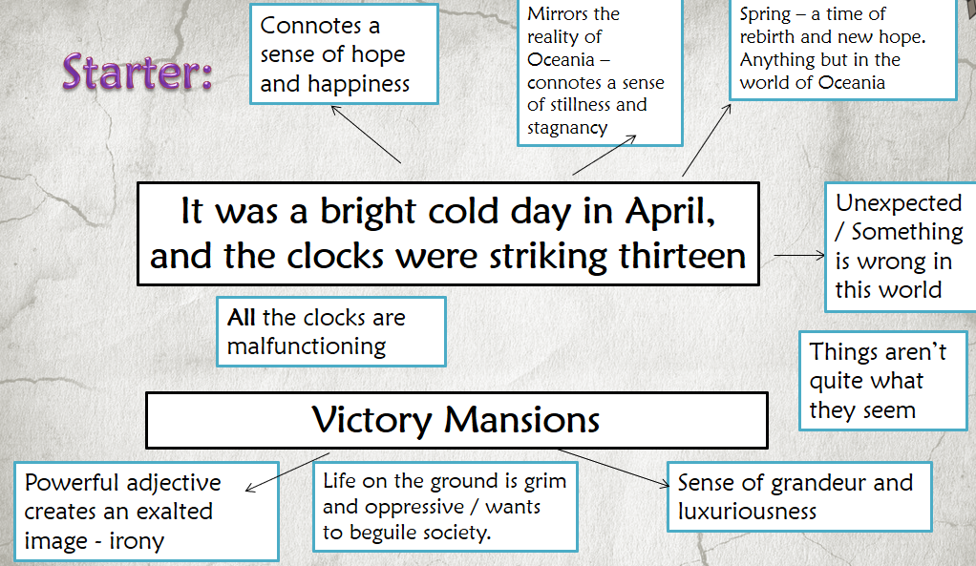
Perpetual: never ending or changing
Omnipresent: widely or constantly encountered; widespread. Something that is everywhere, all the time.
Surveillance: close observation, especially of a suspected spy or criminal.
Propaganda: information, especially of a biased or misleading nature, used to promote a political cause or point of view.
Province: part of a country or empire.
Persecute: treat someone poorly because of their race or political or religious beliefs.
Cult of personality: a situation in which a public figure (such as a political leader) is deliberately presented to the people of a country as a great person who should be admired and loved.
Diligent: having or showing care and conscientiousness in one's work or duties.

Task Three
- Victory Mansions
- Boiled cabbage and old rag mats
- The lift – there was rationed electricity during the day
- BIG BROTHER IS WATCHING YOU
- Windy, no colour in anything, torn posters
- The man on the poster/ the telescreen (either answer is right!)
- The Ministry of Truth
- War is Peace; Freedom is Slavery; Ignorance is Strength
- Ministry of Love, Ministry of Peace, Ministry of Ministry of Plenty
- Works around wars

Task Five
The beginning – what is focused on and why?
The end – what is focused on and why?
Is there a cyclical structure? Do the beginning and end mirror each other? Why?
Shifts in time, place, narrator, focus…

Technique | Definition
Analepsis | Flashback: a past event is narrated at a point later than its chronological place in a story.
Prolepsis | Flashforward: the plot goes ahead of time; meaning a scene that interrupts and takes the narrative forward in time from the current time in the story.

