IAGO
Something from Venice, sure. 'Tis Lodovico
Come from the duke: and, see, your wife is with him.
Enter LODOVICO, DESDEMONA, and Attendants
LODOVICO
Save you, worthy general!
OTHELLO
With all my heart, sir.
LODOVICO
The duke and senators of Venice greet you.
Gives him a letter
OTHELLO
I kiss the instrument of their pleasures.
Opens the letter, and reads
DESDEMONA
And what's the news, good cousin Lodovico?
IAGO
I am very glad to see you, signior
Welcome to Cyprus.
LODOVICO
I thank you. How does Lieutenant Cassio?
IAGO
Lives, sir.
DESDEMONA
Cousin, there's fall'n between him and my lord
An unkind breach: but you shall make all well.
OTHELLO
Are you sure of that?
DESDEMONA
My lord?
OTHELLO
[Reads] 'This fail you not to do, as you will--'
LODOVICO
He did not call; he's busy in the paper.
Is there division 'twixt my lord and Cassio?
DESDEMONA
A most unhappy one: I would do much
To atone them, for the love I bear to Cassio.
OTHELLO
Fire and brimstone!
DESDEMONA
My lord?
OTHELLO
Are you wise?
DESDEMONA
What, is he angry?
LODOVICO
May be the letter moved him;
For, as I think, they do command him home,
Deputing Cassio in his government.
DESDEMONA
Trust me, I am glad on't.
OTHELLO
Indeed!
DESDEMONA
My lord?
OTHELLO
I am glad to see you mad.
DESDEMONA
Why, sweet Othello,--
OTHELLO
[Striking her] Devil!
DESDEMONA
I have not deserved this.
LODOVICO
My lord, this would not be believed in Venice,
Though I should swear I saw't: 'tis very much:
Make her amends; she weeps.
OTHELLO
O devil, devil!
If that the earth could teem with woman's tears,
Each drop she falls would prove a crocodile.
Out of my sight!
DESDEMONA
I will not stay to offend you.
Going
LODOVICO
Truly, an obedient lady:
I do beseech your lordship, call her back.
OTHELLO
Mistress!
DESDEMONA
My lord?
OTHELLO
What would you with her, sir?
LODOVICO
Who, I, my lord?
OTHELLO
Ay; you did wish that I would make her turn:
Sir, she can turn, and turn, and yet go on,
And turn again; and she can weep, sir, weep;
And she's obedient, as you say, obedient,
Very obedient. Proceed you in your tears.
Concerning this, sir,--O well-painted passion!--
I am commanded home. Get you away;
I'll send for you anon. Sir, I obey the mandate,
And will return to Venice. Hence, avaunt!
Exit DESDEMONA
Cassio shall have my place. And, sir, tonight,
I do entreat that we may sup together:
You are welcome, sir, to Cyprus.--Goats and monkeys!
Exit

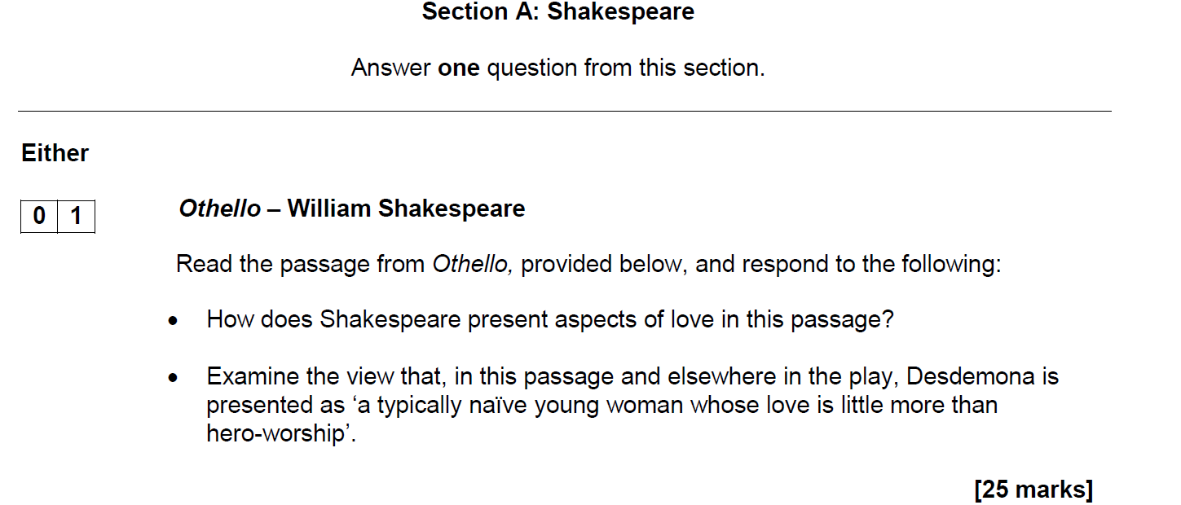
- Examine the view that, in this passage and elsewhere in the play, Othello is presented as ‘a typically violent and suspicious man whose love is little more than a physical attraction’.

