De Aston
English Department
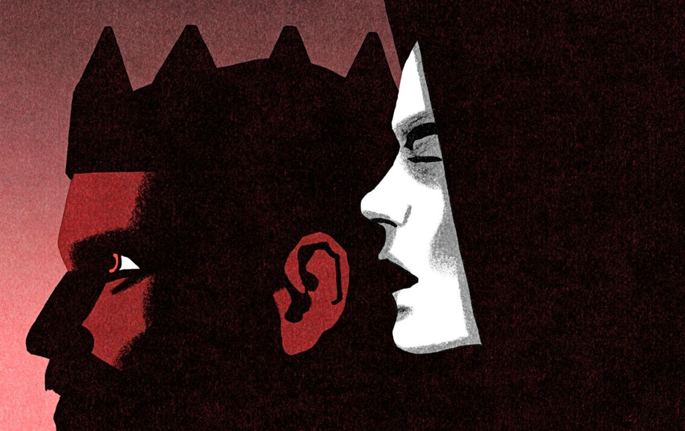
Year 10: Macbeth
Challenge Tasks
(You should be spending 1-2 hours each week on these challenges)

Name:

Week Two:
This week you have really been developing your understanding of the kind of character Macbeth is.
Hard – Make a note of quotes about Macbeth/Lady Macbeth that will help you track their development
Harder – Analyse these quotes for language/context/effect on the audience. Don’t forget to zoom in and use word class
Hardest – Complete the above 2 tasks and repeat for Lady Macbeth

Challenge: Critical Theorist Simone De Beauvoir
Key ideas:
- Gender is different from one’s biological sex and is a social construction. Society expects each gender to behave in a distinct way.
- Women are oppressed as they are only valued for their looks and their societal function as wives and mothers. This is a restrictive gender role.
- Women are ‘the second sex’ as they are seen as less powerful and important to men. Society is therefore patriarchal.
Research this notion and apply your knowledge to the text. Try to include this vocabulary: autonomy, dominant ideologies, dominant/submissive, equality, gender role, liberation, objectification, power reinforce/subvert, stereotypical
Challenge: Critical Theorist Karl Jung
Key ideas:
- All people share a ‘collective unconscious’ i.e. a part of our psyche we are not aware of that operates on an instinctual level.
- Part of this is symbolic character types – or archetypes.
As we are not directly aware of them, these archetypes can only be deduced indirectly by examining human behaviour, images, art, myths, religions, or dreams.
Research this notion and apply your knowledge to Macbeth. Try to include this vocabulary:
Archetype, character type, instinctual, psyche, symbolic, unconscious, universal
Week One:
This week you have learnt a little about the relevant historical context of ‘Macbeth’. Take this further by completing some research of your own, including: the great chain of being and the divine right of kings; King James I’s belief in witchcraft; belief in the supernatural in Shakespeare’s time; regicide; the Gunpowder Plot.
- Create a revision tool for yourself that you can use. This could be a poster, cue cards, fact sheet etc.
- Keep it safe because you will need to keep adding to it.

Week Four-Six: Consolidation
Ensure you are familiar with the plot, themes and characters. Use BBC Bitesize and your revision guides to add to your revision tool.
Make notes on Macbeth, Lady Macbeth, Duncan, Malcolm, Banquo, MacDuff, Lady Macduff and the Porter. It is up to you how you present this. You could use a blank body shape where you write what the character is thinking/feeling on the inside and quotes on the outside. Do not forget to write whereabouts in the play the quotes are from as this will help you track the character. Or you could use cue cards. PowerPoint presentation
Week Three: - Add to your already existing notes
This week is analysis week. Show your understanding of the text so far by choosing a task below:
Hard – Using key vocab and quotes, bullet point how is Macbeth presented at the start of the play?
Harder – Complete the above task and describe how Macbeth’s character is starting to change?
Hardest – Apply one of the critical theories from week 1 or 2

Challenge: Critical Theorist Aristotle
Key ideas:
- A tragedy must have:
- a change of fortune from good to bad
- suffering that creates sympathy in the audience leading to an emotional release
- a realisation of the cause of the misery
- The main tragic hero should:
- be morally good
- have excessive pride
- make a tragic mistake
Research this notion and apply your knowledge to the text. Try to include this vocabulary: anagnorisis, Chorus, fortune, hamartia, hubris, misery, pathos, peripeteia, suffering, tragic hero

Bonus week:
The extract below shows Macbeth’s reaction after the witches told him he would be Thane of Cawdor and then Ross and Angus arrived to tell him he had indeed been made Thane of Cawdor. Complete the ‘all’ question and one more of the questions below:
All: What do we learn about Macbeth’s character from his reaction?
Hard: Analyse the language in the extract – annotate key quotations for language devices.
Harder: Analyse the language in the extract – annotate key quotations for language devices. How could you link this extract to context?
Hardest: In this extract, Shakespeare presents Macbeth as ambitious but cautious. How does his character change by the end of the play?
MACBETH
[Aside] Two truths are told,
As happy prologues to the swelling act
Of the imperial theme.--I thank you, gentlemen.
Aside
Cannot be ill, cannot be good: if ill,
Why hath it given me earnest of success,
Commencing in a truth? I am thane of Cawdor:
If good, why do I yield to that suggestion
Whose horrid image doth unfix my hair
And make my seated heart knock at my ribs,
Against the use of nature? Present fears
Are less than horrible imaginings:
My thought, whose murder yet is but fantastical,
Shakes so my single state of man that function
Is smother'd in surmise, and nothing is
But what is not.

Quotes to Learn – You will be tested on them
Week 3 Macbeth
- ‘what need I fear of thee?’ - pride
- ‘give to the edge o’ the sword his wife, his babes, and all unfortunate souls’ - violence
- ‘give me my armour’ – imperatives and instructions until the end
- ‘she should have died hereafter’ – callous lack of concern – echoes ‘out damn spot!’ – shows that death brings her peace from the permanent stain of guilt
- ‘out, out, brief candle!’
- ‘life’s but a walking shadow, a poor player...signifying nothing
- ‘I bear a charmed life’ – links back to witches but also hubris.

Quote Quest
This is a closed book exam, which means you can’t take a copy of the text into the exam with you. This means you need to learn some quotes off by heart. Choose 10 quotes from the play that you think could be useful and create a resource to help you learn them, such as:
- Flashcards
- Poster
- Rap or song
- Video

Quotes to Learn – You will be tested on them
Week 2 Macbeth
- ‘he’s here in double trust’ – doubt
- ‘vaulting ambition, which o’erleaps itself and fails on the other’ – hamartia
- Lady Macbeth: ‘when you durst do it, then you were a man’ – challenges his masculinity
- ‘I dare to do all that may become a man; who dares do more is none’ – flaw – wants to prove he is a man. Pride.
- ‘is this a dagger which I see before me’ – hallucination as he gets deeper
- ‘Sleep no more! Macbeth does murder sleep, the innocent sleep’ – significance of regicide compromises peace and innocence.
- ‘will all great Neptune’s ocean wash this blood clean from my hand?’ – blood foreshadows his death. Hyperbole.
- ‘never shake thy gory locks at me’ – hallucinations show vulnerability of language.

Quotes to Learn – You will be tested on them
Week 3 Macbeth
- ‘what need I fear of thee?’ - pride
- ‘give to the edge o’ the sword his wife, his babes, and all unfortunate souls’ - violence
- ‘give me my armour’ – imperatives and instructions until the end
- ‘she should have died hereafter’ – callous lack of concern – echoes ‘out damn spot!’ – shows that death brings her peace from the permanent stain of guilt
- ‘out, out, brief candle!’
- ‘life’s but a walking shadow, a poor player...signifying nothing
- ‘I bear a charmed life’ – links back to witches but also hubris.

For more resources, including literacy support, visit www.deastonenglish.com

